Simultaneous Linear Equations

8. EE.C.8a, 8.EE.C.8c Conceptual Understanding and Application Mini-Assessment by Student Achievement Partners

OVERVIEW

This mini-assessment is designed to illustrate the standard 8.EE.C.8, particularly 8.EE.C.8a and 8.EE.C.8c, which sets an expectation for understanding and applying pairs of simultaneous linear equations (systems of equations). This mini-assessment is designed for teachers to use either in the classroom, for self-learning, or in professional development settings to:

* **Gain knowledge** about assessing conceptual understanding and application of pairs of simultaneous linear equations;
* **Use in professional development** as an illustration of CCSS-aligned assessment problems;
* **Evaluate** students’ understanding of 8.EE.C.8a and 8.EE.C.8c in order to prepare to teach this material or to assess skills and understanding;
* **Illustrate best practices** for writing tasks that allow access for all learners; and
* **Support mathematical language acquisition** by offering specific guidance.

MAKING THE SHIFTS

This mini-assessment attends to **focus** as it addresses linear equations, which are at the heart of the grade 8 standards and a key component of the Major Work of the Grade.[1] Standard 8.EE.C.8 shows **coherence** across grades as it builds on foundational work from 6.EE.B.5 (see questions 1–5) to extend understanding of solving an equation to understanding of solving a system of equations. Too often, assessments separate topics so that students are not confronted with choosing the correct solution path. This mini-assessment challenges students to choose whether a linear equation or a system of linear equations correctly models the mathematical situation. In addition, this standard builds on work from grade 7, particularly understanding and using ratios and proportional relationships (7.RP) as well as using equations for problem solving (7.EE.A). Standard 8.EE.C.8a targets *conceptual understanding* and 8.EE.C.8c targets *application*, so this mini-assessment addresses two of the three elements of **rigor**.

**A CLOSER LOOK**

Standard 8.EE.C.8a addresses key concepts important for future student success working with Algebra, Functions, and Modeling. Students should know that a solution to a single equation in two variables is a pair of numbers that makes the equation true. Students should also know that a single equation in two variables generally has infinitely many solutions, in the form of infinitely many pairs of numbers that make the equation true. Solutions to an equation in two variables can be plotted on the coordinate plane. When the equation is linear, these solution pairs will graph in the coordinate plane as a straight line (see cluster 8.EE.B).

**8.EE.C.8.**  Analyze and solve pairs of simultaneous linear equations.

**8.EE.C.8a.** Understand that solutions to a system of two linear equations in two variables correspond to points of intersection of their graphs, because points of intersection satisfy both equations simultaneously.

Students should know that a solution to a system of simultaneous equations in two variables is a pair of numbers that makes all of the equations true simultaneously. Solutions, if there are any, correspond to points of intersection of the equations’ graphs. A system of two simultaneous linear equations in two variables will have 0, 1, or infinitely many solutions. This is easy to understand graphically, since two lines in the plane can have 0, 1, or infinitely many points of intersection.

**8.EE.C.8.**  Analyze and solve pairs of simultaneous linear equations.

**8.EE.C.8c.** Solve real-world and mathematical problems leading to two linear equations in two variables. For example, given coordinates for two pairs of points, determine whether the line through the first pair of points intersects the line through the second pair.

Standard 8.EE.C.8c requires application of the conceptual understanding described in 8.EE.C.8a. Here the phrase “solve real-world and mathematical problems” shows that we are talking about a mix of application problems set in real-world contexts along with application problems that are purely mathematical. Students should have familiarity with both types of applications so that they are prepared for future work with Algebra, Functions, and Modeling.

SUPPORT FOR ENGLISH LANGUAGE LEARNERS

This lesson was designed to include specific features that support access for all students and align to best practice for English Language Learner (ELL) instruction and assessment. Go [here](https://achievethecore.org/page/3165/support-for-the-english-language-learner-adaptation-project-annotated-bibliography) to learn more about the research behind these supports. Features that support access in this mini-assessment include:

* Tasks that allow for multi-modal representations, which can deepen understanding of the mathematics and make it easier for students, especially ELLs, to give mathematical explanations.
* Tasks that avoid unnecessarily complex language to allow students, especially ELLs, to access and demonstrate what they know about the mathematics of the assessment.

Prior to this mini-assessment, ensure students have had ample opportunities in instruction to read, write, speak, listen for, and understand the mathematical concepts that are represented by the following terms and concepts:

* **equation**
* **simultaneous equations**
* **system of equations**
* **solution(s)**
* **infinitely many solutions**
* **coordinate grid**
* **graph**
* **coordinate plane**
* **value(s)**

Students should engage with these terms and concepts in the context of mathematical learning, not as a separate vocabulary study. Students should have access to multi-modal representations of these terms and concepts, including: pictures, diagrams, written explanations, gestures, and sharing of non-examples. These representations will encourage precise language, while prioritizing students’ articulation of concepts. These terms and concepts should be reinforced in teacher instruction, classroom discussion, and student work (for example, through engagement in [mathematical routines](https://achievethecore.org/page/3164/mathematical-language-routines)).

ELLs may need support with the following Tier 2 words found in this mini-assessment:

* **select**
* **decide**
* **describe**
* **consider**
* **explain**
* **check**
* **circle**

In preparation for giving this mini-assessment, teachers should strive to use these words in context so they become familiar to students. It will be important to offer synonyms, rephrasing, visual cues, and modeling of what these words mean in the specific contexts represented in the items in this mini-assessment. Additionally, teachers may offer students the use of a student-friendly dictionary, or visual glossary to ensure they understand what is being asked of them in each item.

|  |  |
| --- | --- |
| Sketch |  |
| Point | • |
| Locate | • |

*An example of a visual glossary for student use.*

Name: ___________________________________________

1. Select all of the answer choices that are solutions to the equation $2x+2y=0$.

|  |  |
| --- | --- |
| **A.** *x* = 0 | **D.** *x* = –2 |
| **B.** *y* = –1 | **E.** *x* = –2, *y* = –2 |
| **C.** *x* = 1, *y* = –1 | **F.** *x* = 0, *y* = 0 |

2 Decide whether each pair of simultaneous equations has no solution, exactly 1 solution, or infinitely many solutions. Check the appropriate box in each row. (1 point)

|  |  |  |  |
| --- | --- | --- | --- |
|  | **No Solution** | **Exactly 1 Solution** | **Infinitely Many Solutions** |
|  |  |  |  |
|  |  |  |  |
|  |  |  |  |

3. A pair of simultaneous equations is shown.

$$y= 7x -15$$

$$y=-\frac{1}{7}x-15$$

How many solutions does the pair of simultaneous equations have? Describe your reasoning.

Answer: I know there are ________________ solutions because __________________________________________________________________________________________________________________________________________________________________________________________________________________________________________

4. Consider the equation:

$-\frac{4}{3}y- \frac{15}{6}x = \frac{-5}{7}$ How many solutions are there to this equation? _________________

Explain what the graph of the solution(s) will look like on a coordinate plane.

5. Which coordinate grid shows graphs of *y* = *mx* + 3 for several values of *m*?

|  |  |
| --- | --- |
| a. | b. |
| c. | d. |

6. Two equations are graphed below.

(a) Circle the point or points on this graph that represent the solution(s) to the system of equations.



(b) Explain how you know that the point or point(s) you circled represent the solution(s) to the system of equations.

7. A music festival has two types of tickets for sale. An Event Day ticket costs $54.95 on the day of the festival. A Pre-Sale ticket purchased before the day of the festival costs $39.95. A total of 20,000 tickets (Event Day and Pre-Sale) were sold for $925,000.

How many Event Day tickets did they sell? How many Pre-Sale tickets did they sell?

8. The coordinate grid below shows the graph of a system of two linear equations.



How many solutions are there? Explain your answer using numbers and/or words.

9. What is the solution to the pair of simultaneous equations shown?

6?

10. The graphs of two linear equations are shown below.



Check the box next to each correct statement.

|  |  |
| --- | --- |
| □ (-3, 2) is a solution to Equation 1.  □ (-3, 2) is a solution to Equation 2.  □ (-3, 2) is a solution to both equations. | □ (-2, 1) is a solution for Equation 1.  □ (0, -6) is a solution for Equation 2.  □ The system of Equation 1 and Equation 2 has (-3, 2) as its only solution. |

11. Henry is four times older than James. Next year, Henry will be three times older than James will be.

How old are Henry and James now?

12. Kim has a small container and a large container as shown.



Kim can fill the large container completely with water by pouring 16 of the small container into it. If Kim pours only 3 of the small container into the large container, there is 1.95 gallons of empty space in the large container.

What is the capacity, in gallons, of the small container? What is the capacity, in gallons, of the large container?

13. Equation 1 and Equation 2 form a system of equations.

* Equation 1: 3*x* + 9 = -4*y* + 2
* Equation 2: The equation of the line that passes through the points (0, 1) and (2, 5).

Does this system have a solution? If so, write the solution(s) to the system of equations. If not, write “no solution.”

1. Students receive full credit for only selecting these two choices:

**C.** *x* = 1, *y* = -1 and **F.** *x* = 0, *y* = 0

|  |  |  |  |
| --- | --- | --- | --- |
|  | **No Solution** | **Exactly 1 Solution** | **Infinitely Many Solutions** |
| $$x=y$$ $$1.25x=1.25y$$ |  |  |  |
| $$9.9=6x+ 8y$$ $$9x=2.5y-8.8$$ |  |  |  |
| $$11x-2y=1.5$$ $$11x-2y=2.5$$ |  |  |  |

1. There is one solution. (Or any answer that expresses the same idea.)

NOTE: There is a variety of possible explanations, such as “I know when $x = 0$ then $y = -15$ for both equations,” “because the slopes are different, the lines will intersect,” “the graph of the lines are not parallel so they will cross,” etc.

1. Infinitely many solutions. (Or any answer that expresses the same idea.)

The graph will be a line.



1. Student circles the intersection points as shown.

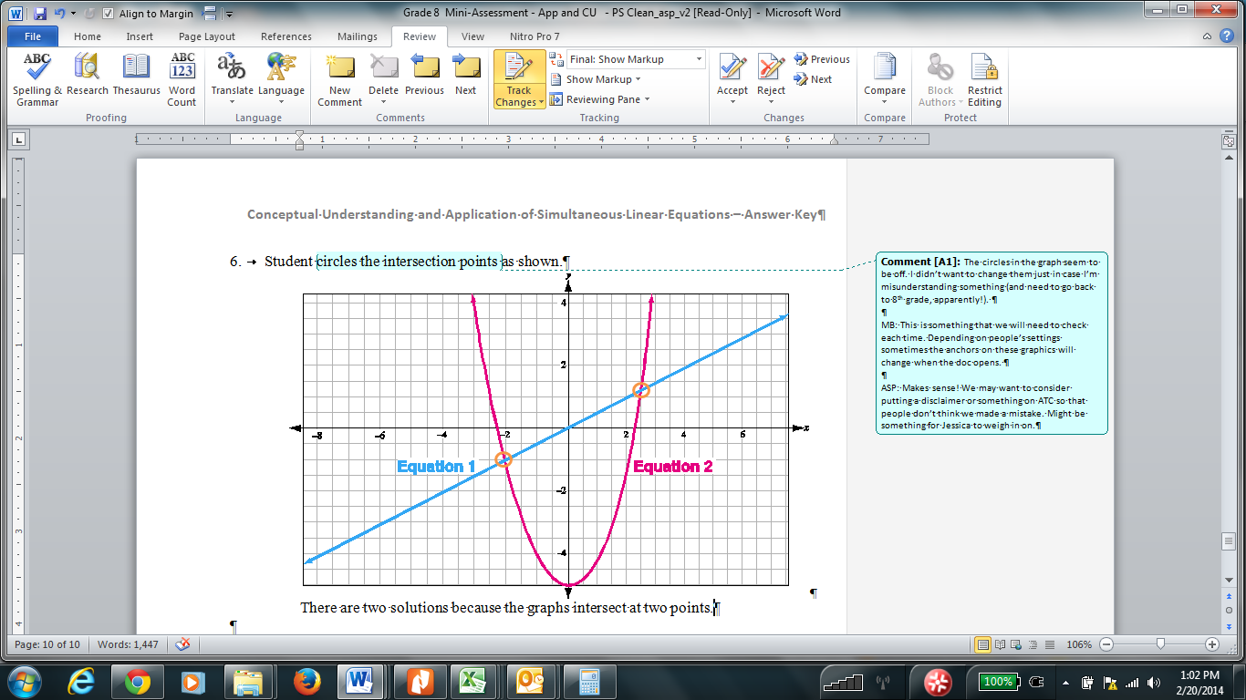

There are two solutions.

There is a variety of possible explanations, including “because the graphs intersect at two points,” “the equations share two values,” “there are two points on the graph of both equations,” etc.

1. 8,400 tickets were sold at the music festival; 11,600 tickets were sold before the music festival
2. There is one solution.

There is a variety of possible explanations, including “because the lines will eventually cross,” “the lines are not parallel,” “the lines have different slopes,” etc.

9. (3.5, –3.5) or any equivalent answer.

10. Student only selects these three statements:

□ (-3, 2) is a solution to Equation 1.

□ (-3, 2) is a solution to Equation 2.

□ The system of Equation 1 and Equation 2 has (-3, 2) as its only solution.

11. James is 2 years old; Henry is 8 years old.

12. The small container holds 0.15 gallons; the large container holds 2.4 gallons.

13. Yes, there is one solution at (-1, -1).

1. For more on the Major Work of the Grade, see [achievethecore.org/focus](https://achievethecore.org/category/774/mathematics-focus-by-grade-level).