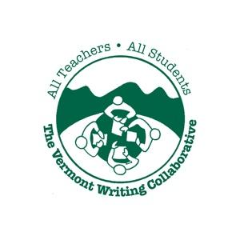
Colorful Language
Professional Development Planning Page
Purpose:
- To become familiar with the language and terminology used in the Common Core State Standards for writing.
- To refine and deepen understanding of grade level expectations in the CCSS .
Audience: K-12 educators, administrators, ELA and content area specialists
Grouping: Groups of two or three, single or multiple grade levels
Materials:
- Set of 3-6 unannotated student pieces of a single writing type (Opinion /Argument, Informative/Explanatory or Narrative). These may be drawn from the On Demand or Range of Writing pieces and may represent a single grade level or a range of grade levels.
- Set of corresponding annotated pieces or internet access to In Common.
- CCSS Writing Standards for the writing type and grade levels being addressed
- Colored pencils, highlighters or crayons
Approximate Time: 30 minutes- 1 hour
Time needed for this activity will vary based on the grade levels of the pieces being analyzed. Elementary pieces are shorter, and can generally be read and analyzed in less than an hour. Middle and high school pieces, because of their length and complexity, generally require much more time.
Advance Preparation:
1. Use the work samples provided or use the In Common Collection to create a customized packet of student work for each participant.
To create a custom packet:
- Go to the Range of Writing and/or the On Demand Writing sections of In Common .
- Choose a writing type to focus on (Opinion/Argument, Informative/Explanatory or Narrative).
- Print the transcribed (unannotated) versions of any pieces you like. Depending on your purpose and audience, you may create a set containing several pieces at a given grade level, or a set showing student writing at a variety of grade levels. Create a packet of unannotated pieces. Copy for each participant.
- Print, or arrange for participants to have electronic access to, the annotated version of the pieces you chose. Create and copy a packet of annotated pieces, or provide a link to In Common so that groups have access as they work .
2. Copy the Common Core Writing Standards for the writing type and grade levels addressed, or ask that participants bring their own copies of the standards.
3. Use the Direction sheet in this packet or choose particular descriptors within a writing type or standard to focus on. Modify the Colorful Language Direction Sheet to reflect your goals for the activity.
4. Not all pieces in the collection are solid examples of a particular descriptor. Be sure to try this activity yourself and adjust the pieces chosen accordingly.
Leading the Activity:
- Introduce the activity and collection of student work samples, using the short PowerPoint or the written protocol included in this resource.

- Group participants as desired. Most activities work best if done in pairs or groups of three. Group members may teach the same grade level or represent multiple grade levels.

- Hand out materials (listed above).

- Review directions for completing the activity on the Protocol, calling attention to the specific direction sheet provided.

- Circulate, answering questions and extending thinking as participants observe, record and reflect on the student work.

- Debrief by sharing observations as a full group.

- Help participants synthesize and summarize what they have learned.

- Optional: As a group, develop a short written synthesis of new learning. Arrange for everyone to get a copy of this group synthesis (This can be e-mailed to participants, created in a Google Doc, printed out and photocopied or even copied by hand by participants).

- Distribute and collect the Exit Ticket below. Be sure to respond to questions and use this feedback before repeating the activity with a different writing type or grade level span.

Exit Ticket

Please reflect briefly on this activity below.

What are the key elements in this writing type at your grade level?

How will what you have learned in this activity help you in planning writing instruction?

What questions do you have about this writing type?

What would make this activity more effective? What suggestions do you have for future activities?

Thank you!
Common Ground Protocols: Using the In Common Collection to Better Understand the CCSS
http://www.achievethecore.org www.vermontwritingcollaborative.org

Common Ground Protocols: Using the In Common Collection to Better Understand the CCSS
http://www.achievethecore.org www.vermontwritingcollaborative.org

Colorful Language

Overview:
In this exercise, you will gain a better understanding of particular aspects of the standards by color coding student samples that provide concrete examples of a descriptor or set of descriptors used in the CCSS. Many descriptors are used repeatedly in the writing standards. Attaching descriptors to actual student writing will help clarify what each means at a particular grade level.
Purpose:
- To refine and deepen understanding of a particular aspect of effective writing .
- To become familiar with, and clarify, terminology used in the Common Core State Standards.
Protocol:
- Choose a piece in the packet and locate the grade appropriate Common Core Writing Standard for Opinion/Argument, Informative/Explanatory or Narrative writing (W.1, W.2, W.3).
- Read the directions on the Colorful Learning sheet to find out which parts of the standard you are to focus on and what colors you will need.
- Annotate the student writing by finding and color coding examples of the descriptors you are focusing on.
- When you have finished, check your observations against the annotated version of the same piece. Be sure to note any questions you have.
Common Ground Protocols: Using the In Common Collection to Better Understand the CCSS
http://www.achievethecore.org www.vermontwritingcollaborative.org

- When you have finished color coding all of the pieces, discuss your observations with a colleague using the questions at the bottom of the Colorful Language sheet.

Colorful Language K-5
(Please adapt this sheet to reflect your professional development goals for this activity)

- Locate, and read, the grade appropriate Common Core Writing Standard for the piece you are working with.
- Look for examples of the following descriptors in the student writing. Color code them using the colors indicated.
Opinion/Argument:
Find and color code examples to show how each of the following are used in the student sample:
Introduction: red
Opinion Statement: light green
Reason #1 and supporting facts and details: yellow
Reason #2 and supporting facts and details: blue
Concluding Section: darker green
*Note: Not all pieces will contain all of the above. How do expectations change from grade to grade?

- When all pieces in your packet have been color coded, discuss the following questions with a colleague:
- How did the writer use these techniques to develop experiences and events or show the responses of characters to situations?
- How might you help students learn to effectively use these techniques in their writing?

A Common Ground Protocol www.vermontwritingcollaborative.org
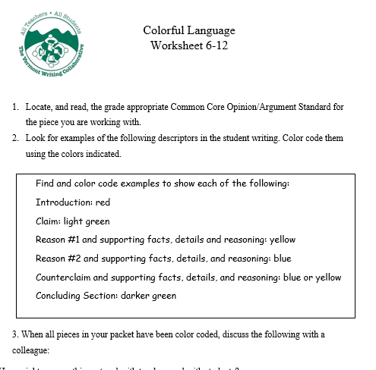
A Common Ground Protocol www.vermontwritingcollaborative.org

3. When all pieces in your packet have been color coded, discuss the following questions with a colleague:
- How did the writer use these techniques to develop experiences and events or show the responses of characters to situations?
- How might you help students learn to effectively use these techniques in their writing?

