Title/Author: How to Bicycle to the Moon to Plant Sunflowers by Mordicai Gerstein
Suggested Time to Spend: 4 Days (Recommendation: two sessions per day, at least 20 minutes per day)
Common Core grade-level ELA/Literacy Standards: RL.1.1, RL.1.2, RL.1.3, RL.1.7; W.1.2; SL.1.1, SL.1.2, SL.1.4, SL.1.5; L.1.1, L.1.4
Lesson Objective:
Students will listen to a story read aloud and use literacy skills (reading, writing, discussion and listening) to determine the meaning of new words and explain the importance of following a plan in sequential order.

Teacher Instructions
Before the Lesson
- Read the Big Ideas and Key Understandings and the Synopsis below. Please do not read this to the students. This is a description to help you prepare to teach the book and be clear about what you want your children to take away from the work.
Big Ideas/Key Understandings/Focusing Question
Well thought out plans make anything seem possible.
How do reality and fantasy help shape our ideas about what is possible?
Synopsis
A young boy creates a plan to travel to the moon on his bicycle in order to plant sunflowers. This blend of reality and fantasy takes the reader step by step through his journey of getting from Earth to the Moon.
- Go to the last page of the lesson and review “What Makes this Read-Aloud Complex.” This was created for you as part of the lesson and will give you guidance about what the lesson writers saw as the sources of complexity or key access points for this book. You will of course evaluate text complexity with your own students in mind, and make adjustments to the lesson pacing and even the suggested activities and questions.
- Read the entire book, adding your own insights to the understandings identified. Also note the stopping points for the text-inspired questions and activities. Hint: you may want to copy the questions vocabulary words and activities over onto sticky notes so they can be stuck to the right pages for each day’s questions and vocabulary work.

Note to teachers of English Language Learners (ELLs): Read Aloud Project Lessons are designed for children who cannot read yet for themselves. They are highly interactive and have many scaffolds built into the brief daily lessons to support reading comprehension. Because of this, they are filled with scaffolds that are appropriate for English Language Learners who, by definition, are developing language and learning to read (English). This read aloud text includes complex features which offer many opportunities for learning, but at the same time includes supports and structures to make the text accessible to even the youngest students.
This lesson includes features that align to best practices for supporting English Language Learners. Some of the supports you may see built into this, and /or other Read Aloud Project lessons, assist non-native speakers in the following ways:

- These lessons include embedded vocabulary scaffolds that help students acquire new vocabulary in the context of reading. They feature multi-modal ways of learning new words, including prompts for where to use visual representations, the inclusion of student-friendly definitions, built-in opportunities to use newly acquired vocabulary through discussion or activities, and featured academic vocabulary for deeper study.
- These lessons also include embedded scaffolds to help students make meaning of the text itself. It calls out opportunities for paired or small group discussion, includes recommendations for ways in which visuals, videos, and/or graphic organizers could aid in understanding, provides a mix of questions (both factual and inferential) to guide students gradually toward deeper understanding, and offers recommendations for supplementary texts to build background knowledge supporting the content in the anchor text.
- These lessons feature embedded supports to aid students in developing their overall language and communication skills by featuring scaffolds such as sentence frames for discussion and written work (more guidance available here) as well as writing opportunities (and the inclusion of graphic organizers to scaffold the writing process). These supports help students develop and use newly acquired vocabulary and text-based content knowledge.

The Lesson – Questions, Activities, and Tasks

Questions/Activities/Vocabulary/Tasks | Expected Outcome or Response (for each)
FIRST READING:  Read aloud the entire book with minimal interruptions. Stop to provide word meanings or clarify only when you know the majority of your students will be confused.  Before the Second Reading:  Teach students that the surface of the moon looks like a face to some people. Also point out to students that this book contains text features to explain the boy’s plan, such as boxes for each step with the text in the boxes, speech bubbles, and numbers in the corners of the boxes. | The goal here is for students to enjoy the book, both writing and pictures, and to experience it as a whole. This will give them some context and sense of completion before they dive into examining the parts of the book more carefully.
SECOND READING:  P.1  - What did we learn about what the boy wants to do?  - Why?  - What is the reaction of his parents?  - Why did they react this way?  P. 2-5  - What did the boy write down and why?  Step 1  - What does it mean to have a plan?  Step 2.  - What is another way of saying that his uncle would loan them to you?  Step 4  - In this text, what does it mean to stretch?  - Look closely at the illustration on this page. How do the big and small pictures work together to help you better understand his plan?  Step 6  - What is an anchor?  Step 7b  - Why do we need the hose to be 238,900 miles long?  Step 7b  - What objects does the boy use in his plan up to this point?  Step 8a and 8b  - Is this part of the story when the boy launches the flagpole with the anchor fantasy or reality? Use evidence from the text to support your answer.  Step 8b  - What does it mean when the boys says that the flagpole will be catapulted into the night sky? | P.1  - The boy wants to go to the moon to plant sunflowers.  - He wants to go to cheer the moon up because it looks like a sad clown face. His parents said that it is probably lonely because nothing lives there.  - His parents laughed/giggled.  - They didn’t think that it was realistic for him to bicycle to the moon.  P. 2-5  - He wrote down his plan for someone else to follow because he didn’t have time due to his homework, soccer and violin responsibilities.  Step 1  - A plan is a set of actions that have been thought of as a way to do or achieve something.  Step 2  - His uncle would let him borrow them.  (To loan something is to give permission to use something for a period of time, or to let them borrow it.)  Step 4  - To stretch something is to make it longer by pulling it.  - The big picture shows the tractor stretching the rubber band down the hill and the small picture gives the reader an idea of how it will look once you tie it around the tree. It’s a before and after picture.  Step 6  - An anchor is a heavy device that is attached to a boat or ship by a rope or chain and that is thrown into the water to hold the boat or ship in place.  Step 7b  - That is the distance from the earth to the moon.  Step 7b  - Flagpole, anchor, garden hoses, inner tube, bicycle, gigantic spool  Step 8a and 8b  - This part is fantasy, because the flagpole would be too heavy to move and would not last in the air.  Step 8b  - A catapult is a device for launching an airplane at flying speed (as from an aircraft carrier). The flagpole will disappear in the night sky with the hose spinning off the spool after it.
THIRD READING:  Reread through Step 9a  - What is a journey? What is a spacesuit?  Step 11a  - Based on the boy’s plan, how would you know that the anchor has finally reached the moon?  Step 12a  - What does NASA stand for?  - What does NASA do?  - Turn and talk to your partner about why the boy may have written to NASA.  Step 12b  - The boy says that your mom will say that it’s too risky. What does that mean?  - What does the boy say will happen that will make your mother realize that this plan is serious?  Step 12c  - Why does the boy assume his parents will say “yes”? (Explain that brimming means that something is almost overflowing, or about to spill.)  Step 13  - What additional supplies does the boy tell you to pack?  - Explain that compost is a decayed mixture of plants (such as leaves and grass) that is used to improve the soil in a garden.  - Explain that a trowel is a small tool with a curved blade that is used by gardeners for digging holes.  - Why do you think he tells you to turn on the faucet?  - What makes you think that?  Step 14  - What does it mean to drift? Use the pictures to help you figure this out.  - What does the boy tell you to do to prepare for Step 14?  Explain that nourishing means providing the things that are needed for health and growth. (Step 15)  Step 17  - What is gravity?  - What clues in the words and illustrations can help you figure this out? | THIRD READING:  Step 9a  - A journey is a trip or an act or instance of traveling from one place to another. A spacesuit is what astronauts wear in space. The suit is really a small spacecraft. It protects the astronaut from the dangers of being outside in space.  Step 11a  - You would hear a tremendous sound.  The spool will stop spinning. If you tug on the hose, you will feel the moon tugging back.  Step 12a  - National Aeronautics and Space Administration  - The agency is in charge of the U.S. exploration of space  - Since NASA explores outer space, they would be able to provide advice about the plan. They are also the only people who would have a spacesuit since they use them all the time when they travel out into space.  Step 12b  - A risk is the possibility that something bad or unpleasant (such as an injury or a loss) will happen.  - NASA sent a space suit.  Step 12c  - When the parents see the letter from NASA, they will realize how serious the plan is and while they will be scared for him to go, they will let him go because they will realize that NASA already knows about it and have sent him a spacesuit to borrow. "IT'S TOO RISKY!" she'll say, her eyes brimming with tears…..and that means yes!  Step 13  - sunflower seeds, compost, and a trowel  - He tells you to turn on the faucet so you will have water in space to plant the sunflower seeds.  - The boy is listing all the supplies that you will need to plant the sunflower seeds.  Step 14  - To drift is to slowly or gradually move or change from one place, condition, etc., to another  - He said to tie the hose between the clothes line pole and the tree and ride your bike on it for practice.  Step 17  - Gravity is the natural force that tends to cause physical things to move towards each other: the force that causes things to fall towards the Earth  - The boy tells you to keep your speedometer at FIVE HUNDRED MILES AN HOUR. You'll feel like you're standing still.
Reread Step 19  - Explain that something is transparent when you can see through it.  - How do we know from the text what vast means?  - How do we know that the boy has changed the way he feels about his plan?  Step 23  - What does the boy tell you to expect about the way you are greeted when you return home? | Step 19  - Vast Empty Space...varies greatly in size or range; Nothing is there; The boy says that you may look back at the earth and feel lonely. The moon will no longer have a face.  - At first the boy was excited because he said that he had a brilliant plan. Then he tells the reader that as you get closer to the moon and further from earth, you might get lonely and start to cry.  Step 23  - You will probably be treated like a hero with TV cameras, interviews, and cheering.
FIFTH READ  The fifth read can be used as a time to prepare students for the culminating activity. The teacher can lead students through filling out the following two charts as a group before they begin their culminating task.  Reread Steps 1-4  - Which of the objects or steps can realistically get you to the moon? (Record student answers on a chart.)  Step Reality Fantasy  - Bicycle  - 2000 inner tubes  3a. Tie inner tubes to make one long rubber band  3b. Tie rubber band to the birch trees.  4. Create a giant slingshot.  Reread Steps 14-18.  - How are the experiences different on earth and space?  Earth Space | Reread Steps 1-4  Step Reality Fantasy  - Bicycle X  - 2000 inner tubes X  3a. Tie inner tubes to make one long rubber band X  3b. Tie rubber band to the birch trees. X  4. Create a giant slingshot. X  Reread Steps 14-18.  How are the experiences different on earth and space?  Earth Space  Solid foods Eat from a straw  Gravity keeps you on the ground There is no gravity, so there will be no force pulling you down. You will float in a vast empty place in your spacesuit.  Cheering, screen doors, dogs, lawn mowers, conversations Quiet space, except for body sounds  Fast, tiring You will move Fast and easy. It will feel like you are still.  Eagles, birds, oceans, clouds Stars & satellites

FINAL DAY WITH THE BOOK - Culminating Task
- Group Activity: Record the steps to the boy’s plan on a chart using phrases & pictures.
- Individual Activity: Write a letter, to the boy, explaining which parts of the plan would be difficult to achieve and why.
(A sample chart and letter are included below.)

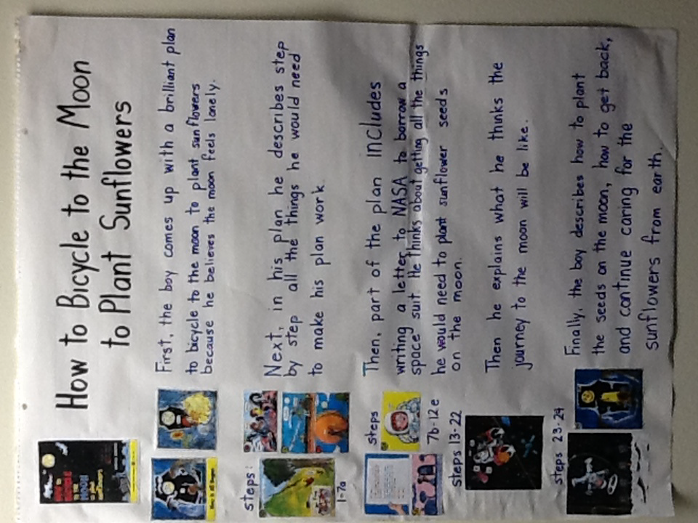

Dear boy,

I was talking with my teacher and friends about your plan. It looks like you planned every step. However, some of your steps look too hard or are a bit unrealistic.

I don’t think your uncle would have that many inner tubes in a store, maybe 50. If you use a tractor to stretch the rubber band, the trees might fall down. I saw some workers putting up a flagpole, they used a crane because it was too heavy. Where would you get a giant spool? I think that the moon is too far for you to reach it with a slingshot, even if it’s huge. I heard that the moon has no gravity. I don’t think you would be able to water the plants because the water would float away.

Please review your plan again and maybe make some changes. I’ll be happy to read through it again.

Your friend,

Sandy

Vocabulary
These words merit less time and attention  (They are concrete and easy to explain, or describe events/  processes/ideas/concepts/experiences that are familiar to your students.) | These words merit more time and attention  (They are abstract, have multiple meanings, and/or are a part  of a large family of words with related meanings. These words are likely to describe events, ideas, processes or experiences that most of your student will be unfamiliar with)
Step 8b.- catapult – a device for launching an airplane at flying speed (as from an aircraft carrier)  Step 13. - compost – a decayed mixture of plants (such as leaves and grass) that is used to improve the soil in a garden  Step 13. - trowel – a small tool with a curved blade that is used by gardeners for digging holes  Step 6. - anchor – a person or thing that provides strength and support  Step 15. – nourishing – providing the things that are needed for health, growth  Step 19. – transparent – able to be seen through  Step 12c. – brimming – the top edge of a glass or a similar container | Step 1. -Plan – a set of actions that have been thought of as a way to do or achieve something  Step 4. - stretch – to make (something) wider or longer by pulling it  Step 2. -loan – permission to use something for a period of time  Step 12b. - risk – the possibility that something bad or unpleasant (such as an injury or a loss) will happen  Step 14. - drift – a slow and gradual movement or change from one place, condition, etc., to another  Step 19.- vast – very great in size, amount, degree, intensity, or especially in extent or range  Step 17. - gravity – the natural force that tends to cause physical things to move towards each other: the force that causes things to fall towards the Earth  Step 9a. - journey – an act or instance of traveling from one place to another: trip

Extension learning activities for this book and other useful resources
- Read additional books about the moon, both fiction and nonfiction. A few suggested titles are below. Suggested key ideas, text-dependent questions, and extension tasks can be found in the Moon Unit on Achieve the Core (http://www.achievethecore.org/page/692/the-moon-research-project). Note: This is particularly supportive of English Language Learners.
  - Carle, Eric. (1986). Papa, please get the moon for me. New York, NY: Scholastic.
  - Crelin, Bob. (2009). Faces of the moon. Watertown, MA: Charlesbridge Publishing. Delta Science Readers. (2003).
  - Finding the moon. Nashua, NH: Delta Education. Fowler, Allan. (1991).
  - So that’s how the moon changes shape! Danbury, CT: Children’s Press.
  - Olson, Gillia M. (2007). Phases of the moon. Mankato, Minnesota: Capstone Press.
- Before the second reading, share the Phases of the Moon PowerPoint from Achieve the Core with the students (http://www.achievethecore.org/page/692/the-moon-research-project)

What Makes This Read-Aloud Complex?
- Quantitative Measure
Go to http://www.lexile.com/ and enter the title of your read-aloud in the Quick Book Search in the upper right of home page. Most texts will have a Lexile measure in this database.

Most of the texts that we read aloud in K-2 should be in the 2-3 or 4-5 band, more complex than the students can read themselves.
2-3 band 420-820L
4-5 band 740-1010L

___690_____

- Qualitative Features
Consider the four dimensions of text complexity below. For each dimension*, note specific examples from the text that make it more or less complex.
Is anything/everything possible if you develop a plan? (Reality VS Fantasy)

How to/Sequential
Letter
Dialogue

New Vocabulary: unfamiliar
academic language
*NASA
*Gravity
*Anchor
Simple Sentences
Easy to understand

Theoretical Knowledge:
- Distance to the moon/space
- Atmosphere in space
Reality vs. Fantasy

Structure
Meaning/Purpose

Language
Knowledge Demands

*For more information on the qualitative dimensions of text complexity, visit http://www.achievethecore.org/content/upload/Companion_to_Qualitative_Scale_Features_Explained.pdf
- Reader and Task Considerations
What will challenge my students most in this text? What supports can I provide?

The theoretical knowledge and new vocabulary will be challenging. Throughout reading, provide opportunities to discuss new vocabulary and use illustrations to help clarify text complexity. Depending upon when story is read within the set of text will determine if it is used to compare reality VS fantasy or to identify questions to be researched.

How will this text help my students build knowledge about the world?

Students will differentiate between Reality VS Fantasy and knowledge of space.

- Grade level
What grade does this book best belong in? 1st Grade

All content linked to within this resource was free for use when this resource was published in March 2018. Over time, the organizations that manage that external content may move or remove it or change the permissions. If the content is no longer available, please email info@studentsachieve.net

