Title/Author: Desert Giant: The World of the Saguaro Cactus by Barbara Bash
Suggested Time to Spend: 5 Days (Recommendation: five 30 minute sessions)
Common Core grade-level ELA/Literacy Standards: RI.2.1, RI.2.2, RI.2.3, RI.2.4, RI.2.6, RI.2.7; W.2.2, W.2.8; SL.2.1, SL.2.2, SL.2.5, SL2.6; L.2.1, L.2.2, L.2.4
Lesson Objective:
Students will listen to an informational text read aloud and use literacy skills (reading, writing, discussion, and listening) to understand the theme of interdependence.

Teacher Instructions
Before the Lesson
- Read the Big Ideas and Key Understandings and the Synopsis below. Please do not read this to the students. This is a description to help you prepare to teach the book and be clear about what you want your children to take away from the work.
Big Ideas/Key Understandings/Focusing Question
Although deserts appear barren, species are able to thrive. Living things depend on one another to survive.
Focus Question: How does the interdependence of plants and animals help them survive the harsh conditions of the desert?
One key takeaway is that the saguaro cactus provides a source of food and shelter for many desert animals. In turn, the cactus depends on desert animals to pollinate its flowers and continue its life cycle.

Synopsis
This is an informational piece of text focusing on the saguaro cactus in the Sonoran Desert. The saguaro cactus provides shelter and food for a diverse population of desert animals and people. While each animal visits the cactus a description of the animal and how it uses the cactus is provided. The story also takes the reader through the life cycle of the cactus. The author provides some text features to support the scientific content.
- Go to the last page of the lesson and review “What Makes this Read-Aloud Complex.” This was created for you as part of the lesson and will give you guidance about what the lesson writers saw as the sources of complexity or key access points for this book. You will of course evaluate text complexity with your own students in mind, and make adjustments to the lesson pacing and even the suggested activities and questions.
- Read the entire book, adding your own insights to the understandings identified. Also note the stopping points for the text-inspired questions and activities. Hint: you may want to copy the questions vocabulary words and activities over onto sticky notes so they can be stuck to the right pages for each day’s questions and vocabulary work.
- Consider pairing this series of lessons on Desert Giant with a text set to increase student knowledge and familiarity with the topic. A custom text set can be found here. Note: This is particularly supportive of ELL students

Note to teachers of English Language Learners (ELLs): Read Aloud Project Lessons are designed for children who cannot read yet for themselves. They are highly interactive and have many scaffolds built into the brief daily lessons to support reading comprehension. Because of this, they are filled with scaffolds that are appropriate for English Language Learners who, by definition, are developing language and learning to read (English). This read aloud text includes complex features which offer many opportunities for learning, but at the same time includes supports and structures to make the text accessible to even the youngest students.
This lesson includes features that align to best practices for supporting English Language Learners. Some of the supports you may see built into this, and /or other Read Aloud Project lessons, assist non-native speakers in the following ways:

- These lessons include embedded vocabulary scaffolds that help students acquire new vocabulary in the context of reading. They feature multi-modal ways of learning new words, including prompts for where to use visual representations, the inclusion of student-friendly definitions, built-in opportunities to use newly acquired vocabulary through discussion or activities, and featured academic vocabulary for deeper study.
- These lessons also include embedded scaffolds to help students make meaning of the text itself. It calls out opportunities for paired or small group discussion, includes recommendations for ways in which visuals, videos, and/or graphic organizers could aid in understanding, provides a mix of questions (both factual and inferential) to guide students gradually toward deeper understanding, and offers recommendations for supplementary texts to build background knowledge supporting the content in the anchor text.
- These lessons feature embedded supports to aid students in developing their overall language and communication skills by featuring scaffolds such as sentence frames for discussion and written work (more guidance available here) as well as writing opportunities (and the inclusion of graphic organizers to scaffold the writing process). These supports help students develop and use newly acquired vocabulary and text-based content knowledge.

The Lesson – Questions, Activities, and Tasks

Questions/Activities/Vocabulary/Tasks | Expected Outcome or Response (for each)
FIRST READING:  Pull the students together or use a document camera so that all can enjoy and use the illustrations. The illustrations play a key role in understanding some of the concepts and vocabulary in the story. Read aloud the entire book with minimal interruptions. Stop to provide word meanings or clarify only when you know the majority of your students will be confused. | The goal here is for students to enjoy the book, both writing and pictures, and to experience it as a whole. This will give them some context and sense of completion before they dive into examining the parts of the book more carefully.
SECOND READING:  As you read this time, focus on close reading and responding to text dependent questions to build meaning and knowledge about the saguaro cactus and its interdependence with other desert species. You may need to break this part into two sessions as the questioning is lengthy.  Reread page 1  Question:  Using evidence from the text describe what a saguaro is.  Reread page 2  Questions:  What facts does the author give you about the saguaro cactus?  Explain in your own words how its features help the cactus survive in the desert.  Reread page 4  Note to teacher: Be sure to build knowledge around the word and meaning of decompose on this page.  Questions:  How does the Gila woodpecker use the saguaro to survive in the desert?  What process does the nest go through to become a food container for the Indians?  Reread Page 6  Question:  Using evidence from the text, compare the ways in which the elf owl and the harris hawk use the saguaro cactus for nesting.  Reread Page 9  Questions:  Using evidence from the text, describe how a bud would emerge from the cactus.  How do the bat and the cactus depend on each other?  Reread Page 11  Questions:  What other creatures participate in pollination.  What is the end result of pollination for a saguaro?  Reread Page 13  Question:  How do the O’odham Indians harvest the fruit?  Reread Page 14  Questions:  Using the illustrations and details from the text, explain what they do with the fruit they have gathered. (Guide students to an understanding of the word mesh during this discussion.)  Give examples of how the O’odham Indians use the saguaro cactus fruit.  Explain the significance of the harvest.  Reread Page 17  Questions:  What type of animal is the curved bill thrasher, how can you tell?  How do other animals use the saguaro cactus for survival?  Reread Page 19  Question:  How do other nocturnal animals depend on the cactus?  Reread Page 21  Questions:  What details from the text help to describe the process of decomposition?  How do the illustrations support the description in the text?  Reread Page 22  Questions:  After the saguaro dies animals continue to depend on it, using the illustrations and evidence from the text explain how animals continue to depend on the saguaro.  Reread Page 23  Questions:  Where are the insects?  If aqua means water, what can you infer about the aquatic beetle? *Teacher Note: Bring attention to the word aqua because it can be leveraged in many context areas through the word family.  Reread Page 25  Question:  What challenges does the saguaro face in order to grow and produce flowers, fruit, and arms?  Reread Page 27  Question:  On the last page, the author states “The 150 year old cactus giant towers quietly over the desert.” The cactus appears alone in this picture. How does that contrast with the rest of the book? | Strange and wonderful tree, grows in the desert, a cactus, Latin name cereus giganteus (good opportunity to discuss authors use of italics for a foreign word using in isolation).  It grows in the Sonoran desert, it can grow as tall as fifty feet, weigh up to several tons, and live for two hundred years, it's sharp spines protect it from harm.  The spines protect it from harm and the pleats expand in the rain to store water.  The male pecks into the flesh to make room for his mate’s eggs to hatch.  The flesh forms a hard callous lining around the nests, when the cactus dies and decomposes the hollow forms are left behind.  The elf owl moves into the Gila woodpecker’s nest and the hawk builds a nest of twigs lined with leaves and grasses.  At night in May, a bud emerges out of the top of the cactus. The bud opens into a large milky white flower.  The bat drinks nectar from the flowers. As the bat drinks, the pollen dust sticks to its face and it then pollinates the next bloom.  White winged doves, a queen butterfly, and a bee.  Fruit begins to form. *This is a good opportunity to refer back to the life cycle of a plant and how the bat, bee, dove, and butterfly participate in that life cycle.  They use gathering poles with prongs that can pull the fruit down. The women scoop up the bright red pulp and tiny black seeds into buckets. The children steal a taste of the pulp and the women leave the hulls as an offering for the rain.  The remove pebbles from the fruit pulp. The mix the pulp with water and cook it for a long time. They use mesh to separate the juice from the seeds (text). The mesh consists of strings of wire tied to sticks with holes for the juice to pour through (illustration).  They make jams, candies, syrups, and wines out of the fruit.  It provides good food to eat and signals that the rain will soon come.  A bird, you can tell by using the description and the illustrations.  The thrasher eats the pulp, the harvester ants scurry around the seeds, and the horned lizard waits by the fallen fruit to catch the ants with his tongue.  The coyote licks the fruit pulp out of the fallen rinds and the javelinas eat the fruit.  Flesh falls away exposing the ribs of the saguaro cactus, weakening tissue make it prey to bacteria.  The saguaro ribs are spreading out like a whisk broom, it also shows the cactus decomposing on the ground.  The termites chew the wood (food), the black widow spins her web, the giant centipede searches for insect in the downed saguaro, the mouse stores seeds inside the downed cactus and the snake uses it for a cool place.  The aquatic beetle is swimming in the channels of the cactus, the hister beetle in in the dark tunnels, and the scorpion is amongst the rubble (discuss this term) inside of the cactus. The millipede searches for decaying (address this term in relation to decompose) saguaro tissue.  The aquatic beetle swims in the water.  Most of the seeds are eaten before they can sprout, they grow slowly so they are easily knocked over by animals or washed away by floods when they are little, and they need the shelter of a nurse plant for protection.  On the last page, the cactus is alone. In the rest of the book, the cactus is constantly surrounded by animals using it for food and/or shelter (Ex: the birds eating the fruit or living in the holes of the flesh, the insects swarming around the decomposing cactus, the O’odham people harvesting the fruit, etc.)
THIRD READING:  Students will create a sketch of the last page of the book. The teacher could guide the students in a directed drawing of the outline of the cactus including spines and arms, leaving room to add additional details, or the teacher could provide the blackline of the cactus outline. Then the teacher will reread the book to the students as they add to their drawings: animals/people using the cactus, flowers growing, nests built, etc. Teacher may need to slow the reading down, or pause for students to work during this read. Be sure that all students have access to the illustrations, maybe using a projector. Students will use these drawings as their graphic organizer in following lessons.  *Note: Teacher should set up minimum expectations for students’ drawings to link to their understanding of interdependence (see example to the right).  When reading is complete, students should share their sketches with a partner, discussing the details they included. | Drawings should include the cactus and at least one of the following:  *Mammal  *Insect  *Bird  *Nocturnal animal  *Reptile
FOURTH READING:
The teacher will inform students that today they will be watching a video. After the video students will add captions for each animal they drew yesterday. Captions should relate to how the animals are dependent on the cactus. Examples: the elf owl is building a nest in the saguaro, the javelinas eat the fallen fruit, etc.
Students should share their captions with a partner.

Link to the video: https://www.youtube.com/watch?v=_vpwhpD_f10
Note: This is a Reading Rainbow video on The Desert Giant. The beginning is relevant, but begins to go off topic, so stop the video at 13:30.

FINAL DAY WITH THE BOOK (Day 5)- Culminating Task
- Discuss the focus question whole group (students should be using their sketches to organize their thoughts for writing): How does the interdependence of plants and animals help them survive in desert conditions? Then, invite students to write a well-developed paragraph with an introductory sentence, concluding sentences, and at least 3 supporting sentences to answer this question. Remind students to use correct punctuation, spelling, and capitalization.
  - Sample answer: Plants and animals are interdependent on each other to survive in desert conditions. Birds use the saguaro cactus for shelter. The Gila woodpecker pecks a hole in the cactus and lays its eggs there. When the woodpecker leaves, the elf owl lives in holes the woodpecker made. Bats, doves, butterflies, and bees drink nectar from the cactus flowers. Then, they pollinate the flowers of the other cacti so more can grow. The O’odham Indians use the fruit to make jams, candies, syrups, and wines. Many other insects and animals also eat the fruit from the saguaro. Even after the saguaro dies, insects, mice and snakes use the decaying cactus for shelter.

Vocabulary
These words merit less time and attention  (They are concrete and easy to explain, or describe events/  processes/ideas/concepts/experiences that are familiar to your students ) | These words merit more time and attention  (They are abstract, have multiple meanings, and/or are a part  of a large family of words with related meanings. These words are likely to describe events, ideas, processes or experiences that most of your student will be unfamiliar with)
Page [1] - cereus giganteus – scientific name for the saguaro cactus  Page [2] – spines – a sharp, pointed part of an animal or plant  Page [2]- accordion like – show a picture of an accordion and discuss  Page [2]- pleats- fold  Page [2]- skin-the natural outer layer of tissue that covers the body of a person or animal  Page [4]- flesh- the soft parts of the body of an animal or person  Page [4]- callous- being hardened and thickened  Page [4]- hallow-an empty space inside of something  Page [6]- nocturnal- active at night  Page [6]- moisture – a small amount of liquid that makes something wet or moist  Page [6]- cooperative society – a group that works together for the greater good  Page [6]- perch – a resting place or vantage point  Page [9]- blossom- the flower of a seed plant  Page [9] - pollinate/ pollen- to give a plant pollen from another plant of the same kind so that seed will be produced  Page [11] - fertilize – to make a plant or flower able to produce seeds  Page [13] - ripening – to become ripe and ready to eat  Page [13] – pulp- the inner, juicy part of a fruit or vegetable  Page [13] - hulls- the outer covering of a fruit, grain, or seed  Page [14] - pebbles- a small, round stone  Page [14]- mesh- addressed in a specific question, using the illustration  Page [16] - thrasher- addressed in a specific question-  Page [ ]- scurry – to move quickly and with short steps  Page [ 18] – rinds- the tough, outer skin of some fruits that is usually removed before the fruit is eaten  Page [ 18] - javelina- wild boar  Page [20]- weakening tissue- weak material that forms the parts in a plant or animal that are becoming  Page [20]- bacteria-  Page [22] - basks – to lie or relax happily in a bright and warm place  Page [23] – aquatic-relating to water, this is explained in a specific text dependent question.  Page [23] - nibble- to eat slowly or with small bites  Page [24] - canopy- something that hangs or spreads out over an area  Page [24] - sprout – to grow or develop, to produce new leaves, buds ect.  Page [24] - germinate – to begin to grow | Page [1] - saguaro – a tall columnar usually sparsely-branched cactus  Page [1] - surrounded – to be on every side of someone or something  Page [2] - several – more than two but not very many  Page [2] - expand- to increase in size, range, or amount: to become bigger  Page [4]- decomposes – to cause something to be slowly destroyed and broken down by natural processes, chemicals ect.  Page [9] – emerge- to come out into view  Page [13] - revealing- showing parts that are usually hidden from view  Page [20] – exploring- to look at in a careful way to learn more about it  Page [20] - gradually- moving or changing in small amounts, happening in a slow way over a long period of time  Page [22] - downed- to or toward the ground or floor  Page [23]- released- to set something free, to stop holding  Page [23] - amidst- in or into the middle of  Page [23] - decaying-to be slowly destroyed by natural processes  Page [24] - products- something that is made or grown to be sold or used  Page [24] – eventually- at some later time

Extension learning activities for this book and other useful resources
- Create a life cycle of the saguaro cactus. Label each stage of the cycle. Example shown below (more details could be added). Note: This is particularly supportive of English Language Learners.
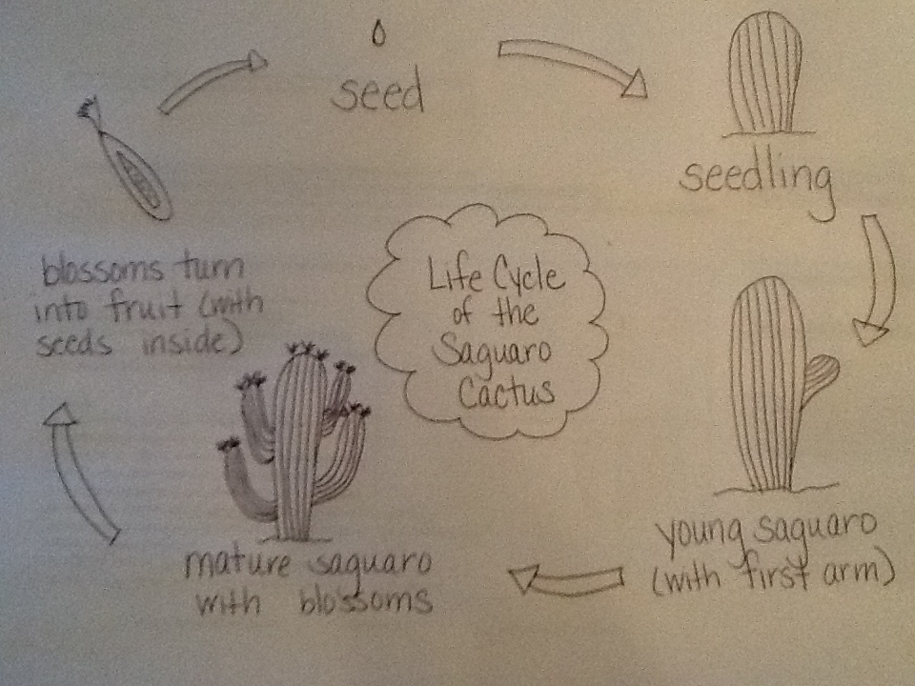

- Write an informative piece about the saguaro cactus. Use other books/resources for additional information Example:
The saguaro cactus is a large cactus that grows in the Sonoran Desert, found mostly in Arizona. It can grow to be fourteen to sixteen feet tall and can live for about 150 years. Its arms begin to grow when it is 75 years old. The cactus’s arms will show its age by how many branches it has. The cactus is able to hold a lot of water, and its pleats expand with the amount of water it is holding. The Gila woodpecker pecks at the cactus to get to the water inside. This leaves many holes where other birds, like the screech owl, build nests and raise their young. Red-tailed hawks also live up high on the cactus where they can see their prey below. The saguaro cactus will grow blossoms when it is about 50 years old. The blossoms only last one night. During this night, bats will drink the nectar and then pollinate the flowers. After 24 hours, the blossoms close forever and then grow into the saguaro fruit. Many animals, like the wild javelinas will eat the fruit. This fruit holds the seeds which will later turn into a new saguaro cactus.

- Bring in several cacti to the classroom to create a dish garden that represents the setting.

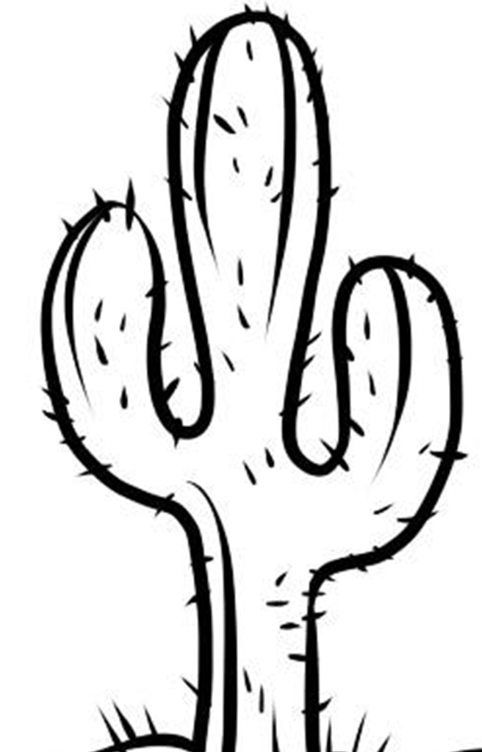
What Makes this Text Complex?
- Quantitative Measure
Go to http://www.lexile.com/ and enter the title of your text in the Quick Book Search in the upper right of home page. Most texts will have a Lexile measure in this database.

2-3 band 420-820L
4-5 band 740-1010L
6-8 band 925-1185L
9-10 band 1050-1335L
11-CCR band 1185-1385L

__980_
_____

- Qualitative Features
Consider the four dimensions of text complexity below. For each dimension*, note specific examples from the text that make it more or less complex.

Living things depend on one another to survive in desert conditions.
A nonfiction text that tells the story of the saguaro cactus and how it impacts other species. The text includes tier 2 and tier 3 vocabulary along with informational text features such as charts.

Text includes specific content vocabulary, diverse language, one simile, complex sentence structures, and onomatopoeia. “Deep inside water is released as the saguaro decomposes, and the aquatic beetle swims through the channels”.

Some students may need background information on desert environment and animals’ basic needs.

Meaning/Purpose
Structure

Language
Knowledge Demands

*For more information on the qualitative dimensions of text complexity, visit http://www.achievethecore.org/content/upload/Companion_to_Qualitative_Scale_Features_Explained.pdf

- Reader and Task Considerations
What will challenge my students most in this text? What supports can I provide?
- This text provides a lot of information, rich vocabulary, and complex sentences. Support using a graphic organizer (student-created illustration with captions), repeated readings, questions to clarify word meanings, time spent on syntax, and attention paid to illustrations.

How will this text help my students build knowledge about the world?
- The text will help students understand the interdependence of plants and other species.

- Grade level
What grade does this book best belong in?
- Grade 2

All content linked to within this resource was free for use when this resource was published in March 2018. Over time, the organizations that manage that external content may move or remove it or change the permissions. If the content is no longer available, please email info@studentsachieve.net.

