Unit 6/Week 2
Title: Grand Canyon: A Trail Through Time
Suggested Time: 5 days (45 minutes per day)
Common Core ELA Standards: RI.4.1, RI.4.2, RI.4.3; W.4.2, W.4.4, W.4.9; SL.4.1; L.4.1, L.4.2, L.4.5

Teacher Instructions (Refer to the Introduction for further details.)
Before Teaching
- Read the Big Ideas and Key Understandings and the Synopsis. Please do not read this to the students. This is a description for teachers, about the big ideas and key understanding that students should take away after completing this task.
Big Ideas and Key Understandings
By observing land formations, wildlife, and other aspects of nature, we can learn about the history of an area and the history of the people who once lived there.
Synopsis
This nonfiction narrative is about the Grand Canyon, its many landforms, and the animals that live there. It explores how the Colorado River and continual erosion created this natural wonder over millions of years. The author takes the readers along the trail to the bottom of the river, describing the flora and fauna along the way, enticing readers with vivid descriptions of what might be seen.
- Read entire main selection text, keeping in mind the Big Ideas and Key Understandings.
- Re-read the main selection text while noting the stopping points for the Text Dependent Questions and teaching Vocabulary.
During Teaching
- Students read the entire main selection text independently.
- Teacher reads the main selection text aloud with students following along. (Depending on how complex the text is and the amount of support needed by students, the teacher may choose to reverse the order of steps 1 and 2.)
- Students and teacher re-read the text while stopping to respond to and discuss the questions and returning to the text. A variety of methods can be used to structure the reading and discussion (i.e.: whole class discussion, think-pair-share, independent written response, group work, etc.)

Text Dependent Questions
Text Dependent Questions | Answers
A metaphor is a figure of speech used to compare two unlike things. In the opening paragraph, what metaphor does the author use to tell about lightning? What comparison is the author making? (Pg. 706) | “Cracks of lightning shatter the dark sky” is a metaphor that suggests the sky is breakable like glass and the lightning bolts are like cracks that cause it to shatter.
Reread the first paragraph on page 707. A plateau is a raised area with a level top. What might a visitor see when dawn arrives on the plateau? | Spires and buttes, worn down by weathering an erosion; coyotes hunting with their pups; thick forests; thousands of visitors from all over the world who are staying in campgrounds and lodges are getting ready for the day.
A simile compares two different things using like or as.  What is the simile on page 707? What two things are being compared? | “Dawn comes, bringing daylight to spires and buttes standing like sentries on the plateau…” The spires and buttes are compared to soldiers standing guard.
Reread the passage on page 708. How long did it take for the Grand Canyon to be formed? How deep is the channel of the Grand Canyon? How long is the channel that runs through the Grand Canyon? What were the major effects that carved the Grand Canyon? | - Six million years  - b. one mile  - c. more than 275 miles  - the Colorado river carved a channel, wind and water wore down the steep sides
Canyon visitors can see many things along the trail to the bottom of the canyon. On page 709, the author describes an Indian tribe that lives in the canyon. What is the name of this tribe? What evidence demonstrates that they lived there long ago? | Havasupai  Symbols of people and animals painted on a boulder
What causes the smaller side canyons to come into view?  Do you think the smaller side canyons are visible at night? Why or why not? (Pg. 709) | The light reaches these areas when the sun is high in the sky, making them visible. No, because without the sun it is unlikely you would be able to see them.
Name the Indian Tribes the author mentions on page 711, as part of the Grand Canyon’s history. What signs might you see that indicate these people lived there? | Anasazi  A granary built by the Anasazi Indians
On page 710, the author states that riders pass, “Layers of rock that display millions of years of Earth’s geologic history.” The word geologic refers to the origin, history, and structure of the earth. What is some of the evidence of geologic change the author describes? | Fossils of fish teeth and seashells (pg 710) fossils of prehistoric trilobites
How did “fossils of fish teeth and seashells” end up in the Grand Canyon? (Pg. 711) | In layers of shale from when the land was a primeval sea
Reread page 713. Identify two things that widened or deepened the Grand Canyon. Explain how each thing did this. What vivid words did the author use to describe this action? | eroding rock and moving water made it deeper, blustering winds and pounding rain continued to widen it
Review the last page. Do you think the Grand Canyon will continue to grow? Why or why not? Provide evidence from the text to support your answer. (Pg. 713) | Yes- because the author says “the endless cycle of eroding rock and moving water”- endless cycle means that it will continue to happen. The author also states “Millions of years into the future, the same forces of nature will continue to reshape the Grand Canyon.”

 | KEY WORDS ESSENTIAL TO UNDERSTANDING | WORDS WORTH KNOWING  General teaching suggestions are provided in the Introduction
TEACHER PROVIDES DEFINITION  not enough contextual clues provided in the text | ancient (706)  Spires, buttes, sentries (707)  channel (708)  inner gorge, crevice, (710)  granary, prehistoric trilobites (711)  eroding, blustering wind, corral (713) | erosion (707)  chasm (708)  geologic (710)  embedded, shale, primeval sea (711)
STUDENTS FIGURE OUT THE MEANING  sufficient context clues are provided in the text | glistens (711)  cascading rapids (712) | splendor (707)  craggy (708)  scurries (711)
Vocabulary
Culminating Task
- Write a paragraph about what can be learned about the history of the Grand Canyon and the people that lived there by observing its landforms, wildlife or other aspects of nature. Support your answer with details from the text.
Answer:
The ancient history of the Grand Canyon and the people and animals that lived there can still be seen by visitors today. Forces of nature have gradually shaped the Grand Canyon over time and there are tiny changes happening now due to erosion from these forces. Ancient mountains once stood where there are now enormous peaks, valleys and trenches. For nearly six million years the Colorado River has carved out the canyon to be currently about a mile deep and more than 275 miles long. Layers of multicolor rocks are exposed at the base of these nearly two billion year old mountains. The rushing waters continue to erode and reshape the canyon. Visitors to the Grand Canyon can see evidence of peoples and animals from long ago. Ancient symbols of people and animals were painted by the Havasupai Indians. These Indians still make their homes today in the canyon, where their ancestors lived. Visitors may also witness an ancient granary built about a thousand years ago by the Anasazi Indians. At one time, these Indians thrived in the canyon and stored crops and plants in this granary for food and trade. The canyon walls have more evidence of Earth’s geological history with fossils of fish teeth and seashells from when the area was covered by a sea. Fossils of prehistoric trilobites in the shale, where they have been for millions of years, are reminiscent of an even more distant past. It’s understandable why the Grand Canyon is considered on the Seven Wonders of the World, with its ancient history and continually changing landscapes.

Additional Tasks
- Students use the graphic organizer to observe another environmental area and apply the key understandings to this observation. They are able to identify land formations, wildlife, scenery and evidence of people of the specified area. Students use this data to describe how these features contribute to the history of the area and the people have lived there.

Environmental Observation Chart
Area______________________________________
Feature | Using your five senses describe each feature. | What does this tell you about the history of the area? | What does this indicate about the people who have lived there?
Land formations
Wildlife
Scenery
Evidence of People

Sample:
Environmental Observation Chart
Area: Bayou Manchac Swamp
Feature | Using your five senses describe each feature. | What does this tell you about the history of the area? | What does this indicate about the people who have lived there?
Land formations | Shallow dark water surrounding everything Cypress knees bulging out of the water Wet, spongy land soft, low ground saturated with water | Plenty of standing water gives evidence of waterways nearby that once flowed through the area. | To live in a swamp you must be adapted to water travel.
Wildlife | Crocodiles and alligators, birds, fish, deadly snakes, nutria, raccoon, swamp deer, long-legged waterfowl, mosquitoes and other insects | The area supports animals that live in a water environment. | People who live in this area are likely to eat fish and other animals that can be caught or trapped in the swamp. They are able to tolerate mosquitoes and other insects as part of their daily life.
Scenery | lily pads floating in brackish water  age-old cypresses laden with Spanish moss | This area has been covered with water for a very long time. | People who live in swamp areas are accustomed to a humid climate.
Evidence of People | 1000 ft boardwalk into the bayou  Gator traps hanging off tree limbs  Pirogues and airboats | People have been living in this area for a long time. | The swamp economically supports the people who live there. It is also the basis of their leisure activities.

- Students create a brochure to advertise the Grand Canyon. The brochure can include a collage of photos and/or drawings of things you can see or do at the Grand Canyon. They will use a creative and personal approach to example their knowledge and understanding of the Grand Canyon. Students write brochures for Grand Canyon visitors who are interested in learning about the canyon's geology and history. They should then create brochures that describe how the canyon was formed, and the brochures should include diagrams and pictures to illustrate their written explanations.

The following is a sample Microsoft brochure template that can be provided to students, or they can make their brochures on the computer using Microsoft Word and choose a brochure template. Students can use photos from the internet, clip art, or draw to add illustrations to their brochure. A completed brochure is attached.

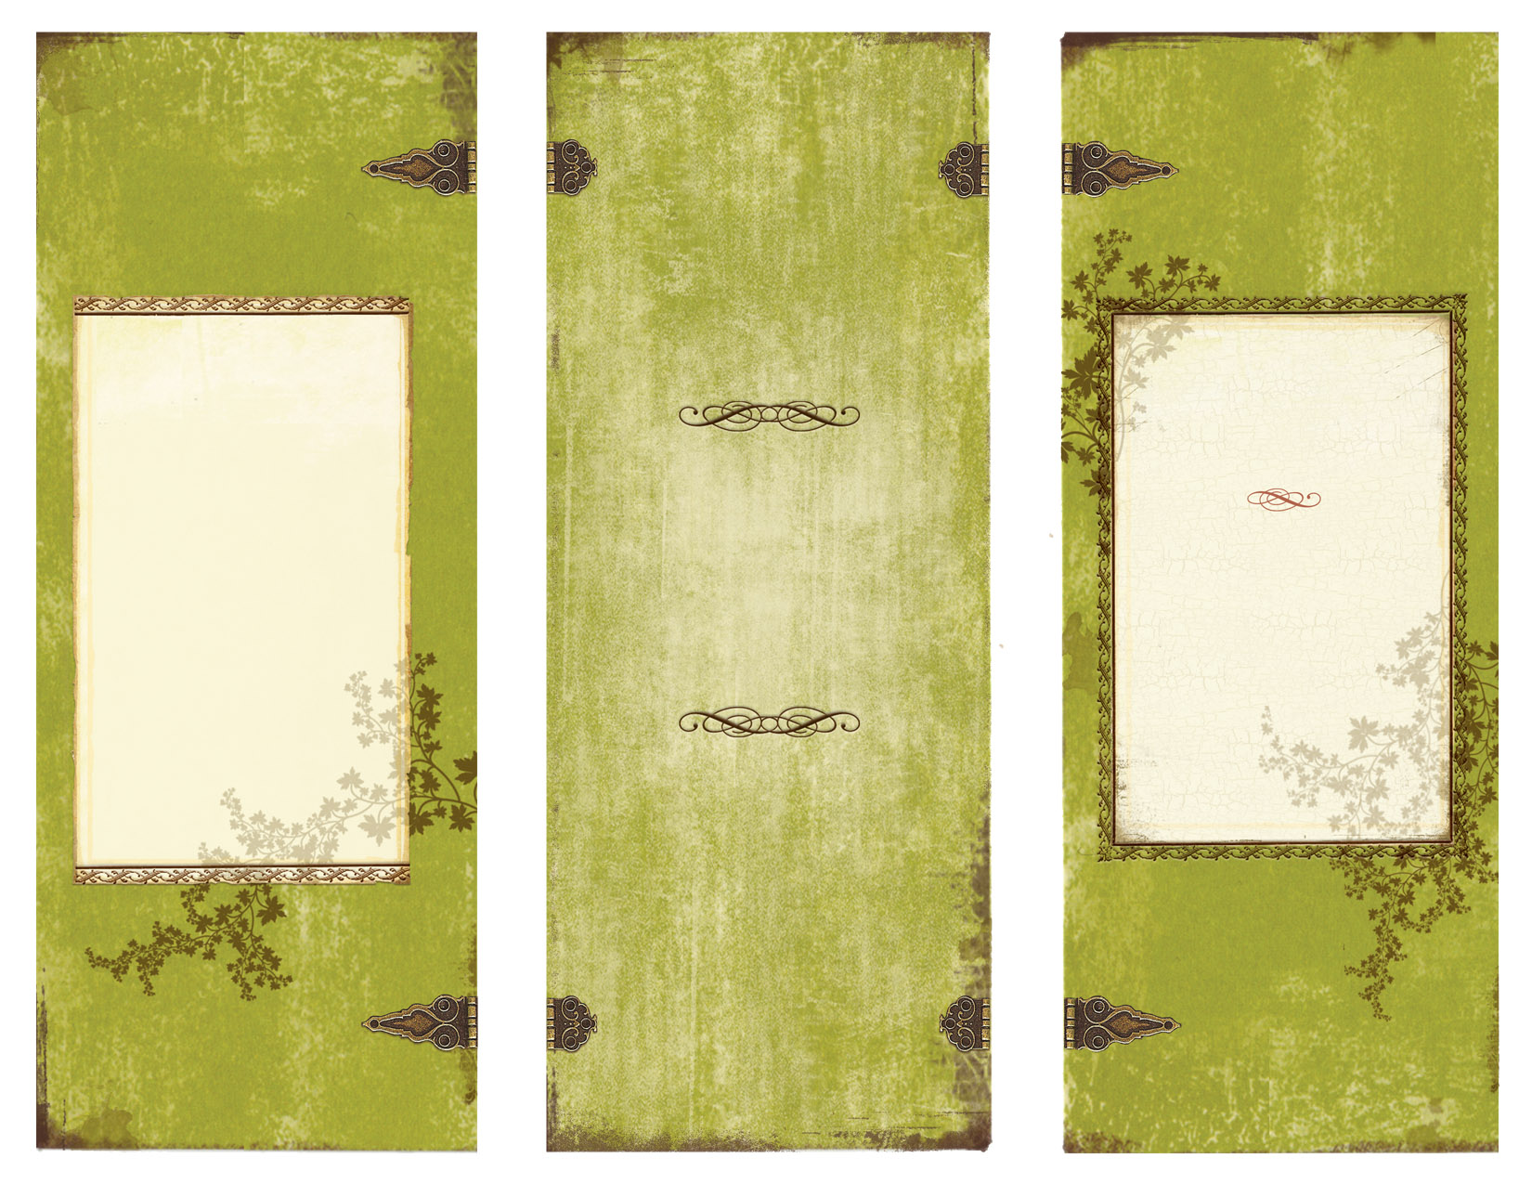

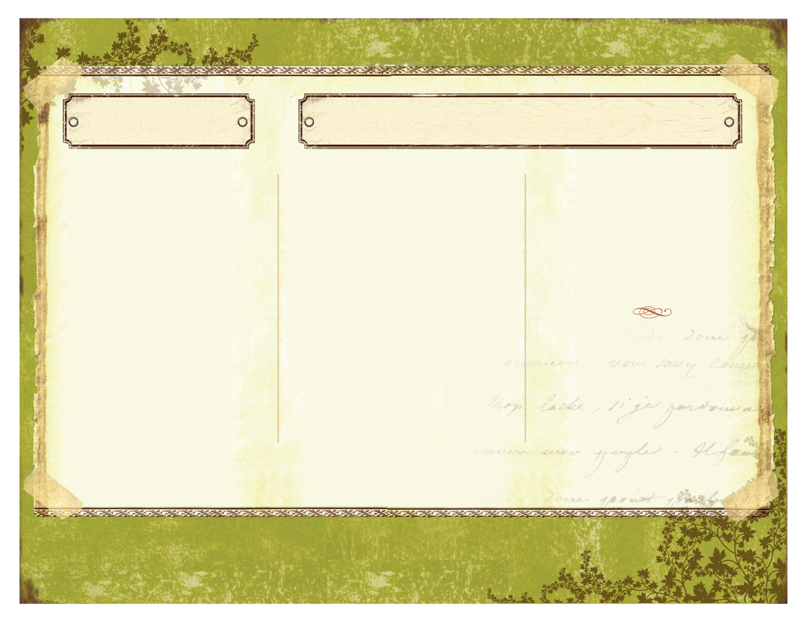

Take in the beauty of this natural wonder on the back of a gentle pack mule. On the 5 hour journey you will see peaks, valleys and trenches where ancient mountains once stood. Nature also provides many plants and animals, in addition to the multi-colored ribbons of rock.
You will experience the ancient culture by viewing a boulder painted long ago by the Havasupai Indians and a granary built almost 1000 years ago by the Anasazi Indians.
The Grand Canyon National Park
“Marvel at one of the Seven Natural Wonders of the World!”

Ph 555.555.5555
Fx 555.555.5555
Arizona 55555
View the splendor of the Grand Canyon
Campgrounds and lodges near the north and south rims.
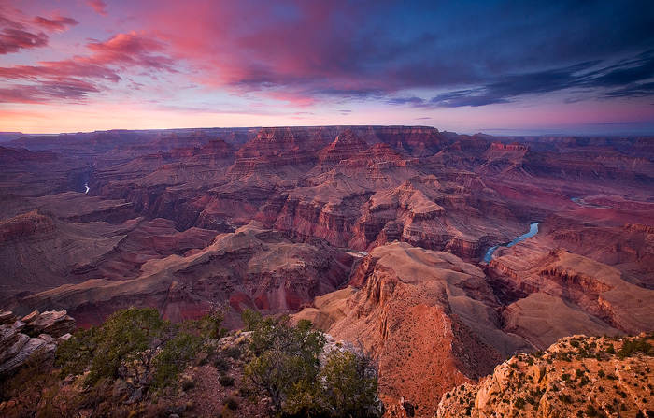
.

Adventure of a lifetime!

Breath-taking views
Awaken your senses taking in all the Grand Canyon has to offer. You will see ribbons of color in the rocks and purple and pink wildflowers along the way. There are Indian relics from nearly a thousand years ago and fossils from millions of years ago embedded in the rock. You will hear the rumbling of the Colorado River as it continues to carve its way through the canyon. Smell the sweet scent of the pink and purple wildflowers. At the bottom, you will share in laughter as riders and hikers share their stories of the decent into the canyon. Create memories that will last a life time.

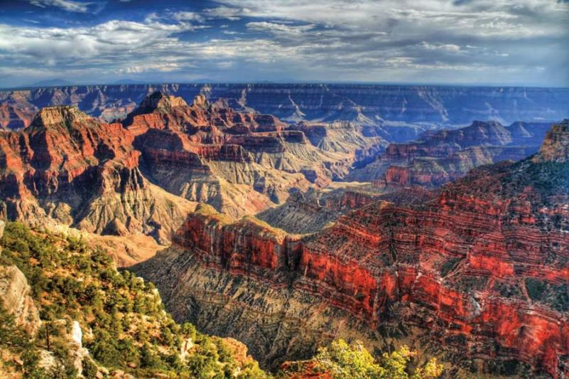
HISTORY. BEAUTY. CULTURE. NATURE’S OWN.
Stay in the comfort of one of our lodges, tents or share the bunkhouse. No matter where you stay, you are sure to enjoy the breath taking views and the wonderful atmosphere.
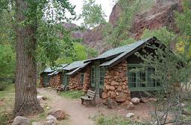.
The journey to the bottom of the canyon takes about 5 hours on a pack mule or you can walk down at your own pace. After your overnight stay; enjoy the 7 mile journey back where every moment is filled with living history!

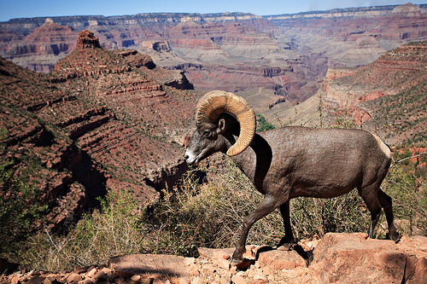

Wildlife you may encounter on your journey includes big horn sheep, ringtail cats, canyon wrens, lizards and squirrels and lots more. See them in their natural environment.
Plan your trip of a lifetime now! Talk to your family and friends and share the adventure with those you love.

- Pretend you went to the Grand Canyon on your summer vacation. Write a narrative nonfiction article, for your school newspaper, about your visit to the Grand Canyon and what you saw while you were there. You should include factual details from the text. Your composition should contain at least 3 paragraphs, tell a story, and each paragraph should contain a main idea and supporting details. Be sure to check your composition for correct spelling and punctuation.
Answer: Students writings will vary. Key components are:
- Includes factual details from the text.
- contains at least 3 paragraphs,
- follows the genre of narrative nonfiction eg. each paragraph has a main idea and supporting details
- uses correct spelling and punctuation

A Deep and Wide Holiday
I never imagined anything created by nature could be so very deep and wide, but here I am, waking up at a lodge on the north rim of the Grand Canyon. With my hat and my backpack on, I am ready for a trip to the bottom of the Grand Canyon. It took the Colorado River almost six million years to carve this hole that is a mile deep! I’m glad it won’t take me that long to get to the bottom.
The trip down to the bottom takes about five hours on the back of a mule. As we ride single file, our guide points out strange paintings on a boulder and everybody looks at the symbols created by Indians long ago. I try to imagine what it was like when the Indians lived here. Looking around, I see Bighorn sheep climbing along the steep sides of the canyon and wonder how they do it. All along the path we come across canyon animals like the wren tending her nest and the lizard soaking up the sun. Who would have thought there would be so much life among those cliffs of colored rock.
As we near the bottom, I can hear the sounds of the mighty river that carved this huge wonder of the world. With the sun setting the canyon comes alive with bright colors of pink, white and gray glistening off the rocks. At the camp, everyone is tired but full of stories to share about their trip to the bottom. Both people and mules rest for the night. That night in the lodge at the bottom of canyon, I could hardly sleep as I dreamt of what we may see on seven-mile trip back to the top. The next day was just as exciting as the first.
Visiting the Grand Canyon is like visiting nature’s museum of natural art. It’s hard to imagine this natural wonder is a continuous work of art that the forces of nature took millions of years to carve. I wonder what the canyon looked like when the dinosaurs roamed the area and what it will look like a million years from now. I don’t think it matters when you visit; it’s just important if you ever get the chance to see this ancient and living wonder that you take it. I will remember the amazing sights and sounds of the Grand Canyon for a very long time.
- With your partner make a chart of the main idea the author uses in the last paragraph of “Grand Canyon: A Trail Through Time”. Across from the main idea, list the facts the author uses to support this idea.

Main Idea | Supporting facts

Answer:
Main Idea | Supporting facts
The forces of nature have and will continue to gradually change the land over time. | “Weather and erosion make tiny changes every day in the rock walls”  “Millions of years in the future the same forces will continue to reshape”

- Reread pages 708 and 712. With your partner complete a Venn-Diagram comparing and contrasting morning and afternoon in the Grand Canyon.
Answer:
Afternoon:
Sun hangs low in sky, the river is near, the water is heard, animals drink from the river, people share stories
Morning:
The sun climbs and it reveals cliffs as it chases away shadows, pack mules start journey, dust follows mules, the river is far below

Both:
the sun plays an important part, the river is mentioned in both

Notes to Teacher
- Suggested cross-curricular activities:
  - Social Studies (landforms)
  - Science (rocks)
  - Math (measurement word problems)

Name _____________________________________________ Date _________________

“Grand Canyon: A Trail Through Time”

- A metaphor is a figure of speech used to compare two unlike things. In the opening paragraph, what metaphor does the author use to tell about lightning? What comparison is the author making? (Pg. 706)

- Reread the first paragraph on page 707. A plateau is a raised area with a level top. What might a visitor see when dawn arrives on the plateau?

- A simile compares two different things using like or as. What is the simile on page 707? What two things are being compared?

- Reread the passage on page 708. How long did it take for the Grand Canyon to be formed? How deep is the channel of the Grand Canyon? How long is the channel that runs through the Grand Canyon? What were the major effects that carved the Grand Canyon?

- Canyon visitors can see many things along the trail to the bottom of the canyon. On page 709, the author describes an Indian tribe that lives in the canyon. What is the name of this tribe? What evidence demonstrates that they lived there long ago?

- What causes the smaller side canyons to come into view? Do you think the smaller side canyons are visible at night? Why or why not? (Pg. 709)

- Name the Indian Tribes the author mentions on page 711, as part of the Grand Canyon’s history. What signs might you see that indicate these people lived there?

- On page 710, the author states that riders pass, “Layers of rock that display millions of years of Earth’s geologic history.” The word geologic refers to the origin, history, and structure of the earth. What is some of the evidence of geologic change the author describes?

- How did “fossils of fish teeth and seashells” end up in the Grand Canyon? (Pg. 711)

- Reread page 713. Identify two things that widened or deepened the Grand Canyon. Explain how each thing did this. What vivid words did the author use to describe this action?

- Review the last page. Do you think the Grand Canyon will continue to grow? Why or why not? Provide evidence from the text to support your answer. (Pg. 713)

Supports for English Language Learners (ELLs)
to use with Basal Alignment Project Lessons
When teaching any lesson, it is important to make sure you are including supports to help all students. We have prepared some examples of different types of supports that you can use in conjunction with our Basal Alignment Project Lessons to help support your ELLs. They are grouped by when they would best fit in a lesson. While these supports reflect research in how to support ELLs, these activities can help ALL students engage more deeply with these lessons. Note that some strategies should be used at multiple points within a lesson; we’ll point these out. It is also important to understand that these scaffolds represent options for teachers to select based on students’ needs; it is not the intention that teachers should do all of these things at every lesson.
Before the reading:
- Read passages, sing songs, watch videos, view photographs, discuss topics (e.g., using the four corners strategy), or research topics that help provide context for what your students will be reading. This is especially true if the setting (e.g., 18th Century England) or topic (e.g., boats) is one that is unfamiliar to the students.

- Provide instruction, using multiple modalities, on selected vocabulary words that are central to understanding the text. When looking at the lesson plan, you should note the Tier 2 words, particularly those words with high conceptual complexity (i.e., they are difficult to visualize, learn from context clues, or are abstract), and consider introducing them ahead of reading. For more information on selecting such words, go here. You should plan to continue to reinforce these words, and additional vocabulary, in the context of reading and working with the text. (See additional activities in the During Reading and After Reading sections.)
Examples of Activities:
- Provide students with the definition of the words and then have students work together to create Frayer models or other kinds of word maps for the words.
- When a word contains a prefix or suffix that has been introduced before, highlight how the word part can be used to help determine word meaning.
- Keep a word wall or word bank where these new words can be added and that students can access later.
- Have students create visual glossaries for whenever they encounter new words. Then have your students add these words to their visual glossaries.
- Create pictures using the word. These can even be added to your word wall!
- Create lists of synonyms and antonyms for the word.
- Have students practice using the words in conversation. For newcomers, consider providing them with sentence frames to ensure they can participate in the conversation.
  - Practice spelling the words using different spelling practice strategies and decoding strategies. Students could take turns spelling with a partner.

- Use graphic organizers to help introduce content.

Examples of Activities:
- Have students fill in a KWL chart about what they will be reading about.
- Have students research setting or topic using a pre-approved website and fill in a chart about it. You could even have students work in groups where each group is assigned part of the topic.
- Have students fill in a bubble map where they write down anything that they find interesting about the topic while watching a video or reading a short passage about the topic. Then students can discuss why they picked the information.

During reading:

- Read the text aloud first so that ELLs can hear the passage read by a fluent reader before working with the text themselves.

- Allow ELLs to collaborate in their home languages to process content before participating in whole class discussions in English. Consider giving them the discussion questions to look over in advance (perhaps during the first read) and having them work with a partner to prepare.

- Encourage students to create sketch-notes or to storyboard the passage when they are reading it individually or with a partner. This will help show if they understand what they are reading as they are reading it.

- Ask questions related to the who, what, when, why, and how of the passage. For students that may need a little more help, provide them with sentence stems.

- Continue to draw attention to and discuss the words that you introduced before the reading.
Examples of Activities:
- Have students include the example from the text in their glossary that they created.
- Create or find pictures that represent how the word was used in the passage.
- Practice creating sentences using the word in the way it was using in the passage.
- Have students discuss the author’s word choice.

- Use graphic organizers to help organize content and thinking.
Examples of Activities:
- Have students fill in a chart to keep track of their 5ws while they read to help them summarize later and figure out the central idea of a passage.
- It may again be beneficial to have somewhere for students to store new words that they encounter while reading the text. Students could use a chart to keep track of these new words and their meanings as they read.
- If you had students fill in a KWL, have them fill in the “L” section as they read the passage.
- Utilize any illustrations or text features that come with the story or passage to better understand the reading.
- Compare/contrast the passage with what the illustrations convey about the passage. Have students consider if the illustrations look the way they visualized the passage in their own minds or if the passage matches their predictions based on the illustrations.
- Identify any text features such as captions and discuss how they contribute to meaning.

After reading:
- Present directions for any post-reading assignments orally and visually; repeat often; and ask English Language Learners to rephrase.

- Allow ELLs to use English language that is still under development. Students should not be scored lower because of incorrect spelling or grammar (unless the goal of the assignment is to assess spelling or grammar skills specifically). When grading, be sure to focus on scoring your students only for the objective(s) that were shared with students.

- Scaffold questions for discussions so that questioning sequences include a mix of factual and inferential questions and a mix of shorter and more extended responses. Questions should build on each other and toward inferential and higher-order-thinking questions. There are not many factual questions already listed in the lesson instructions, so you will need to build some in as you see fit. More information on this strategy can be found here.

- Reinforce new vocabulary using multiple modalities

Examples of activities:
- Using the words that you had students work with before reading, have students write sentences in reference to the passage that you just finished reading.
- Require students to include the words introduced before reading in the culminating writing task.
- For newcomers, print out pictures that represent the words that you focused on and have students match the words to the pictures.
- Based on different features of the words, have the students sort them into different categories and explain their choices. For example, the students could sort the words by prefixes, suffixes, connotation, etc.

- After reading the passage, continue to examine important sentences (1–2) in the text that contribute to the overall meaning of the text. Guide students to break apart these sentences, analyze different elements, and determine meaning. More information on how to do this, including models of sentence deconstruction, can be found here.

- Provide differentiated scaffolds for writing assignments based on students’ English language proficiency levels.

Examples of Activities:
- For all students, go over the prompt in detail, making sure to break down what the prompt means before having the students get to work. Then have the students explain the directions back to you.
- Have students create an evidence tracking chart during reading, then direct them to look back over their evidence chart and work with a group to see if their evidence matches what the rest of the class wrote down. If some of the chart does not match, students should have a discussion about why.
- For students who need more support, model the proper writing format for your students and provide them with a properly formatted example for reference.
- For newcomers, you may consider creating sentence or paragraph frames to help them to write out their ideas.
- To further discussion about the passage, have students create their own who, what, when, where, why, and how questions related to the passage to ask each other and have students pair up and practice asking each other the questions. If available, pair students of the same home language to support the use of language still under development.

