Title/Author: Are Trees Alive?
Suggested Time to Spend: 8 Days (8 20-minute sessions)
Common Core grade-level ELA/Literacy Standards: RI.K.1, RI.K.2, RI.K.3, RI.K.4, RI.K.7; RI.K.10; W.K.2, W.K.8; SL.K.1, SL.K.2, SL.K.3, SL.K.4, SL.K.5, SL.K.6; L.K.1, L.K.2, L.K.4
Lesson Objective:
Students will listen to an informational book that is read aloud. They will use literacy skills (reading, writing, speaking, and listening) to understand the main idea and details related to the book’s topic.

Teacher Instructions
Before the Lesson
- Read the Big Ideas and Key Understandings and the Synopsis below. Please do not read this to the students. This is a description to help you prepare to teach the book and be clear about what you want your children to take away from the work.
Focusing Questions
- How are trees like people?
  - One key takeaway is that both trees and people have similar structure and functions. Trees and people make products and procreate, and both are affected by the seasons.
- Are trees alive?
  - One key takeaway is that, since trees and people have similar processes, trees are indeed alive. Trees, much like people, may differ in physical appearance. Despite these differences in how they look, trees as well as people function in the same way around the world.
Key Understandings
- Both trees and people have similar structure and functions. Trees and people make products and procreate, and both are affected by the seasons.
- Since trees and people have similar processes, trees are indeed alive.
- Trees, much like people, may differ in physical appearance. Despite these differences in how they look, trees as well as people function in the same way around the world.
Synopsis
Through the use of simple language and vibrant illustrations, Are Trees Alive? shares details about the structure, functions, products, and seasonal changes of trees. This information is made comprehensible to young listeners by comparing these attributes of trees to humans. Throughout the book, trees from around the world are featured, as well as the diverse people who populate the regions where the trees are naturally found.
- Go to the last page of the lesson and review “What Makes This Read-Aloud Complex.” This was created for you as part of the lesson and will give you guidance about what the lesson writers saw as the sources of complexity or key access points for this book. You will of course evaluate text complexity with your own students in mind, and make adjustments to the lesson pacing and even the suggested activities and questions.
- Read the entire book, adding your own insights to the understandings identified. Also note the stopping points for the text-inspired questions and activities. Hint: you may want to copy the questions vocabulary words and activities over onto sticky notes so they can be stuck to the right pages for each day’s questions and vocabulary work.
- Consider pairing this series of lessons on Are Trees Alive? with a text set to increase student knowledge and familiarity with the topic. A custom text set can be found here. Note: This is particularly supportive of ELL students.

Note to teachers of English Language Learners (ELLs): Read Aloud Project Lessons are designed for children who cannot read yet for themselves. They are highly interactive and have many scaffolds built into the brief daily lessons to support reading comprehension. Because of this, they are filled with scaffolds that are appropriate for English Language Learners who, by definition, are developing language and learning to read (English). This read aloud text includes complex features which offer many opportunities for learning, but at the same time includes supports and structures to make the text accessible to even the youngest students.
This lesson includes features that align to best practices for supporting English Language Learners. Some of the supports you may see built into this, and /or other Read Aloud Project lessons, assist non-native speakers in the following ways:

- These lessons include embedded vocabulary scaffolds that help students acquire new vocabulary in the context of reading. They feature multi-modal ways of learning new words, including prompts for where to use visual representations, the inclusion of student-friendly definitions, built-in opportunities to use newly acquired vocabulary through discussion or activities, and featured academic vocabulary for deeper study.
- These lessons also include embedded scaffolds to help students make meaning of the text itself. It calls out opportunities for paired or small group discussion, includes recommendations for ways in which visuals, videos, and/or graphic organizers could aid in understanding, provides a mix of questions (both factual and inferential) to guide students gradually toward deeper understanding, and offers recommendations for supplementary texts to build background knowledge supporting the content in the anchor text.
- These lessons feature embedded supports to aid students in developing their overall language and communication skills by featuring scaffolds such as sentence frames for discussion and written work (more guidance available here) as well as writing opportunities (and the inclusion of graphic organizers to scaffold the writing process). These supports help students develop and use newly acquired vocabulary and text-based content knowledge.

The Lesson – Questions, Activities, and Tasks

Questions/Activities/Vocabulary/Tasks | Expected Outcome or Response (for each)
FIRST READING:  Read aloud the entire book (or chapter) with minimal interruptions. Stop to provide word meanings or clarify only when you know the majority of your students will be confused.  The use of a document camera may be helpful.  After the first reading, each student will trace her forearm and hand onto a piece of paper, approximately 11” by 14”. | The goal here is for students to enjoy the book, both writing and pictures, and to experience it as a whole. This will give them some context and sense of completion before they dive into examining the parts of the book more carefully.  The traced forearm and hand will eventually become a picture of a tree. Following each day’s reading, the students will add details to the drawing that correspond to what was learned about trees. By the end of the 8 day period, each student will have a drawing that features details corresponding to the parts, functions, products, and seasonal stages of a tree.
SECOND READING: pages 1 - 10  This book has a very rich informational author and illustrator aspect. Explain to the students that in the introduction the author explains that she wrote the book to answer her daughter’s question, “Are trees alive?” The author asked for help from foresters, botanists and naturalists to answer the question and enable her to write the book. Tell the students that the book Are Trees Alive? is an informational book, because it gives information that answers a question.  For each reread of the book, use the document camera to show how the author uses details in the illustrations as well as text to present information about a tree.  In the following lessons, the essential and nonessential vocabulary is underlined.  Begin this day’s lesson by starting a 4-section vocabulary chart, featuring the vocabulary for the parts, functions, and products of a tree, as well as the seasons. (See example chart in the Vocabulary section below.)  Questions – pages 1 and 2 :  Define: Minerals are nutrients found in the soil that keep plants  healthy.  Example: When we eat healthy foods, like fruits and  vegetables, we take in minerals. Minerals make our  bodies strong and healthy.  Ask: Why do trees need minerals? What part of the tree sucks  the minerals from the soil?  “Roots anchor a tree”: If you are standing, how do your feet “anchor” you when you are pushed? Why, then, would it be important for roots to anchor a tree?  Repeating question: How are trees and people the same?  Questions - pages 3 and 4  Repeat the word sturdy, and make a gesture of flexing biceps. Ask students what they think sturdy means.  Repeating question: How are trees and people the same?  Questions – pages 5 and 6  What do branches hold? What do people use to hold things?  Repeating question: How are trees and people the same?  Questions - pages 7 and 8  What is the meaning of bark in the book?  What is another meaning for bark?  Repeating question: How are trees and people the same?  Questions – pages 9 and 10  What makes up the crown of a tree? Why do you think the leaves are called a crown?  Repeating question: How are trees and people the same?  Repeating question, comparing pages 5 – 6 to pages 9 – 10: Looking at the pictures of the people and the tree, how are they the same? How are they different?  Activity  As students reread Are Trees Alive? on Days 2 through 5, they will add details to their forearm-and-hand tree to represent the information learned that day about trees.  Students will draw in the parts of the tree:  - Roots  - Bark: students may choose from several available shades of brown crayons, to lightly color in the bark. They will then use a darker shade of brown to add the horizontal or vertical markings found on tree bark.  - Branches: using the same shade of brown, students will color in the “fingers” to represent branches.  - Do not add leaves to the tree until the culminating activity. See the directions for the Culminating Activity for more details. | Every question, activity or task should be addressed here. Please line the bullets up or create more rows so teachers can easily see the alignment.  To the Parts section of the chart, students should contribute words used during the lesson, and suggest a picture to represent the word. The words should include roots, bark, branches, and crown.  Students should be able to answer these literal questions based on the text on page 2.  Students should conclude that your feet help you to stand and to keep your balance. Likewise, roots anchor a tree so that it will stand and not fall.  Trees and people are the same because roots help a tree to stand straight and tall, without moving, just like our feet help us to stand tall and not fall.  (Each time the repeating question is posed, the students’ responses should reflect literal information from the pages’ text and illustrations, and the students’ prior knowledge.)  Sturdy means strong  A trunk supports the tree’s body, just as our legs support our bodies.  Branches hold animals, nests, and tree houses. People use their hands and arms to hold things.  Both trees and people hold things. Trees use branches to hold things, and people use arms and hands to hold things  Both trees and people have a protective covering: bark for trees, and skin for people.  Students could identify bark as the sound a dog makes.  In this text bark is used to refer to the outer part of the tree trunk. The bark covers and protects the tree just like people’s skin covers and protects a person  Students should conclude that the uppermost leaves of a tree, are called the crown and is located at the very top, just like the crown is the very top of a person’s head.  The very top of a tree, and the very top of a person’s head, is the crown.  At the end of each reread lesson, before engaging in the activity, this question is posed as students compare and contrast the people and trees on the cited pages. The objective is to use information from the text to build awareness of the diversity among trees as well as people. This analysis should provide students the visual evidence that, though trees and people may differ in physical appearance, they still function in much the same way around the world.  Comparing pages 5 and 6 to pages 9 and 10, the students should conclude that both trees have branches where birds can perch, and leaves. However, the gum tree’s roots are underground while the banyan has aerial roots that extend from the branches to the ground. Also, students should observe that the mother on each page is standing closely to her daughter, while noting that the mother and daughter on one page is dressed differently from the other.  Check in with students to see if they can name the parts of the tree that are being added to their drawings.
THIRD READING: pages 11 – 18  This lesson’s development of vocabulary will be supported by the use of realia. In education, realia are objects from real life used in classroom instruction by educators to improve students' understanding of other cultures and real life situations. Since many of the concepts on these pages refer to tree functions, which are not as apparent to the observer, realia will be used to help students understand the inner workings of a tree.  Today, students will revisit the 4-part vocabulary chart, and add the vocabulary that applies to tree functions and tree products.  For the Products section, flowers, seeds, sap, leaves, and fruit are some of the words that you can expect students to offer.  For the Functions section of the chart, students should supply words from today’s lesson, such as stomata, pores, sap.  Questions – pages 11 and 12  “Instead of using noses and lungs, leaves breathe through thousands of tiny pores known as stomata.” For students to unpack this sentence, provide  - A teacher demonstration of inflating a balloon, as a model of how lungs take in air. Ask: how does the air get into the lungs?  - Several magnifying glasses, so that small groups of students may observe the pores on each other’s nose, arm, etc. Provide tree leaves, and challenge students to find the stomata on the leaves.  - Ask: If you breathe through your nose, through what does a leaf breathe?  “Leaves flutter in the breeze like your hair blows in the wind:” demonstrate flutter by providing a strip of tissue paper to students. Have them hold one end of the strip while blowing on it.  Ask: Can we see the wind? Refer students to the white swirls in the illustration. The illustrator chooses to add the swirls to represent the wind. In reality, we don’t see the wind, rather, we see its effects. Ask if there is anything in the illustration that shows that it is windy?  Repeating question: How are trees and people the same?  Questions – pages 13 and 14  Provide students with a real leaf. Have them do the comparison that the text suggests, comparing the veins in their hand to the veins in the leaf. Ask: What moves through your veins?  State that the veins in a leaf are connected to the tubes that carry sap throughout the tree. Sap is the water that carries the minerals and sugars throughout a tree.  Display a bottle of maple syrup, and explain that the man in the illustration harvested sap from a maple tree to make syrup. Ask: What does he use to harvest the sap? Why will he make syrup? Are there other things from trees that people can use?  Repeating question: How are trees and people the same?  Questions – pages 15 through 18  Ask students to name the tree products shown on pages 15 – 18. Which of these products would be harvested? Where do these products go after they are harvested? Who uses these products?  Repeating question: How are trees and people the same?  Repeating question, comparing pages 11 – 12 to pages 15 – 16: Looking at the pictures of the people and the tree, how are they the same? How are they different?  Activity  Ask students to suggest an illustration to include alongside each word. | Every question, activity or task should be addressed here. Please line the bullets up or create more rows so teachers can easily see the alignment.  These experiences with the realia and answering the questions should result in students understanding that the stomata on leaves functions in much the same way as one’s nose and pores.  Students should conclude, with teacher support, that breathing is how air is drawn into the lungs.  Again with teacher support, students should conclude that the a leaf breathes air through the stomata.  Discuss that fluttering is the rippling movement of the blown paper.  The students should conclude that one cannot see the wind, just its effects on the world around us.  Text evidence of the wind in the illustration is the sideways position of the leaves on the weeping willow, and the short lines about the kite, which represent movement.  Both trees and people breathe in air: people through pores and their nose, and trees through stomata.  Students: Blood moves through a person’s veins. Sap moves through a tree’s veins.  Students should state various ways that syrup is used to sweeten food.  Allow students to examine other products from trees: seeds, pollen, fruit, blossoms, etc.  Both trees and people have a special type of liquid that carries minerals and nutrients to where they are needed. In trees, it is the sap. In people, it is the blood.  Again, the use of a document camera would allow students to examine the illustrations in order to provide answers and observations based on the text.  Seeds grow into trees, just as babies grow to become adults.  Students could observe that both trees have leaves; the weeping willow leaves are slender and small, while banana leaves are quite large. Some trees bear fruit while others do not. Also, people around the world like to have fun, whether flying a kite or smiling to make a friend.  The teacher will include a sketch suggested by the students next to each vocabulary word.
FOURTH READING: pages 19 - 26  Again, the use of a document camera would be helpful, allowing students to see the details of a tree and other illustrated text information.  To the vocabulary chart, students will add words from the text that relate to the seasons.  Questions – pages 19 and 20  Define: Disease is sickness.  Example: Trees can get sickness, or disease, when insects suck  too much of the sap out of the tree.  Ask: What might be other ways that a tree could get disease?  Define: “…storm damage:” ways that a storm breaks or harms  things or people.  Example: A storm can bring with it extreme winds and too  much rain.  Ask: What kind of damage could happen to a tree if there is too  much wind or rain?  Repeating question: How are trees and people the same?  Questions – pages 21 and 22  Ask questions to unpack the sentence “During winter some trees have bare limbs and twigs that lace the cold winter sky.”  Ask: what does it mean when you have bare feet? So, what do you think bare limbs are?  Ask: What is the difference between limbs and twigs? Point out the limbs and twigs on the pages. Ask students to turn to a partner and tell the difference between limbs and twigs. Have a few students share out to the whole group.  Say: Shoestrings lace a shoe. Using your own fingers, model for students the crisscrossing of the shoestrings, and ask them to do the same with their own fingers. Tell students that the shoestrings, their fingers, and the branches and twigs lace one over the other.  Repeating question: How are trees and people the same?  Questions - pages 23 and 24  Explain that “leaf buds” are the tiny new leaves.  After reading, ask students what are the differences between the spring trees and the winter tree on pages 21 and 22.  Repeating question: How are trees and people the same?  Questions – pages 25 and 26  Unpack the personification on the last page by asking:  Are the trees really having a picnic? Are the leaves making food the same way your mom makes food? How do leaves make food? Why did the author say things this way?  Ask: What color are the leaves on these pages? What season is it when the leaves turn yellow and orange?  Close today’s reading by stating that we have seen pictures of trees during winter, spring, and autumn/fall. Which season is left? How do trees look in summer?  Repeating question: How are trees and people the same?  Activity  The students will suggest an illustration for the season words that are added to the vocabulary chart.  They will also talk about the products that are associated with each season: blossoms and buds with spring, green leaves and fruit with summer, orange and yellow leaves  with autumn/fall, etc. | Encourage students to connect their prior knowledge on how people and trees can grow to become very old.  Students should refer to the illustration as well as their prior knowledge to determine that bare means without covering.  Students should conclude that limbs are large, thick branches, while twigs are slender, sticklike shoots growing from branches.  There are times when both trees and people are bare.  Students should note that the winter tree has no leaves, while the spring trees have leaf buds and blossoms.  Now that students are viewing the effects of the seasons on trees, they should note that trees look different in each season, just as people look different in each season due to the seasonal clothing they wear.  Explain that the author is using a figurative way of explaining the facts about the trees; functions, by comparing the trees functions to things that people do. Support students in understanding that the author is making a metaphor, by comparing two things that are seemingly not alike, and that the author does this to keep the text interesting to the reader.  Students should conclude that it is autumn/fall.  The remaining season is summer, when leaves are green and full grown, and a tree’s fruit is ripe.  The appearance of both trees and people is affected by the seasons.

FINAL DAYS WITH THE BOOK: DAYS 5, 6, 7 and 8 - Culminating Task
Day 5
Reread the book in its entirety to the class.
- Following the reading, engage the students in a discussion about the title, Are Trees Alive?. Pose the question, and allow students to respond. Lead students toward a consensus that, because trees are so much like people, and since people are alive, then trees are alive too.
- Students will now complete their “arm” tree. Place into a bag an assortment of green, orange, red, and white Unifix cubes. Each student draws a cube from the bag. The color represents the season, and the type of tree products, that the student should add to his tree:
Red Spring: blossoms and leaf buds
Green Summer: green leaves and ripe fruit
Orange Autumn: Orange and yellow leaves on the branches and on the ground below
White Winter: Since there are no leaves, blossoms, or fruit to add, students with white cubes will add a bucket to the picture, placed next to the tree, to represent the collecting of the sap that takes place in the winter. Their oral presentation will include an explanation of the purpose of tree sap, how sap is collected for use by humans, and what is made from the sap
Days 6, 7, and 8
- The students will use their completed trees in small group oral presentations on a tree’s parts, functions, products, and the effect of the seasons.
Day 6:
- The teacher will model how the oral presentation should sound and look. The teacher will demonstrate how the student will refer to the features on her tree while speaking about the parts, functions, and products of her tree, and the season of the year that is represented. The teacher will also show how the vocabulary chart can be checked to recall the names for these various features of the tree.
- Students will be paired up, to practice their oral presentation and to receive feedback. If they have not already done so, students should include on their pictures labels for the parts of the tree and the name of the season, as applicable.
Days 7 and 8:
- Students make small group oral presentations to the class. A group of students with trees representing the same season will display their trees before the class. Each student will be prepared to share one fact about a tree’s parts, functions, or products, or about a seasonal characteristic of the tree.
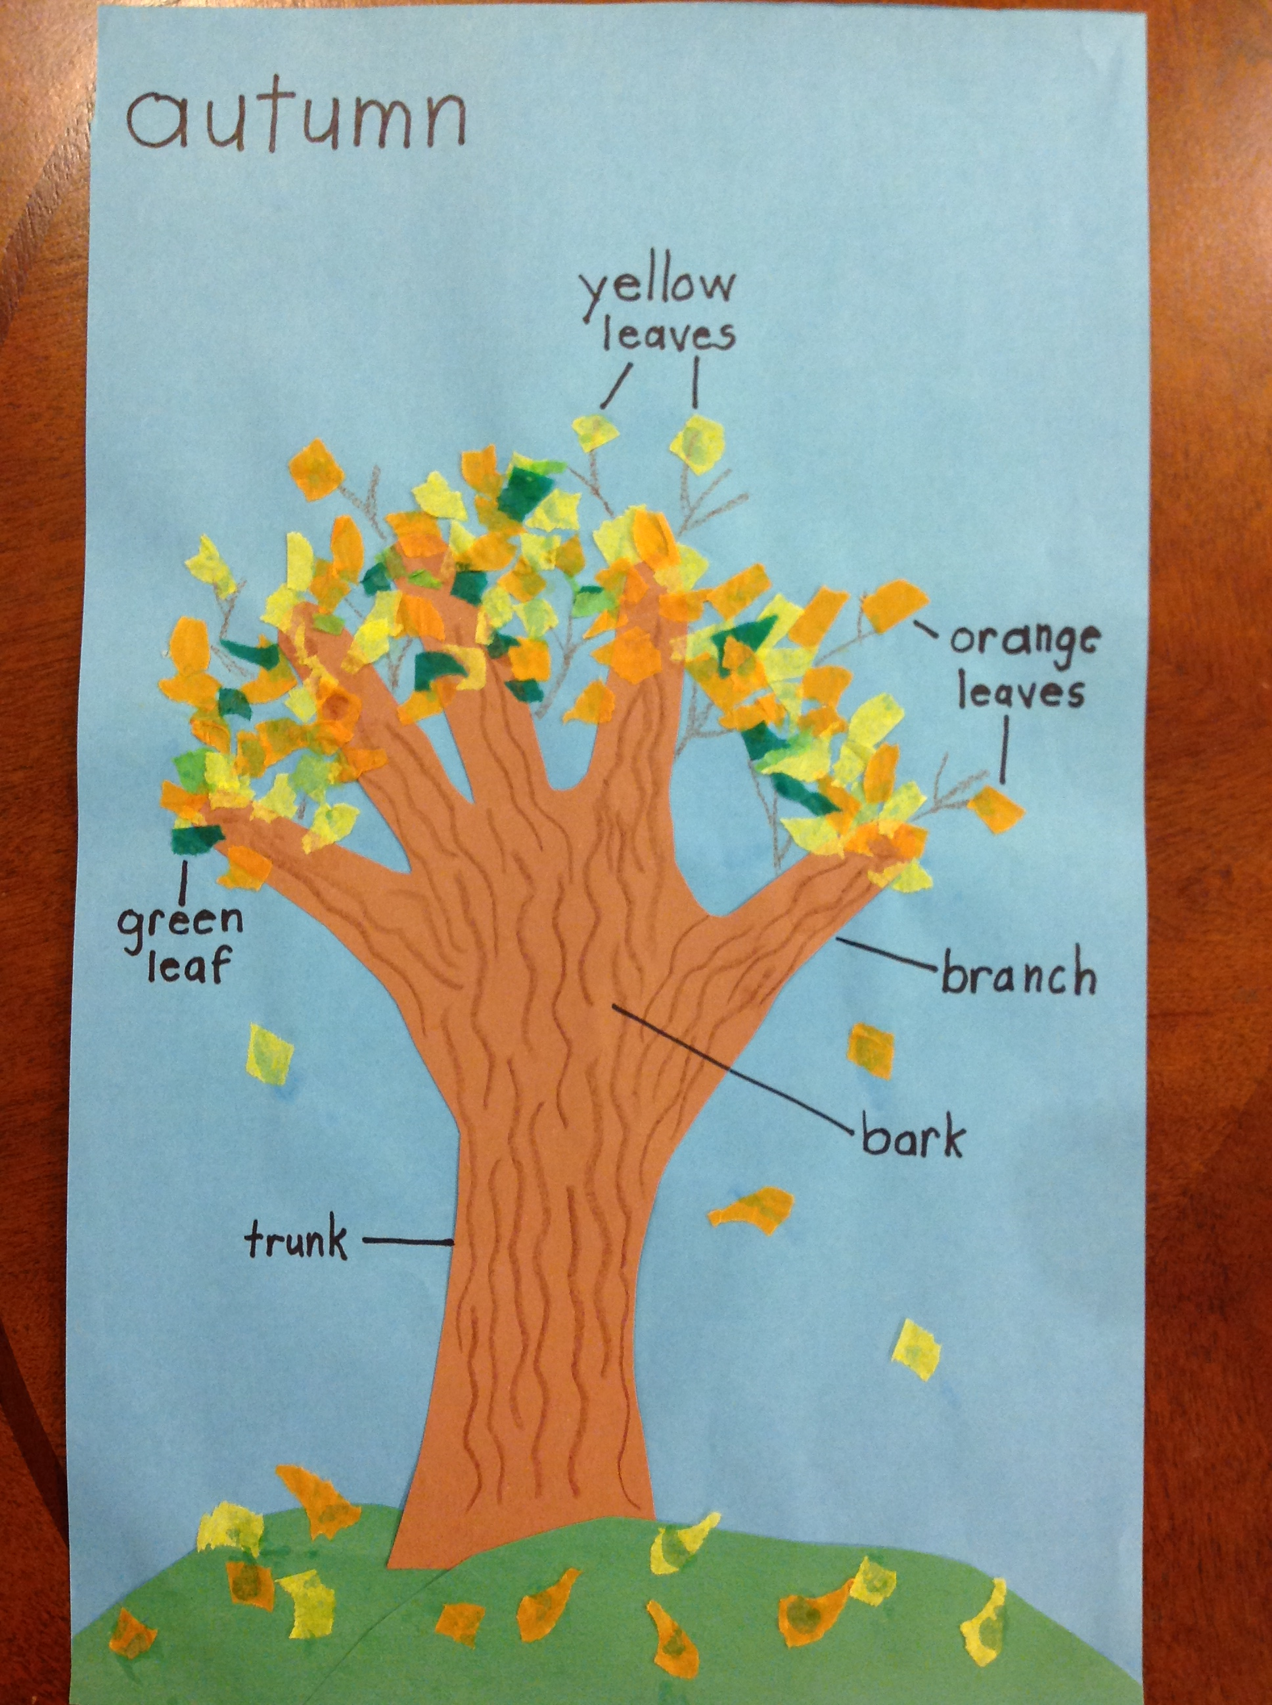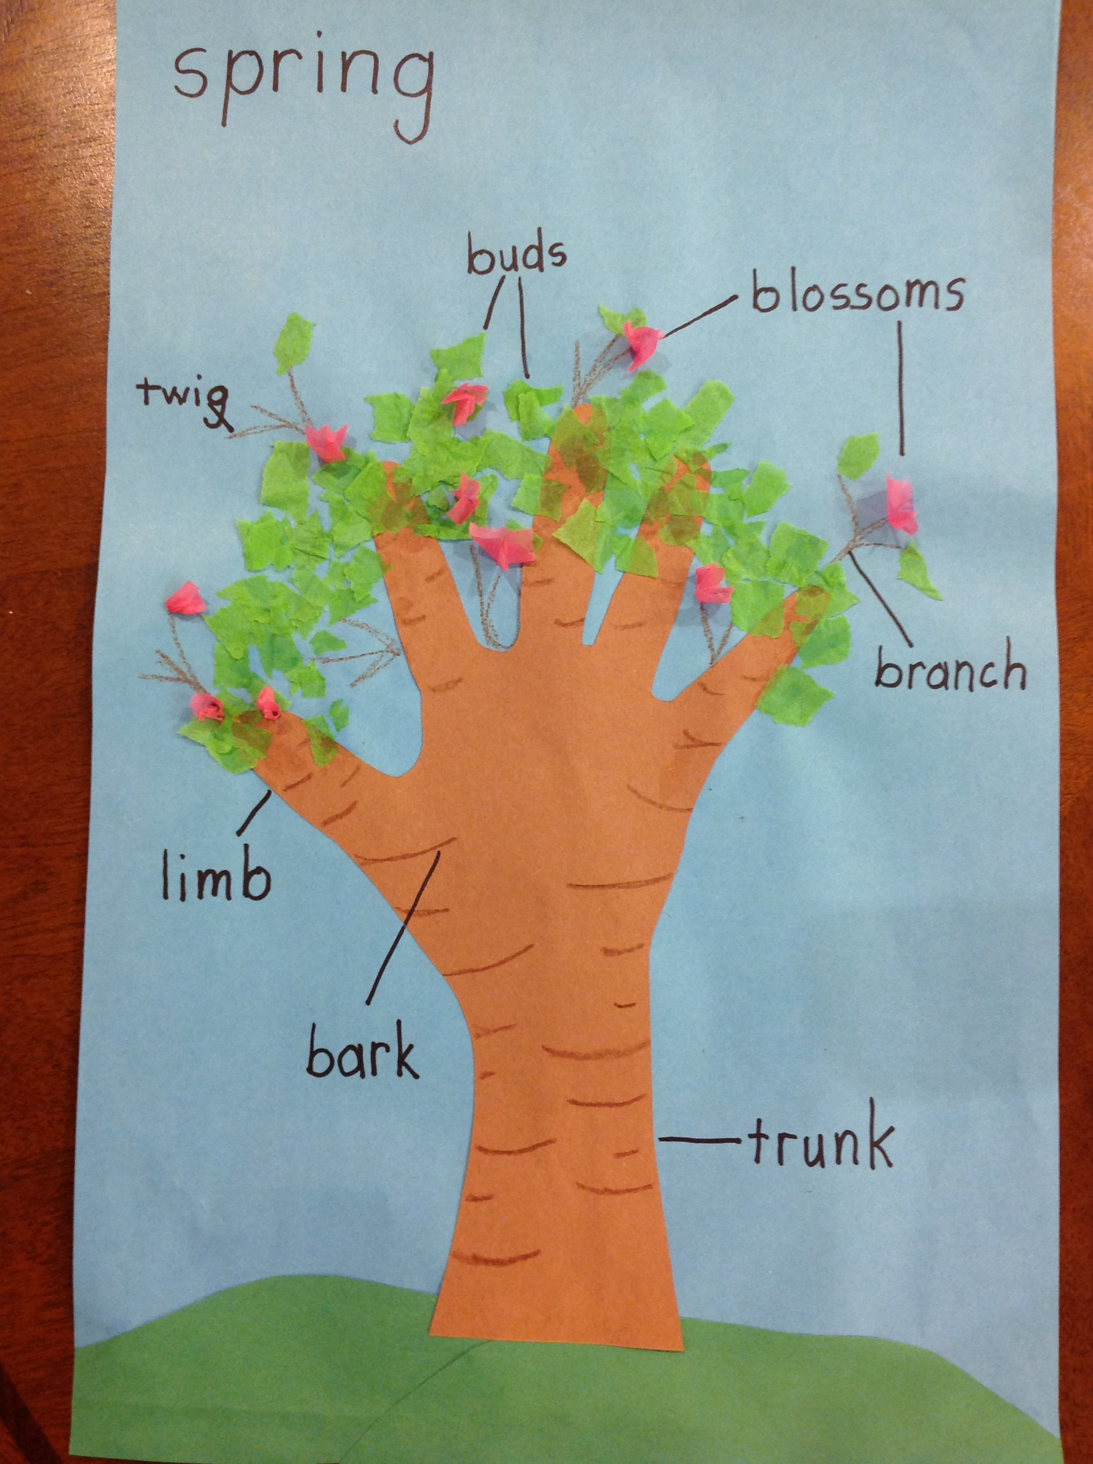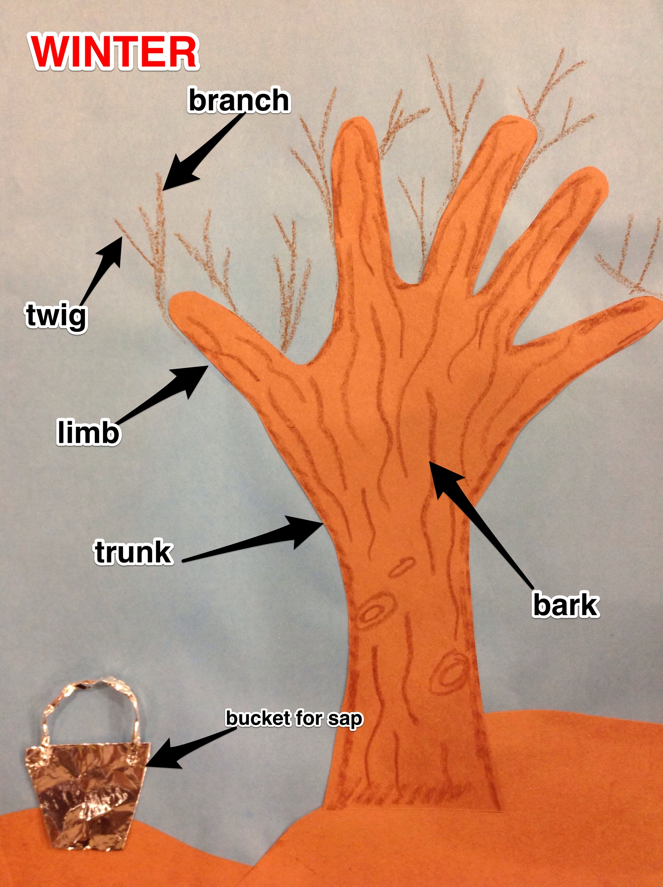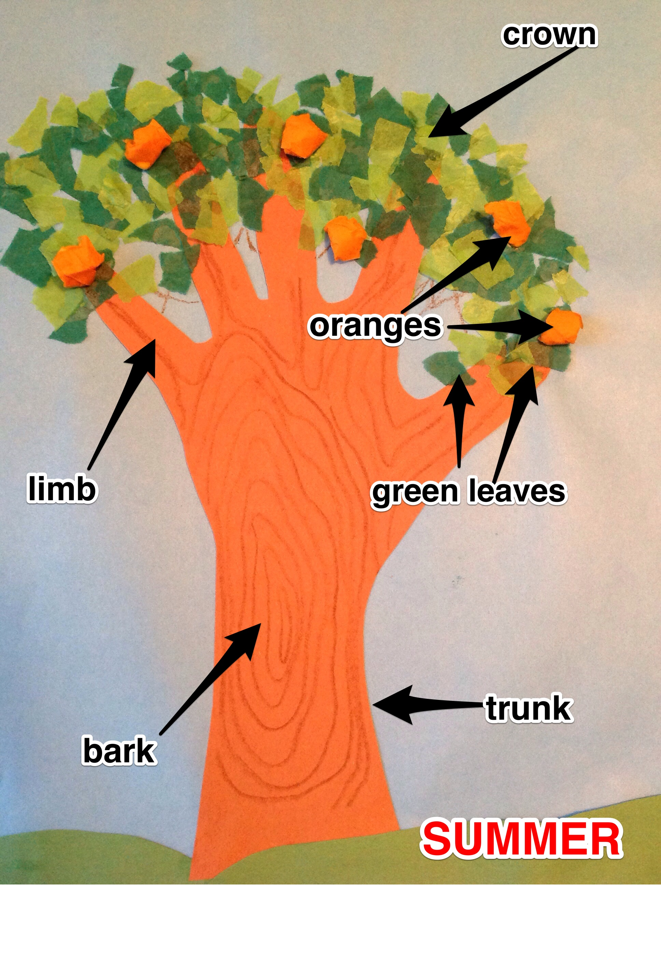

Vocabulary
These words merit less time and attention  (They are concrete and easy to explain, or describe events/  processes/ideas/concepts/experiences that are familiar to your students.) | These words merit more time and attention  (They are abstract, have multiple meanings, and/or are a part  of a large family of words with related meanings. These words are likely to describe events, ideas, processes or experiences that most of your student will be unfamiliar with)
Page 2- minerals: nutrients  Page 3 – sturdy: strong  Page 11 – flutter: wave rapidly in the air  Page13 – sap: fluid that carries nutrients throughout the tree  Page 13 – veins: tubes that carry nutrients through the leaves  Page 13 – harvested: picked for later distribution  Page 19 – disease: sickness  Page 19 – damage: physical harm caused to something  Page 22 – lace: crisscross | Page 2 – anchor: establish  Page 8 – bark: protective exterior covering of a tree  Page 9 – crown: the upper branching part of a tree  Page 11 – pores: opening in an organism that allow for the passage  of air  Page 11 – stomata: leaf pores  Page 11 – lungs: body organs that collect and expel air  Page 22 – bare: uncovered  Page 22 – limbs: thick tree branches  Page 22 – twigs: slender shoots that grow from branches
Example of the Vocabulary Chart
Question: Are trees alive?
Parts | Functions | Products | Seasons
roots  bark  branches  crown | Stomata  Pores  Veins  sap | flowers  seeds  sap  leaves  fruit | winter  bare  spring  buds  blossoms | summer  green leaves  fruit  fall/autumn  orange leaves  yellow leaves
- Answer: Because trees are so much like people, and since people are alive, then trees are alive too.

Extension learning activities for this book and other useful resources
- Technology: Students may use an app or computer program to enhance the visual that is used during the oral presentation. The student may then add labels to the tree he made. The image can then be projected while the student speaks about his tree’s features.
- Again, this book has a very rich informational author and illustrator aspect. Show the “About the Trees” section at the end of the book. Point out to students that in an informational book, this section is called a glossary: a list of terms from the book, with explanations. Show that the trees and the animals for each page in the book are the same. Read one or two of the informational pieces as you refer back to the illustration. Ask the students about how the illustrations provide more information to help us understand and identify the trees, animals and places in the world. Also show the map in the front and back covers. Explain that the map gives even more information regarding the area in which each tree grows. Note: This is particularly supportive of English Language Learners.
- Home Connection: Students are given the name of an animal from the book’s glossary. As a home assignment and with support from an adult, the student will locate, learn, and memorize two facts about the animal, and from which continent the animal originates.
- At school, students will share their research through an oral presentation. The teacher will project a map of the world, using a document camera. The student will pin or tape a picture of their animal to the appropriate continent on the projection, and orally present information on the animal to the class.

Note to Teacher
- Website for Debbie S. Miller: www.debbiemilleralaska.com
- Other books by Debbie S. Miller for an author study:
- A Caribou Journey
- A Polar Bear Journey
- Arctic Lights, Arctic Nights
- Disappearing Lake: Nature’s Magic in Denali National Park
- The Great Serum Race
- Survival at 40 Below
- Survival at 120 Above
- Grizzly Bears of Alaska
- Go to Debbie S. Miller on YouTube, for short videos of various animals in their natural habitat

What Makes This Read-Aloud Complex?
- Quantitative Measure
Go to http://www.lexile.com/ and enter the title of your read-aloud in the Quick Book Search in the upper right of home page. Most texts will have a Lexile measure in this database.

Most of the texts that we read aloud in K-2 should be in the 2-3 or 4-5 band, more complex than the students can read themselves.
2-3 band 420-820L
4-5 band 740-1010L

____640L____

- Qualitative Features
Consider the four dimensions of text complexity below. For each dimension*, note specific examples from the text that make it more or less complex.

To compare the life and functions of a tree to a human
Informational
Codependence among humans, animals, and trees
Illustrations depict different cultures, parts of the world, and trees indigenous to those areas
Clear connection made between human life and tree life
Details set forth in a straightforward manner
Glossary: info on trees, animals, and countries of origin

A few multiple meaning words
One Tier 3 word: stomata
Essential/nonessential vocabulary: sap, veins, saplings, sprout, limbs, twigs
Dense text on the last page: personification

Knowledge of human body structure, trees

Meaning/Purpose
Structure

Language
Knowledge Demands

*For more information on the qualitative dimensions of text complexity, visit http://www.achievethecore.org/content/upload/Companion_to_Qualitative_Scale_Features_Explained.pdf

- Reader and Task Considerations
What will challenge my students most in this text? What supports can I provide?
- Students without knowledge of names of body parts may struggle with the comparisons of trees to people.
- A review of the names of body parts or a labeled
- graphic of the human body will help in supporting struggling students.
How will this text help my students build knowledge about the world?

- The use of repeated questions will help students to contrast pictures of people and trees from page to page, guiding students toward the realization that people and trees function the same throughout the world, though their physical appearance may differ.
- Grade level
What grade does this book best belong in? K

All content linked to within this resource was free for use when this resource was published in March 2018. Over time, the organizations that manage that external content may move or remove it or change the permissions. If the content is no longer available, please email info@studentsachieve.net.

