Linda R. Monk, Words We Live By: Your Annotated Guide to the Constitution - Grade 8

Originally published in New York: Hyperion, 2003.

Learning Objective: The goal of this one to two day exemplar is to give students the opportunity to observe the dynamic nature of the Constitution through the close reading and writing habits they’ve been practicing. By reading and re-reading the passage closely, and focusing their reading through a series of questions and discussion about the text, students will explore the questions Monk raises and perhaps even pursue additional avenues of inquiry. When combined with writing about the passage, not only will students form a deeper appreciation of Monk’s argument and the value of struggling with complex text, but of the Preamble of the Constitution itself.

Reading Task: Re-reading is deliberately built into the instructional unit. Students will silently read the passage in question on a given day— first independently and then following along with the text as the teacher and/or skillful students read aloud. Depending on the difficulties of a given text and the teacher’s knowledge of the fluency abilities of students, the order of the student silent read and the teacher reading aloud with students following might be reversed. What is important is to allow all students to interact with challenging text on their own as frequently and independently as possible. Students will then re-read specific passages in response to a set of concise, text-dependent questions that compel them to examine the meaning and structure of Monk’s argument.

Vocabulary Task: Most of the meanings of words in this selection can be discovered from careful reading of the context in which they appear. Where it is judged this is not possible, underlined words are defined briefly for students in a separate column whenever the original text is reproduced. At times, this is all the support these words need. At other times, particularly with abstract words, teachers will need to spend more time explaining and discussing these words. Teachers can use discussions to model and reinforce how to learn vocabulary from contextual clues. Students must be held accountable for engaging in this practice. In addition, for subsequent readings, high value academic (‘Tier Two’) words have been bolded to draw attention to them. Given how crucial vocabulary knowledge is to students’ academic and career success, it is essential that these high value words be discussed and lingered over during the instructional sequence.

Sentence Syntax Task: On occasion students will encounter particularly difficult sentences to decode. Teachers should engage in a close examination of such sentences to help students discover how they are built and how they convey meaning. While many questions addressing important aspects of the text double as questions about syntax, students should receive regular supported practice in deciphering complex sentences. It is crucial that the help they receive in unpacking text complexity focuses both on the precise meaning of what the author is saying and why the author might have constructed the sentence in this particular fashion. That practice will in turn support students’ ability to unpack meaning from syntactically complex sentences they encounter in future reading.

Discussion Task: Students will discuss the passage in depth with their teacher and their classmates, performing activities that result in a close reading of Monk’s text. The goal is to foster student confidence when encountering complex text and to reinforce the skills they have acquired regarding how to build and extend their understanding of a text. A general principle is to always re-read the portion of text

that provides evidence for the question under discussion. This gives students another encounter with the text, reinforces the use of text evidence, and helps develop fluency.

Writing Task: Students will paraphrase Thurgood Marshall’s quote and then write an explanation of Monk’s text in response to one of three prompts. Teachers might afford students the opportunity to rewrite their explanation or revise their in-class paraphrase after participating in classroom discussion, allowing them to refashion both their understanding of the text and their expression of that understanding.

Text Selection: This selection, taken from Appendix B of the CCSS, while brief, allows for an in-depth investigation into three of the most highly charged words in the Constitution and offers a capsule history of the dramatic and sweeping changes to how the phrase “We the People” has been interpreted over the years. Rich both in meaning and vocabulary, not only does the excerpt from Monk’s text validate the close reading approach, but it also presents a focused and concise opportunity that students in both ELA and history classrooms will find engaging.

Outline of Lesson Plan: This lesson can be delivered in one or two days of instruction and reflection on the part of students and their teacher, with the possibility of adding additional days of instruction (see Appendix A) or an additional day devoted to peer review and revision of the culminating writing assignment.

Standards Covered: The following Common Core State Standards are the focus of this exemplar: RI.8.1, RI.8.2, RI.8.3, RI.8.5, RI.8.6; W.8.2, W.8.4, W.8.9; SL.8.1, L.8.4

The Text: Monk, Linda R. Words We Live By: Your Annotated Guide to the Constitution

Exemplar Text | Vocabulary
From “The Preamble: We the People”  The first three words of the Constitution are the most important. They clearly state  that the people—not the king, not the legislature, not the courts—are the true rulers in  American government. This principle is known as popular sovereignty.  But who are “We the People”? This question troubled the nation for centuries. As Lucy Stone, one of America’s first advocates for women’s rights, asked in 1853, “‘We the People’? Which ‘We the People’? The women were not included.” Neither were white males who did not own property, American Indians, or African Americans—slave or free. Justice Thurgood Marshall, the first African American on the Supreme Court, described the limitation:  for a sense of the evolving nature of the constitution, we need look no further than the first three words of the document’s preamble: ‘we the people.’ when the founding fathers used this phrase in 1787, they did not have in mind the majority of America’s citizens . . . the men who gathered in Philadelphia in 1787 could not... have imagined, nor would they have accepted, that the document they were drafting would one day be construed by a Supreme Court to which had been appointed a woman and the descendant of an African slave.  Through the Amendment process, more and more Americans were eventually included in the Constitution’s definition of “We the People.” After the Civil War, the Thirteenth Amendment ended slavery, the Fourteenth Amendment gave African Americans citizenship, and the Fifteenth Amendment gave black men the vote. In 1920, the Nineteenth Amendment gave women the right to vote nationwide, and in 1971, the Twenty-sixth Amendment extended suffrage to eighteen-year-olds. | Elected body that creates laws  interpreted  formal change to a legal contract  membership in a state or nation with rights, privileges, and duties

Used by permission of Hyperion Publishing.

Day One: Instructional Exemplar for Monk’s Words We Live By
Summary of Activities
- Teacher introduces the day’s passage with minimal commentary and students read it independently (5 minutes)
- Teacher then reads the passage out loud to the class and students follow along in the text (5 minutes)
- Teacher asks the class a small set of guiding questions and tasks about the passage in question (40 minutes)
- Teacher assigns homework that asks students to write an analysis of Monk’s passage.

Text under Discussion |  | Directions for Teachers/Guiding Questions For Students
The first three words of the Constitution are the most important. They clearly state that the people—not the king, not the legislature, not the courts—are the true rulers in American government. This principle is  known as popular sovereignty.  But who are “We the People”? This question troubled the nation for centuries. As Lucy Stone, one of America’s first advocates for women’s rights, asked in 1853, “‘We the People’? Which ‘We the People’? The women were not included.” Neither were white males who did not own property, American Indians, or African Americans—slave or free. Justice Thurgood Marshall, the first African American on the Supreme Court, described the limitation:  for a sense of the evolving nature of the constitution, we  need look no further than the first three words of the document’s preamble: ‘we the people.’ when the founding fathers used this phrase in 1787, they did not have in mind the majority of America’s citizens . . . the men who  gathered in Philadelphia in 1787 could not... have imagined, nor would they have accepted, that the document they were drafting would one day be construed by a Supreme Court to which had been appointed a woman and the descendant of an African slave.  Through the Amendment process, more and more Americans were eventually included in the Constitution’s definition of “We the People.” After the Civil War, the Thirteenth Amendment ended slavery, the Fourteenth Amendment gave African Americans citizenship, and the Fifteenth Amendment gave black men the vote. In 1920, the Nineteenth Amendment gave women the right to vote nationwide, and in 1971, the Twenty-sixth Amendment extended suffrage to eighteen-year-olds. | Elected body that creates laws  interpreted  formal change to a legal contract  membership in a state or nation with rights, privileges, and duties | - Introduce the text and students read independently Other than giving the brief definitions offered to words students would likely not be able to define from context (underlined in the text), avoid giving any background context or instructional guidance at the outset of the lesson while students are reading the text silently. This close reading approach forces students to rely exclusively on the text instead of privileging background knowledge and levels the playing field for all students as they seek to comprehend Monk’s argument. It is critical to cultivating independence and creating a culture of close reading that students initially grapple with rich texts like Monk’s passage without the aid of prefatory material, extensive notes, or even teacher explanations.  - Read the passage out loud as students follow along Asking students to listen to Words We Live By exposes students a second time to the content and structure of  her argument before they begin their own close reading of  the text. Speaking clearly and carefully will allow students to follow the shape of Monk’s argument, and reading out loud with students following along improves fluency while offering all students access to this complex text. Accurate and skillful modeling of the reading provides students who may be dysfluent with accurate pronunciations and syntactic patterns of English.

Text under Discussion |  | Directions for Teachers/Guiding Questions For Students
The first three words of the Constitution are the most important. They clearly state that the people—not the king, not the legislature, not the courts—are the true rulers in American government. This principle is known as popular sovereignty.  But who are “We the People”? This question troubled the nation for centuries. As Lucy Stone, one of America’s first advocates for women’s rights, asked in 1853, “‘We the People’? Which ‘We the People’? The women were not included.” Neither were white males who did not own property, American Indians, or African Americans—slave or free. | Elected body that creates laws | 3. Ask the class to answer a small set of text-dependent guided questions  and perform targeted tasks about the passage, with answers in the form of notes, annotations to the text, or more formal responses as appropriate.  As students move through these questions, and re-read Monk’s text, be  sure to check for and reinforce their understanding of academic vocabulary in the corresponding text (which will be boldfaced the first time it appears in the text). At times, the questions may focus on academic vocabulary.  (Q1) What is (and isn’t) the meaning of “popular sovereignty”? Why does Monk claim that this is the form of government in America?  These are fairly straightforward questions for students to answer but  must be grasped to understand the remainder of Monk’s analysis. The second question requires students to infer that the first three words of the Constitution refer to the doctrine of popular sovereignty, and perceptive students will be able to connect the title of the chapter and/or the opening of the second paragraph to the Constitution’s Preamble.  (Q2) Is Lucy Stone confused when she asks “Which ‘We the People’?” Why does Monk say this question has “troubled the nation”?  Students need to be able to discern that Stone is not confused but rather critical of the seemingly all-embracing phrase “We the People” when looked at in the light of America’s history. It is this history that Monk says is “troubled”. Then it is revealed that the “true rulers in American Government” did not include women, Native Americans, free blacks, enslaved African-Americans, or even white males who did not own property. Students should be able to deduce that those with the vote were primarily white men with property.  N.B. Assuming this is a part of a unit on government/civics, students should be familiar with terms like Constitution, Supreme Court, and Preamble. Given their importance, teachers should still “check-in” with students and briefly review to help solidify students’ grasp of these concepts. If it is not, then this reading will serve as a solid introduction to these essential words.

Text under Discussion |  | Directions for Teachers/Guiding Questions For Students
Justice Thurgood Marshall, the first African American on the Supreme Court, described the limitation:  for a sense of the evolving nature of the constitution, we need look no further than the first three words of the document’s preamble: ‘we the people.’ when the founding fathers used this phrase in 1787, they did not have in mind the majority of America’s citizens . . . the men who gathered in Philadelphia in 1787 could not... have imagined, nor would they have accepted, that the document they were drafting would one day be construed by a Supreme Court to which had been appointed a woman and the descendant of an African slave. | interpreted | (Q3) What does the phrase “founding fathers” mean? Why does  Marshall think the founding fathers could not have imagined a female or black Supreme Court Justice?  This question is a good way to summarize the argument so far as answering it will drive students back to what was read and discussed earlier. The correct answer relies on making the connection between the lack of political rights granted to women and blacks by the founders—those who wrote the Constitution— and recognizing Marshall’s point that at the time he was writing both a female and the descendant of a slave were members of the Supreme Court—the judicial body that holds the final interpretation of the Constitution.  Having discussed the meaning of Marshall’s quote, ask students to put his ideas into their own words in a brief two to three sentence paraphrase, carefully considering sentence structure as they do so.  Insisting that students paraphrase Marshall at this point will solidify their understanding of Monk’s analysis as well as test their ability to communicate that understanding fluently in writing. Teachers should circulate and perform “over the shoulder” conferences with students to check comprehension and offer commentary that could lead to on the spot revision of their “translation” of Marshall’s ideas.  Sidebar: Images of the Supreme Court over the last century  If students are particularly intrigued by the composition of the Supreme Court, Appendix B includes a series of images of the justices every forty years starting in 1890, vividly illustrating the demographic changes the court has undergone.

Text of “The Preamble: We the People” |  | Directions for Teachers/Guiding Questions For Students
Through the Amendment process, more and more Americans were eventually included in the Constitution’s definition of “We the People.” After the Civil War, the Thirteenth Amendment ended slavery, the Fourteenth Amendment gave African Americans citizenship, and the Fifteenth Amendment gave black men the vote. In 1920, the Nineteenth Amendment gave women the right to vote nationwide, and in 1971, the Twenty-sixth Amendment extended suffrage to eighteen-year-olds. | formal change to a legal contract  membership in a state or nation with rights, privileges, and duties | (Q4) What evidence is there in this paragraph regarding Marshall’s claim about the “evolving nature of the constitution”?  This question requires students to methodically cite evidence to completely answer the question and grasp that the amendment process changed the meaning of who was included in “the people.”  Sidebar: The Goals of the Constitution  If students are intrigued, teachers can share with students the text of the Preamble and ask them to identify what the founding fathers were trying to accomplish in forming a Constitutional government through popular sovereignty:  Text of the Preamble  We the People of the United States, in Order to form a more perfect Union, establish Justice, insure domestic Tranquility, provide for the common defence, promote the general Welfare, and secure the Blessings of Liberty to ourselves and our Posterity, do ordain and establish this Constitution for the United States of America.

Explanatory Writing Assignment: Directions for Teachers and Students / Guidance for Teachers
For homework, write a paragraph length explanation that answers one of the following prompts. Provide evidence from the text in your response to justify your analysis:

- Explain how the notion of who “the people” were has changed over time in America.
- How does Thurgood Marshall’s presence on the Supreme Court illustrate the evolution of the constitution?
- Analyze Monk’s explanation of the modifications that have been made to the Constitution.

Extension Activity for Day Two: During the next class period, teachers could have students peer review or revise the explanatory writing pieces they completed for homework.

Teachers might wish to consider the following guidance with regards to evaluating the following prompts:
- Explain how the notion of who “the people” were has changed over time in America.
Teachers should look for a logical explanation of the evolution of who has been considered a “person” in the eyes of America over time. The paragraph could be organized chronologically, noting that at the nation’s founding the creators of the constitution would not “have in mind the majority of America’s citizens” and primarily saw persons as white males with property. Students should then observe that over time, however, the notion of “We the People” has grown to include African Americans (through the 13th, 14th, and 15th Amendment), as well as women with the Nineteenth Amendment. They might invoke Thurgood Marshall’s observation that these two groups, previously discriminated against, now have representatives on the Supreme Court—the final arbiter of the Constitution’s “We the People.” Students could end by noting the extension of the franchise to 18 year olds and perhaps point out that the final status of one group mentioned early on remains unexplained—Native Americans.

- How does Thurgood Marshall’s presence on the Supreme Court illustrate the evolution of the constitution?
Teachers should look for student essays that address the question asked, i.e. focus on why the fact that Thurgood Marshall is on the Supreme Court reflects the notion of an evolving constitution. Students might start by explaining that Marshall was “the first African American on the Supreme Court” and note that at the founding of America “We the People” did not recognize the status of African Americans, “slave or free.” They might go on to explain what is meant by an evolving constitution, citing the fact that “[t]hrough the amendment process” groups that were earlier not included under the framework of popular sovereignty were now added (in the case of African Americans, the 13th, 14th, and 15th amendments added to the constitution specifically addressed their status), paving the way for Marshall’s ascension to the court a century later. To round out their essay, they might integrate Marshall’s ironic observation that “[t]he men who gathered in Philadelphia in 1787 could not . . . have imagined . . . that the document they were drafting would one day be construed by a Supreme Court to which had been appointed . . . the descendant of an African slave.”

- Analyze Monk’s explanation of the modifications that have been made to the Constitution.
Students might begin their paragraph by observing that Monk begins her analysis noting the significance of the doctrine of popular sovereignty and how that opens up the question of who “the people” are. Teachers should look for students then to consider the various causal mechanisms for change to the Constitution, from the role of “advocates for women’s rights” like Lucy Stone to the importance of trailblazers like Thurgood Marshall, “the first African American on the Supreme Court.” But students should give special emphasis to “the amendment process” and how through it “more and more Americans were eventually included in the Constitution’s definition of ‘We the People.’” Students might round out their paragraphs by citing some of the changes to the constitution in the form of various amendments (e.g. “the Nineteenth Amendment gave women the right to vote nationwide”).

Appendix A: Additional Instructional Opportunities for
Monk’s Words We Live By: Your Annotated Guide to the Constitution

If teachers wish to add additional instructional time, they might consider having small groups of students of mixed ability or even individual students pursue one of these lines of investigation.

- Although Marshall is right in claiming that the Founding Fathers did not imagine an African-American or a woman serving on the court, they did envision possible changes to the Constitution and created an amendment process to accommodate such changes. Indeed, right after the Constitution was written, ten Amendments were passed, commonly referred to as the Bill of Rights. Students could look into the reasons why the Constitution was altered so soon after it was adopted or pick one of the Amendments in the Bill of Rights and research the history of that particular amendment or a particular legal case connected with it. (e.g. Gideon v. Wainwright and the Sixth Amendment).

- The idea of a changing definition of “people” in Monk’s text will intrigue middle school students. They could examine the different “types” of people at the nation’s founding (immigrants, Native Americans, indentured servants, slaves, etc) and how they have been viewed within a Constitutional framework. Specific historical events could be used to illuminate the treatment of groups not protected by the constitution, from the Cherokee Removal to the Chinese Exclusion Act to even the failure of the Equal Rights Amendment.

- There are many times the Constitution is invoked on both sides of a debate about rights. To reinforce the concept that the U.S. Constitution is a living document, students could investigate an area of debate where the interpretation of an Amendment or amending the Constitution is central to the argument and then debate it in class. Some possibilities are gun control, balancing the federal budget, gay marriage, or even the legality of selling alcohol.

- Students could select one of the amendments mentioned by Monk that expanded the conception of who “the people” were and research it more in depth, examining the historical background, the reasons for its adoption, and its effects both intended and otherwise.

Appendix B: Images of the Justices of the Supreme Court

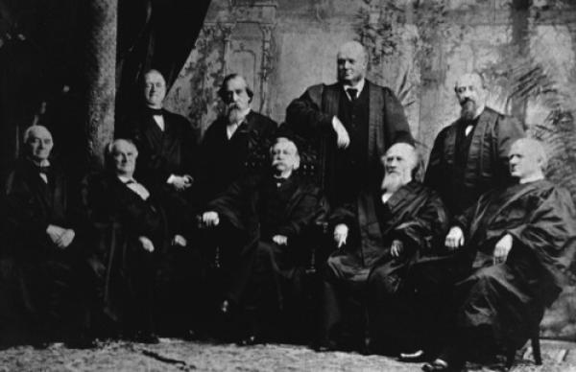

Fuller Court, 1890

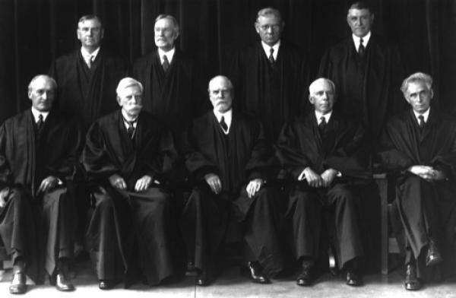

Taft Court, 1925 - 1930

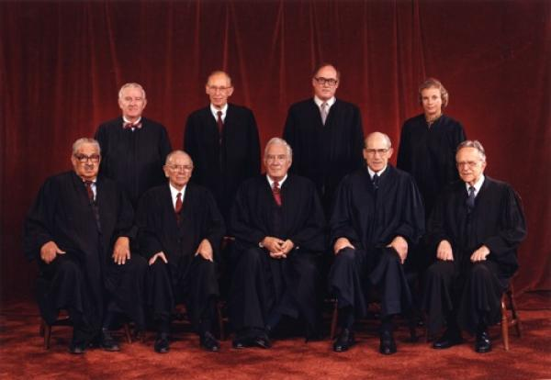

Burger Court, 198

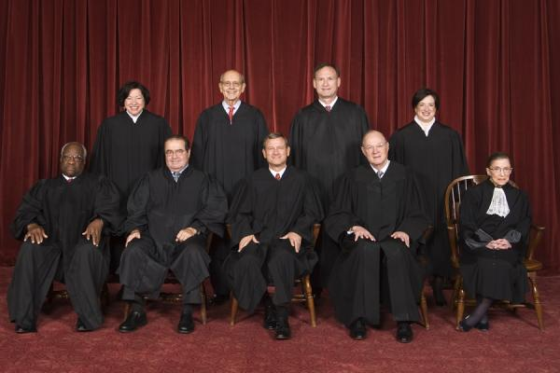

Roberts Court, 2010

This work was supported by the Bill and Melinda Gates Foundation

Appendix C: Selected Vocabulary List

The role of vocabulary in this lesson set:
The chart below lists the vocabulary words the teachers who wrote this lesson identified as important to understanding the text for this lesson.

It is important to note the very high number of words recommended for instruction in these passages, more than many of us have been used to teaching. This reflects the importance of vocabulary to comprehending the complex text called for by the CCSS. Students who are behind need to learn even more words. This can only happen if we can teach word meanings efficiently; devoting more time and attention to those words that merit it, and less to those that can be learned with less time and attention. Clearly, there will not be time in the few days of this lesson set to explicitly and extensively teach all the words listed below. Many of the words, however, can be taught quickly, while others deserve explicit and lengthy examination. Teachers should make intentional choices based on professional judgment, the needs of students, and the guidance provided below.

The organization of the charts below:

Each vocabulary word below has been categorized based on the question: “Can students infer the meaning of the word from context?”

The definitions of many words can be inferred in part or in whole from context, and practice with inferring word meanings is an integral part of instruction. The words in the first group have meanings which can be inferred from context within the text. Words in this category are printed in bold below and in the scaffolded version of the student text provided above. Definitions for these words have not been provided here; instead of directly providing definitions for these words draw students’ attention to these word and ask them to try to infer the meaning.

Words in the second group have meanings, or are being used in ways, which cannot reasonably be inferred from context within the text alone. These words are printed in underline, here and in the text, and their definitions are provided in the margins of the text for student reference.

Determining which words to spend more time on

As mentioned above, some words must be taught extremely quickly, sometimes in mere seconds by providing a quick definition and moving on. Other words are both more difficult and more important to understanding this text or future texts and hence deserve time, study, discussion and/or practice. In using this lesson exemplar, teachers will need to determine for themselves which words from the list above deserve more time and which deserve less. Use the guidelines below to help you determine which words to spend more time on. In addition the additional vocabulary resources listed in Appendix B below can help you learn more about selecting and teaching vocabulary.

Quicker and easier to learn — words that are concrete, have only one meaning, or are limited to a specific topic area, such as fires or the ocean etc. These words should be addressed swiftly, when they are encountered and only as needed.

Take more time and attention to master — words that are abstract, represent concepts unlikely to be familiar to many students, have multiple meanings, are a part of a word family, and/or are likely to appear again in future texts. These words require more instructional time.
Selected Vocabulary List

Words that can be inferred from text  Ask students to generate a definition |  | Words that cannot be inferred from text  Provide these definitions to students
Vocabulary Word |  | Vocabulary Word | Definition
principle |  | legislature | elected body that creates laws
popular sovereignty |  | construed | interpreted
advocates |  | Amendment | formal change to a legal contract
limitation |  | citizenship | membership in a state or nation with rights, privileges, and duties
evolving
drafting
appointed
descendant
extended suffrage

Appendix D: Additional Vocabulary Resources

Hungry for more vocabulary? Check out the Academic Word Finder.

The words in the list above were selected by an expert teacher as valuable to teach in the context of this lesson. But these are just some of the many words you could draw from this passage to help your students build their vocabulary. If you are interested in a tool which can quickly help you identify more of the high-value, Tier 2 academic vocabulary words that appear in this passage, visit the free Academic Word Finder at http://achievethecore.org/academic-word-finder/ (registration required).

Please note: Some of the words you will find with this tool will not overlap with those listed above.
This is a good thing, because it points out even more words that can help your students! The list above focuses on words crucial to understanding the key points of the passage and includes both Tier 2 and Tier 3 words, whereas the Academic Word Finder focuses on high-frequency Tier 2 words which will be valuable to your students across a variety of texts, (but which may not be particularly central to the meaning of this passage). These words often have multiple meanings or are part of a word family of related words. In addition the Academic Word Finder provides multiple related words and the variety of shades of a word’s meaning all in one location, so teachers can see the depth and diversity of word meanings they can teach around a word. Teachers then decide how and when to expose students to different word senses to promote their vocabulary growth.

Both sources of words are valuable, but for different purposes. Ultimately you will have to rely on your professional judgment to determine which words you choose to focus on with your students.

Eager to learn more about how to select and teach vocabulary? Check out Vocabulary and The Common Core by David Liben.

This paper includes a summary of vocabulary research and practical exercises to help you learn to select and teach vocabulary. Written by classroom veteran and literacy researcher David Liben, the exercises will help you hone your professional judgment and build your skill in the vocabulary teaching crucial to success with the Common Core State Standards.

Download the paper and exercises here:
http://achievethecore.org/page/974/vocabulary-and-the-common-core-detail-pg

