Name: Date:
Kindergarten
Sharing your Expertise
Student Writing Resource Packet

Keeping the Earth Healthy
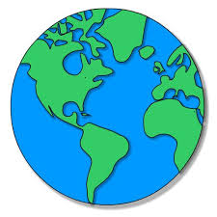

✓  Done | Steps
 | Learn from a Model
 | Write a Focus Statement
 | Write the first piece of evidence
 | Write the second piece of evidence
 | Write the third piece of evidence
 | Write a Concluding Statement
 | Revise/Edit
 | Publish, Share and Celebrate!
Learn From a Model

Green | Focus Statement
Yellow | Evidence 1
Blue | Evidence 2
Light Blue | Evidence 3
Green | Conclusion

I can help the earth by saving water. I can turn off the water when I brush my teeth. I can take a shorter shower. I can plant plants that need less water. Using less water will help preserve the water on earth.

Write the Focus Statement
I can write an informative piece in which I name a topic. (W.K.2)

- Reread the focus statement from the model:
I can help the earth by saving water.
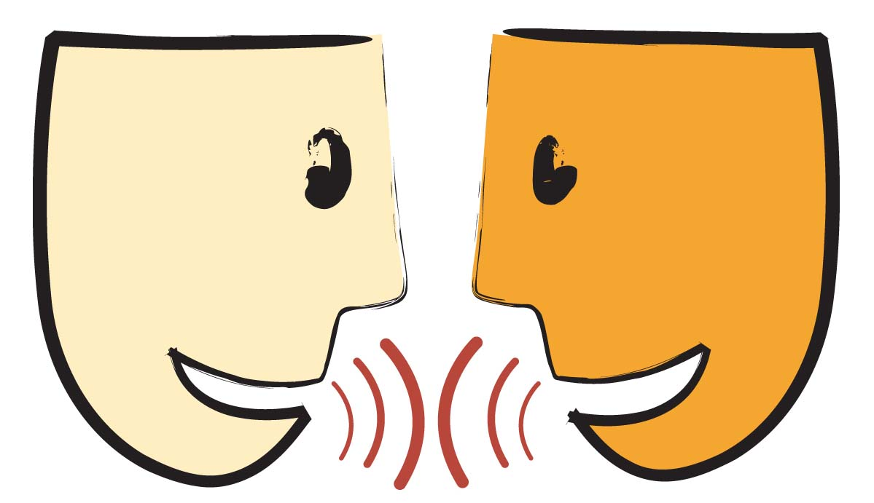
2. Talk with a partner about what you are going to write.
3. Write your focus statement on the lines below.
_____________________________________________
_______________
_______________

4. Revise and Edit (see checklist on page 8)

Write the Evidence
I can write an informative piece using information about a topic. (W.K.2)

- Reread the first piece of evidence from the model:
I can turn off the water when I brush my teeth.
- Look at one piece of evidence from our chart and talk with a partner about what you are going to write.
- Write your first piece of evidence on the lines below.
____________________________________________________________________
4. Revise and Edit (see checklist on page 8)
Write the Evidence
I can write an informative piece using information about a topic. (W.K.2)
- Reread the next piece of evidence from the model:
I can take a shorter shower.
- Look at another piece of evidence from our chart and talk with a partner about what you are going to write.
- Write your second piece of evidence on the lines below.
_____________________________________________________________________________________
4. Revise and Edit (see checklist on page 8)
Write the Evidence
I can write an informative piece using information about a topic. (W.K.2)
- Reread the next piece of evidence from the model:
I can plant plants that need less water.
- Look at another piece of evidence from our chart and
talk with a partner about what you are going to write.
- Write your third piece of evidence on the lines below.
_____________________________________________________________________________________
4. Revise and Edit (see checklist on page 8)
Write the Concluding Statement
I can write an informative piece. (W.K.2)
- Reread the concluding statement from the model:
Using less water will help preserve the water on earth.
- Reread your focus statement. Talk with a partner about how you might say that again using slightly different words.
- Write your concluding statement on the lines below.
___________________________________________________
_________________
4. Revise/Edit (See checklist on page 8)
Final Revision and Editing
I can work with peers to improve my writing. (W.K.5)

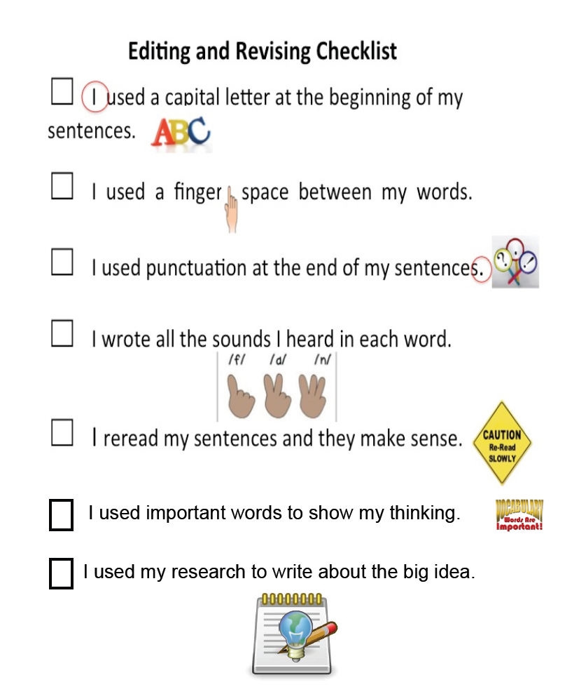

Publish and Celebrate
Congratulations you are an expert and a scholar!

It is time to publish your writing by making a chapter book!

I would like to celebrate by:
☐ Reading my chapter book to another student

☐ Reading my chapter book to the principal

☐ Reading my chapter book to my family

☐ Other idea: ____________________________

