TEACHER RESOURCE PACKET

Grade: Kindergarten

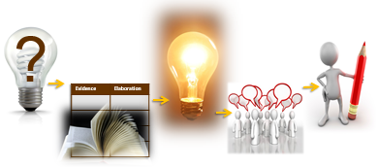
Based on the Writing for Understanding Approach, Vermont Writing Collaborative ©2011

A SIX WEEK SHARED RESEARCH AND WRITING PROJECT
On
Keeping the Earth Healthy

INCLUDES:
- Research Project Overview pgs. 2-5
- Directions for Class Research Packet (Focus on Land) pgs. 6-17
- Directions for Writing Resource Packet Pages pgs.18-26
- Chapter Book Writing Resource pgs.27-31
- Directions for Group Research Packet (Focus on Air) pgs. 32-41

Note: Sample responses are included for teacher reference, actual student responses will vary.

Research Question: What can you do to help the earth?
Research Project Overview

The “Rule of Two”: A Plan for Gradual Release of Responsibility

ENGAGEMENT:
Students listen to the picture book “I Can Save the Earth” to lay the foundation of living a “green” life, as a way to keep the earth clean and healthy. In this text the main character, Max the Little Monster, notices his actions can hurt the beauty of the environment. This causes Max to make changes in his behavior by reducing, reusing, and recycling the things that he uses. This leads to a healthy earth and, a healthier little Max.

INSTRUCTION:
CLASS RESEARCH PACKET
The anchor text, “Growing Up Green”, will be used for both the class and small group (guided practice) research. Providing student access to the text is important and can be done by purchasing multiple copies or typing certain pages for locating evidence.

After reading the anchor text, aloud, the class focuses on the idea of keeping the earth healthy by exploring the research question “How can I take care of the earth’s land?” This research will be done as a whole class with the teacher guiding the process, which is supported by a Class Research Packet. The Class Research Packet is designed to be student friendly with picture support to drive the process of researching a topic.

Embedded in the Teacher Resource Packet are the directions, processing lessons, and anticipated student responses for the class packet. Together, the class does research, takes notes and writes Chapter 1, which is a report on how to take care of the earth’s land.

GROUP RESEARCH PACKET (GUIDED PRACTICE):
The class divides into small study groups of 3-4 students each. Using the anchor text “Growing Up Green” and any supplemental texts (optional), each group researches the question “ How can I take care of the earth’s air?”

This research will be done with the support of a modified Group Research Packet. Students will be instructional resources for each other as they are given more responsibility in researching this next question as a group. Information is added to a set of group notes and discussed. Each student then writes Chapter 2, an individual report about the group’s ideas on how to take care of the earth’s air.

STANDARDS ADDRESSED
NGSS Standard
ESS3.C: Human Impacts on Earth Systems
Things that people do to live comfortably can affect the world around them. But they can make choices that reduce their impacts on the land, water, air, and other living things.

CCSS Writing Standards:
W.K.2 Use a combination of drawing, dictating, and writing to compose informative/explanatory texts in which they name what they are writing about and supply some information about the topic.
W.K.5 With guidance and support from adults, respond to questions and suggestions from peers and add details to strengthen writing as needed.
W.K.7 Participate in shared research and writing projects (e.g., explore a number of books by a favorite author and express opinions about them).
W.K.8 With guidance and support from adults, recall information from experiences or gather information from provided sources to answer a question.

Supporting CCSS Reading Standards:
RI.K.1 With prompting and support, ask and answer questions about key details in a text.
RI.K.3 With prompting and support, describe the connection between two individuals, events, ideas, or pieces of information in a text.
RI.K.5 Identify the front cover, back cover, and title page of a book.
RI.K.7 With prompting and support, describe the relationship between illustrations and the text in which they appear (e.g., what person, place, thing, or idea in the text an illustration depicts).
RI.K.10 Actively engage in group reading activities with purpose and understanding.
RF.K.4 Read emergent-reader texts with purpose and understanding.

Supporting CCSS Speaking and Listening/Language Standards:
SL.K.6 Speak audibly and express thoughts, feelings, and ideas clearly.
L.K.6 Use words and phrases acquired through conversations, reading and being read to, and responding to texts.

TEXTS
Idea | Examples
recycle | paper  cans  plastic  glass
reuse | old toys  clothes  books  reuseable water bottles
start a compost pile | fruit scraps  vegetable scraps
Introductory Text (context/engagement): I Can Save The Earth by Alison Inches
ISBN-13: 9781416967897, Publisher: Little Simon , Publication date: 9/9/2008
Barnes & Noble Price: 3.99

Anchor Text: Growing Up Green Jeanne Sturm Rourke Publishing ISBN-13: 9781615903016 ,
Publication date: 8/28/2010
Amazon Price: 6.99

Student Texts (for small group research): Additional Copies (10-15) of Anchor Text

Supplemental Texts (Optional):
10 Things I Can Do To Help My World by Melanie Walsh
The Earth Book by Todd Parr
Sample Student Responses for Class and Group Research Project
Below are sample student responses similar to those expected of students at the end of this sequence. Actual responses will vary. This section is for teacher reference only. DO NOT SHARE WITH STUDENTS.


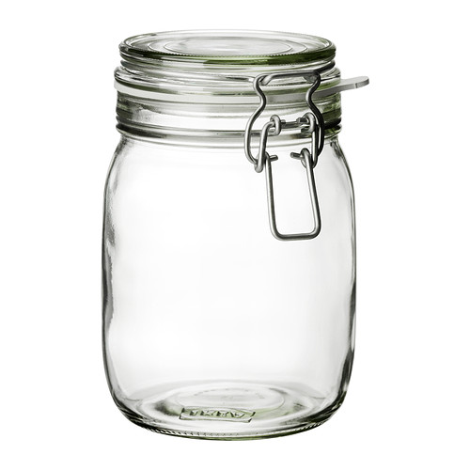
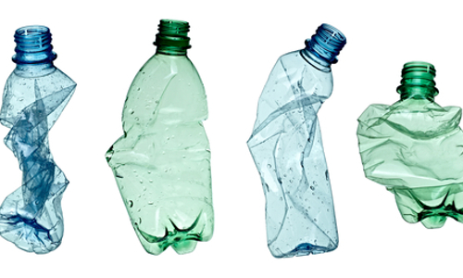
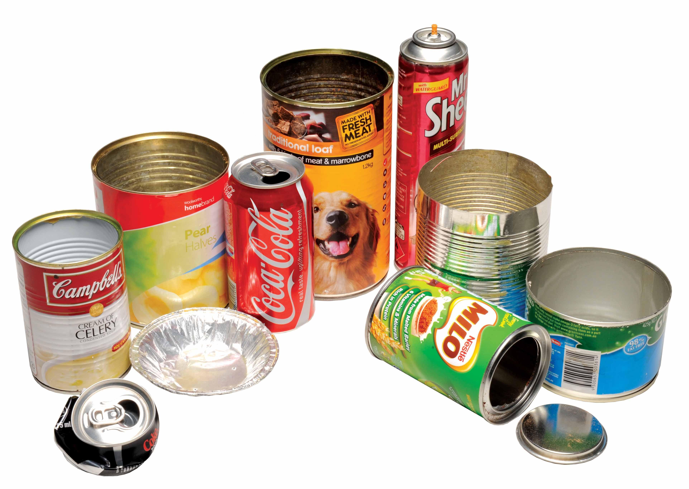
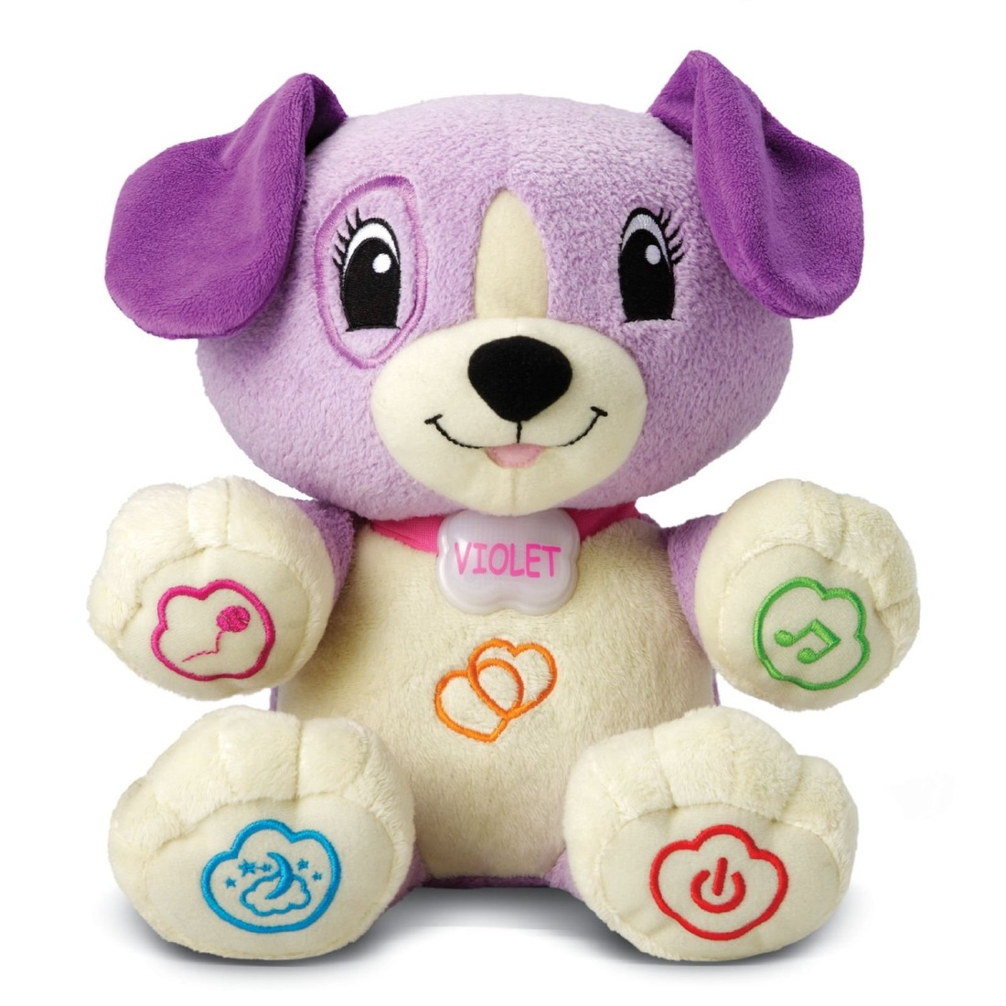
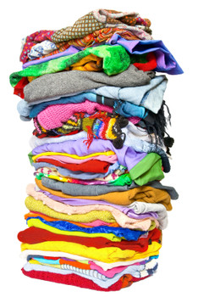

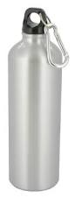
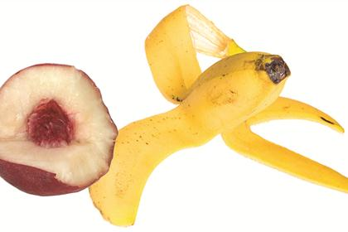
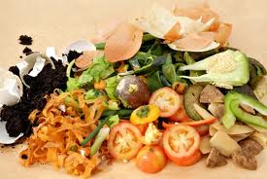
CLASS RESEARCH PROJECT (Focus on Land) SAMPLE GRAPHIC ORGANIZER:

CHAPTER 1 SAMPLE STUDENT REPORT (Exemplar):

I can help the Earth by taking care of the land. I can throw my garbage in a trashcan. I can recycle things like plastic and glass. I can reuse things instead of throwing them away like toys and books. I can start a compost pile with fruit scraps. Taking care of the land will keep the Earth beautiful forever.

SMALL GROUP RESEARCH PROJECT (FOCUS ON AIR) SAMPLE GRAPHIC ORGANIZER

Idea | Examples/Elaboration
Reduce carbon dioxide by… | Turning off the lights  Riding a bike instead of a car  Taking a bus instead of a car  Planting a tree

CHAPTER 2 SAMPLE STUDENT REPORT (Exemplar):

I can take care of the earth’s air by reducing carbon dioxide. I can turn the lights off when I leave the room. I can ride a bike instead of a car. I can plant a tree in my back yard. Reducing carbon dioxide makes the earth’s air healthy.

Teacher Research Packet
Kindergarten

Based on the Writing for Understanding Approach, Vermont Writing Collaborative ©2011

My Class Research Project on
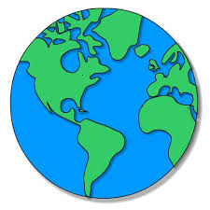
Keeping our Earth Healthy

Class Research Question
How can I take care of the earth’s land?
Becoming an Expert
Class Research Packet
An expert is someone who knows a lot about a particular topic. Follow these steps to become an expert.

- Students will write a check mark when they complete each step in the research process.
- The pacing is flexible. Some steps may take longer than a day and some days you may be able to complete multiple steps.
Becoming an Expert
An expert is someone who knows a lot about a particular topic.
✓  Done | Steps
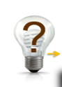
Where am I going?

Text Structure
 | First Read
 | Close Read
 | Thrilling Three
 | 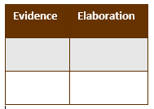 Reading for Evidence
 | Recording Evidence
 |  The Focus Statement
 |  Working with Evidence

 | Where Am I Going?  I can use sources to participate in a research project. (W.K.8)

Tell students that when you do research, you study a topic to find out more information. Read the research question below to the students.
Research Question: How can I take care of the earth’s land?
Tell students that a source is something we use to get information to answer the research question. A source might be a book, an article, a video or a website.
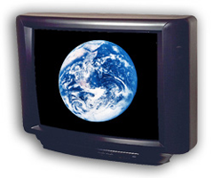


books | internet | videos

Pass out the book Growing Up Green. With your partner (or small group), look through the source (book) I have given to you and discuss how this source can help you answer your research question. Ask the students:
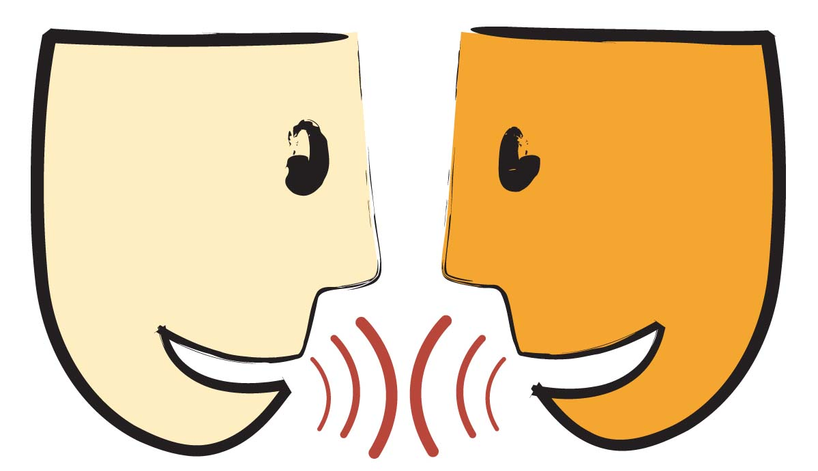
Turn and Talk: How can this source help you answer your research question?
Have students share their ideas.
Tell students it is important to list the sources you use, so you can remember where you got your information. Have students write the title and the author of the source below.

Title: _______________________________________________________________________

_______________________________________________________________________

Author:
_______________________________________________

 | Text Structure  I can find parts of a text. (RI.K.5)

Tell students that the Table of Contents is a way an author lets a reader know where to find specific information.

Circle what page number a reader will find information about clean water.
Turn to page 20. This author uses a heading to tell the reader the main idea of a page or chapter.

Circle the heading on this page.

What is different about the heading and the other words on the page?
Tell students that authors use different ways to tell information. This author uses photographs, captions, and words that are in bold.

Circle the photograph.
Circle the caption.
Circle the word in bold.

Explain how the author uses each one.

First Read
I can listen to a text read aloud. (RF.K.4)

Listen closely as your teacher reads the text aloud.
Teacher reads the text all the way through without stopping while students follow along. By reading the text without stopping, students will hopefully get a feel for the “big idea” and key understandings. It is also important for students to hear the flow and syntax of the text.
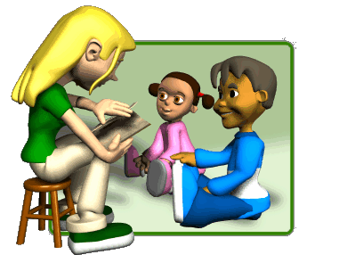

Close Read
I can answer questions about a text. RI.K.1)

Be creative when having students look for evidence to answer these questions. Possible suggestions to make it more interactive:  - Turn and talk  - Assign each group a question to answer and illustrate and then share with the other groups.  - Retype the chapter on Clean Land and have students highlight the answers.  - Have students use the student page in their packet to record answers. | Why did the author ask: But what else can we do?  The author wanted the reader to know that there are other ways to protect the land besides throwing trash away (turn and talk).

Using the photograph, what is an example of a plastic (or paper) that can be recycled? water bottle, milk carton (have students draw/write the answer).
 | How is reusing something different than recycling? Reuse is using something in a different way and recycle is using something to make a new product.
 | What are some things that can be reused? clothing, toys, books, reusable water bottle (have students draw/write the answer).
Which item can be reused and which one can be recycled?
The plastic bottle can be reused and the silver (aluminum) one can be reused (turn and talk).
How is reusing food helpful to the land?
It can feed your garden (turn and talk).

Thrilling Three
I can use words I learned in a sentence. (L.K.6)

Tell students that there are three words that are important to understanding the text. They are recycle, green, and reuse.
- Discuss each definition and picture. Be sure to discuss the multiple definitions for the word green.
- Have students write the correct word on the lines below.
- Additional Vocabulary Activities:
  - Mix-Freeze-Match
  - Act out the words/definitions
  - Add words to a word wall
  - Match words and pictures
  - Use words in sentences
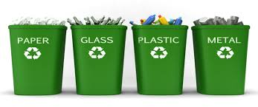
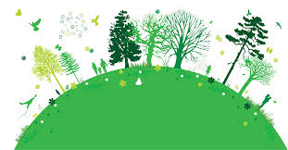
  - Tally each time a student uses a word
Caring for our land, air, and water

(green)
_______________________________
Making new things with old paper, glass, and plastic

(recycle)
________________________________
Use something again

(reuse)
________________________________
Reading for Evidence
I can gather information to answer a research question. (W.K.8)
Research Question: How can I take care of the earth’s land?
- Model finding the first idea “recycling”. Be sure to model looking for the evidence, thinking about the evidence (talking aloud), and placing a sticky note on the evidence. Say something like “The text says here (pointing to book) that recycling is one way to protect the planet. So I am going to place a sticky note here. The picture shows an example of what type of things can be recycled. I see paper, cans, plastic, and glass so I am going to place sticky notes here because those are examples of what can be recycled.”


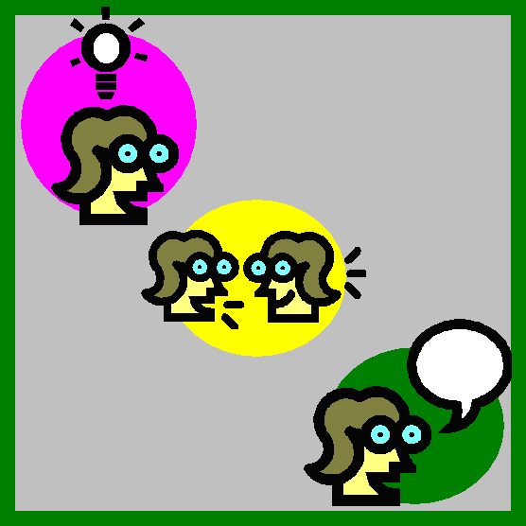

Sticky note on evidence
Think and Discuss

Look

- Tell students to turn to page 10. Give students time to reread pages 10-11 in their small groups. If your students are having difficulty rereading the text, you may choose to reread it aloud to them. Tell students to find another idea on how to take care of the earth’s land (reuse) and find examples (reuseable water bottle, old clothes...). Provide sticky notes for students to mark where they found the evidence (examples) for that idea.
Remind students to look for the evidence, think and talk about the evidence, and place a sticky note to show where they found the evidence.
- Give students time to reread pages 12-13 in pairs or small groups to recall the idea of starting a compost pile. Provide sticky notes for students to mark where they found the evidence (examples) for that idea. Remind students to Look, Think and Discuss, and then place the sticky note.

Recording Evidence
I can record information to answer a research question. W.K.8

- The recording of the evidence will be done whole group to create public notes.
- You will record the evidence on a large chart paper that has a column titled “Idea” and a column titled “Examples”. The purpose of creating the public notes is so ALL students have visual access.
- Use the clip art on the following page as a visual for the students as you record the evidence.
- Model recording the evidence you found for recycling. Have the groups take turns sharing evidence they found for the ideas reusing and starting a compost pile. Talk about what words and pictures from the text they should include on the public notes. Record the evidence for each idea. (see sample public notes below)
- Be sure to monitor the groups making sure their ideas and examples are correct.
Idea | Examples
recycle | paper  cans  plastic  glass
reuse | old toys  clothes  books  reuseable water bottles
start a compost pile | fruit scraps  vegetable scraps

Clip Art for Recording Evidence Chart

The Focus Statement
I can answer a research question using information that I gathered. (W.K.8)

Research Question: How can I take care of the earth’s land?
- Reread the research question to the students.
- Have students look carefully at all of the evidence you have gathered. Revisit the large chart (public notes) of recorded evidence.
- Ask: What is the “big idea” that came out of our research? Have students turn and talk to a partner.
Turn and talk with your partner about what you think is the ‘big idea”.

- Gather students back as a whole group and have students share their ideas.

A focus statement tells what you have learned from your research in a single sentence.
- The focus statement is a sentence that captures the big idea based on the evidence collected.
- Read to the students the definition of a focus statement.
- Record ideas that students have and discuss the vocabulary that might be included in the statement
- Decide as a class a good focus statement and have the students write it on the lines below.
Focus Statement: I can help the earth by taking care of the land.

_____________________________________________________________

Working with Evidence
I can speak in a complete sentence using ideas from my notes. (SL.K.6)
I can use words I learned through reading and discussions. (L.K.6)
The ideas below can be changed to meet the needs of your students. You may choose to do both the whole group and small group working with evidence activities or just one. However, in order for students to be successful in their writing, they will need enough time working with the evidence and practice using the evidence to speak in complete sentences. Remember: If you can’t say it, you can’t write it!
- Preparing for Working with Evidence
  - Collect and bring in the following products (Optional: use pictures instead):
    - Recycling items: paper (writing paper, cardboard boxes…), aluminum (cans, foil…), plastic (water bottles, milk carton, grocery bags...), glass (jars, glass milk bottles…)
    - Reusable items: old toys, old clothing, old books, reusable water bottles
    - Composting: fruit scraps (banana peels, apple cores), vegetable scraps (potato peels, lettuce, celery stalks…)
  - Collect Hula-Hoops or string to create three circles
  - Write the words recycle, reuse, and start a compost pile on three separate index cards (you will need two more sets of these words for working with evidence in small group.)
  - Write the focus statement on three different sentence strips (for working with evidence small groups).
  - Prepare three sentence strips with the following sentence frame:
I can __________ by ___________.

- Working with Evidence Whole Group
  - Place one of the three index cards in each circle (using Hula-Hoops or yarn) and one sentence strip I can __ by ____ under each circle.
  - Have students help you sort the items (or clip art) into the appropriate circle. This is done as a whole group.
  - Once the items are sorted into the proper circle, divide the class into three groups. Place one group at each Hula-Hoop (circle). Have students practice using the evidence from their circle to speak in complete sentences. Students can refer to the sentence frame I can ____ by _____ if needed. Example for students at the recycling circle: I can recycle by not throwing plastic bottles in the trash.
  - Once students have had an opportunity to practice working with the evidence, students will rotate to the next circle, practice using the evidence from that circle in a complete sentence.
  - Students will then rotate to the last circle.

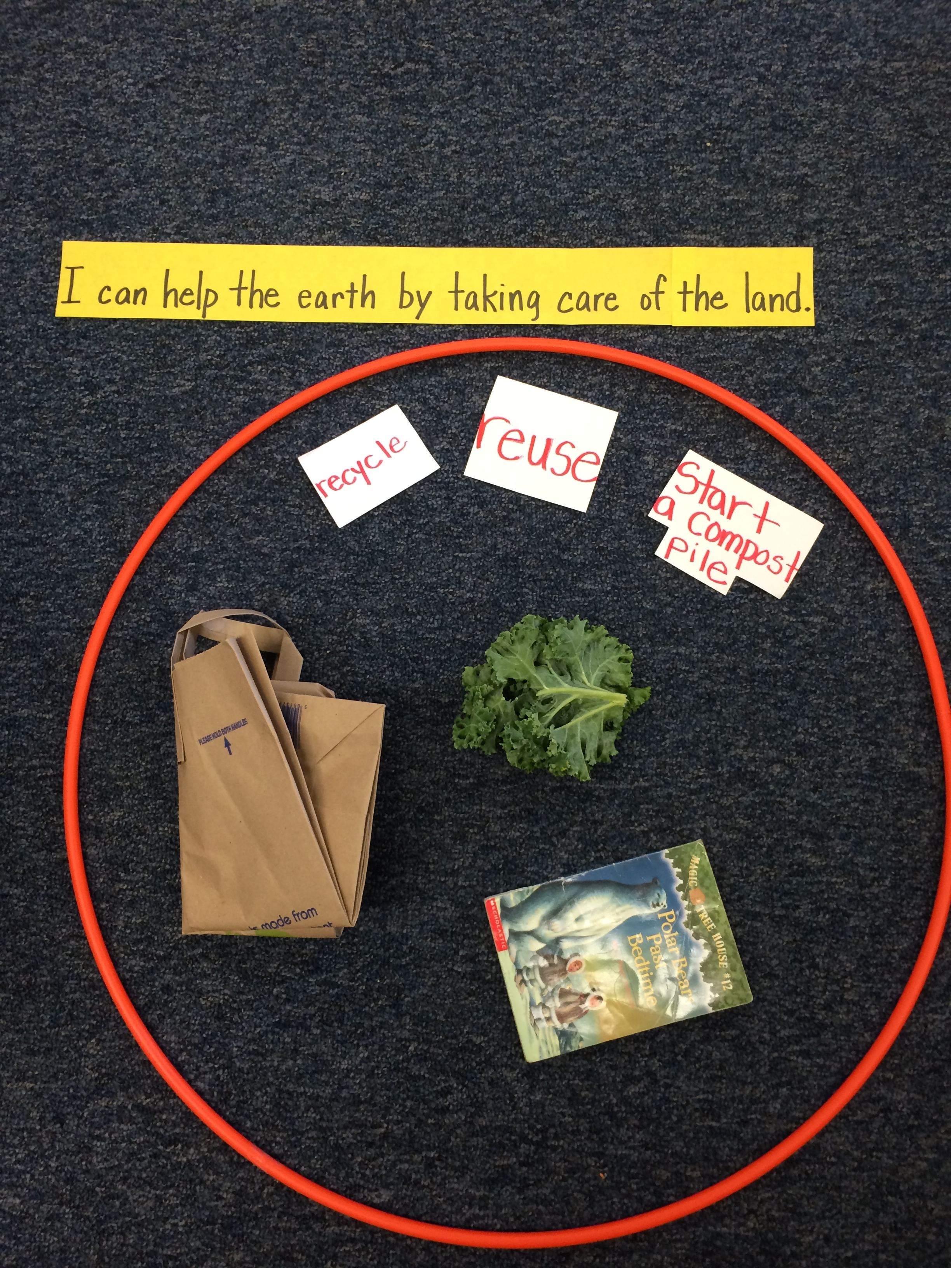
- Working with Evidence in Small Group
  - Place the following in three different places throughout the room:
  - Hula-Hoop
  - at least one item from each idea (recycle, reuse, start a compost pile)
  - the words or phrase “recycle”, “reuse”, and “start a compost pile”
  - the focus statement written on a sentence strip
- Divide students into three groups.
- Students will take turns orally rehearsing by reading the focus statement followed by the three things they can do to take care of the earth’s land.
Example: “I can help the earth by taking care of the land. I can recycle by not throwing a paper bag in the trash. I can reuse by borrowing a book from a friend. I can start a compost pile by adding old lettuce.”
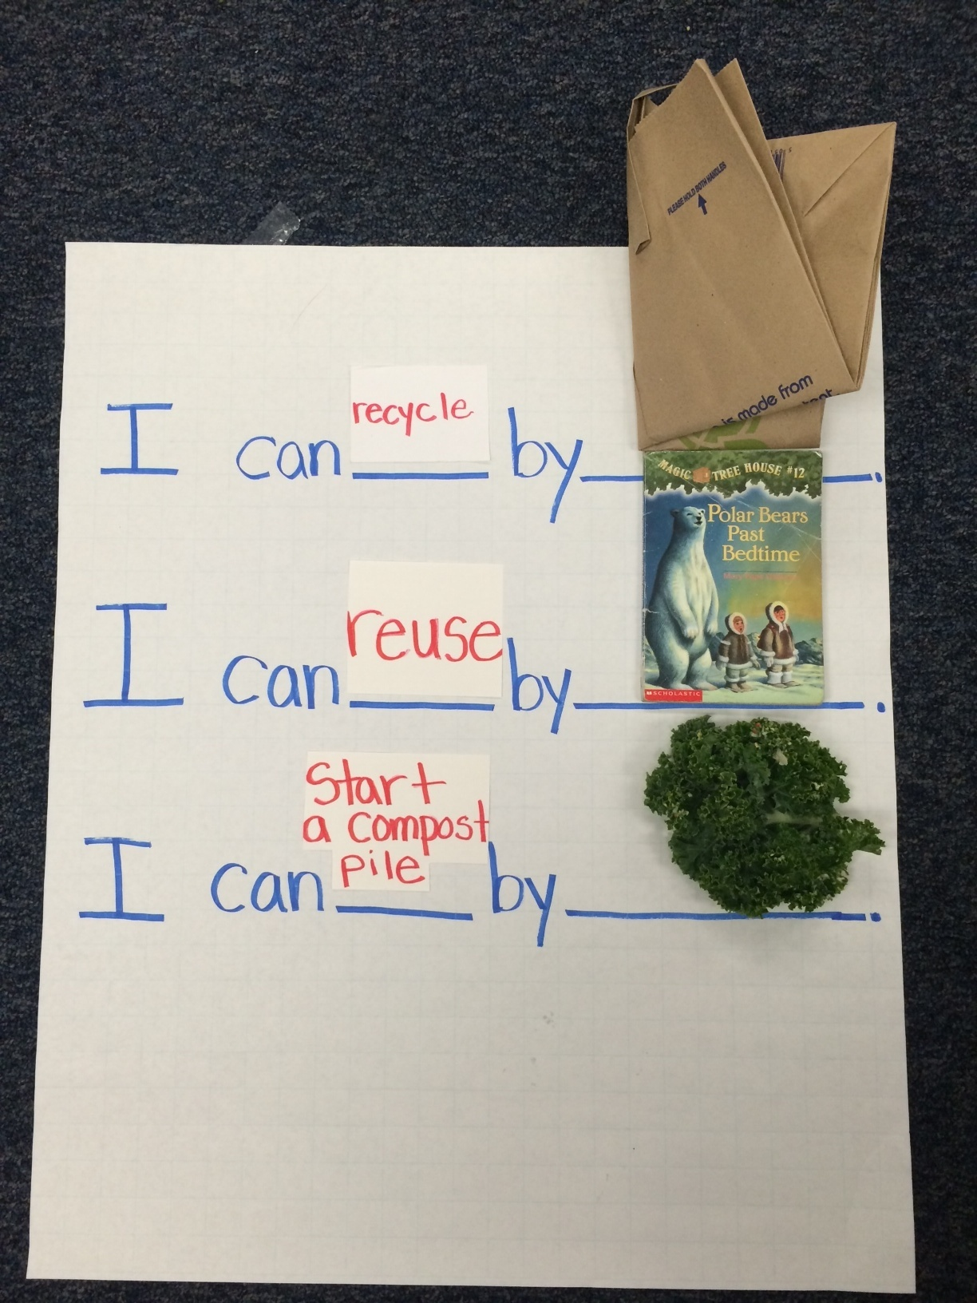
- You may consider writing the three sentence frames on a large chart paper and students can manipulate the words and items (pictures) on the chart before orally rehearsing.


Now you are ready to write!
Use your Writing Resource Packet to write about your research. Check off each step when you complete it.
Keeping the Earth Healthy
Sharing your Expertise
Teacher Writing Resource Packet

- Have students write a check in each box below as they complete each step.
Use this record sheet with your Writing Resource Packet.
✓  Done | Steps
 | Learn from a Model
 | Write a Focus Statement
 | Write the first piece of evidence
 | Write the second piece of evidence
 | Write the third piece of evidence
 | Write a Concluding Statement
 | Revise/Edit
 | Publish, Share and Celebrate!
- The pacing is flexible. Some steps may take longer than a day and some days you may be able to compete multiple steps.
- The students will need two copies of the student writing research packet. One for when they write about keeping the earth’s land healthy (chapter 1) and one for keeping the earth’s air healthy(chapter 2). The process and directions are the same for each chapter.

Learn From a Model

Green | Focus Statement
Yellow | Evidence 1
Blue | Evidence 2
Light Blue | Evidence 3
Green | Conclusion
Read the model below on helping the earth by saving water.
- Explain to students that all good informational writing starts with an introduction (focus statement). Have students read the focus statement in the paragraph below and highlight (color) it green. The color green is to remind students that this is the “big idea”.
- Explain to students that the middle part of the paragraph is evidence that supports the focus statement (big idea). In this paragraph there are three pieces of evidence that combine to create the big idea or focus statement. Have students find/read the first piece of evidence and highlight (color) it yellow.
- Continue reading/finding the other two pieces of evidence. Highlight (color) the second piece of evidence blue and the third piece of evidence light blue. Explain that the yellow piece of evidence combined with the blue evidence creates the green big idea or focus statement.
- Explain to students that all good writing has a conclusion. Often the conclusion is a restatement of the opening and should reflect the new learning based on the evidence. Tell students that this means you write the conclusion in a slightly different way than the introduction. Have them highlight (color) the conclusion in a different shade of green.
I can help the earth by saving water. I can turn off the water when I brush my teeth. I can take a shorter shower. I can plant plants that need less water. Using less water will help preserve the water on earth.
Write the Focus Statement
I can write an informative piece in which I name a topic. (W.K.2)

1. Reread the focus statement from the model:
I can help the earth by saving water.
This focus statement is about saving water to help the earth. Looking at our evidence, what part of earth does our evidence help? (the land) Revisit the focus statement that was crafted as a class. Students may refer back to the focus statement they wrote in their student research packet.

2. Talk with a partner about what you are going to write.
3. Write your focus statement on the lines below.
____________________________________________________________
4. Revise and Edit (see checklist on page 9)
It is at the teacher’s discretion to revise and edit after each section or wait until the end.
Write the Evidence
I can write an informative piece using information about a topic. (W.K.2)

- Reread the first piece of evidence from the model:
I can turn off the water when I brush my teeth.
- Look at one piece of evidence from our chart and talk with a partner about what you are going to write.
Be sure the evidence chart is visible for all students. You may want to point to the row “recycle” and have the students only focus on this idea.
- Write your first piece of evidence on the lines below.
You may choose to write all three pieces of evidence in one day, depending on your students’ stamina and developmental levels or a piece each day.
____________________________________________________________________
4. Revise and Edit (see checklist on page 9)
Write the Evidence
I can write an informative piece using information about a topic. (W.K.2)
- Reread the next piece of evidence from the model:
I can take a shorter shower.
- Look at another piece of evidence from our chart and talk with a partner about what you are going to write.
Be sure the evidence chart is visible for all students. You may want to point to the row “reuse” and have the students only focus on this idea.
- Write your second piece of evidence on the lines below.
_____________________________________________________________________________________
4. Revise and Edit (see checklist on page 9)
Write the Evidence
I can write an informative piece using information about a topic. (W.K.2)
- Reread the next piece of evidence from the model:
I can plant plants that need less water.
- Look at another piece of evidence from our chart and
talk with a partner about what you are going to write.
Be sure the evidence chart is visible for all students. You may want to point to the row “start a compost pile ” and have the students only focus on this idea.
- Write your third piece of evidence on the lines below.
_____________________________________________________________________________________
4. Revise and Edit (see checklist on page 9)
Write the Concluding Statement
I can write an informative piece. (W.K.2)
- Reread the concluding statement from the model:
Using less water will help preserve the water on earth.
Ask the students, “How is this concluding statement similar to the focus statement? How is it different? Have them notice that the conclusion statement is another shade of green from the introduction because all the ideas come together to form a new idea.
- Reread your focus statement. Talk with a partner about how you might say that again using slightly different words.
- Write your concluding statement on the lines below.
___________________________________________________
_________________
4. Revise/Edit
Final Revision and Editing
I can work with peers to improve my writing. (W.K.5)

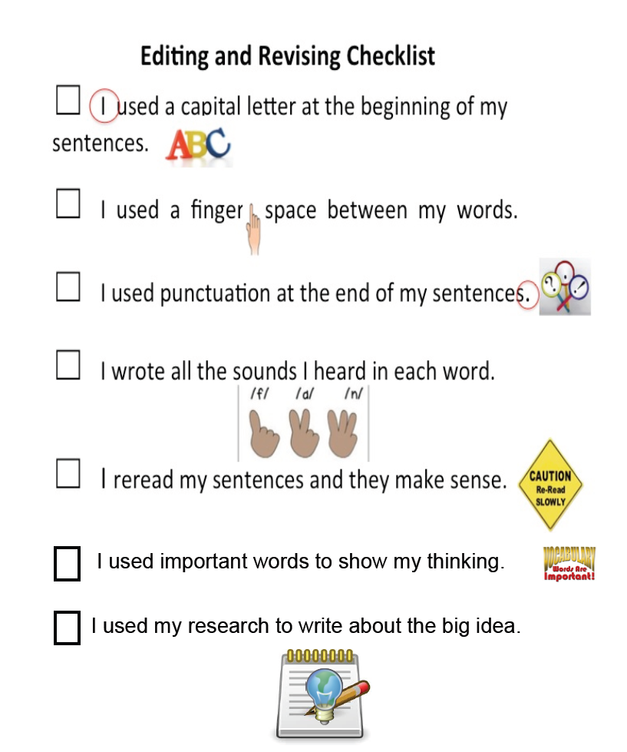

Publish and Celebrate
Congratulations you are an expert and a scholar!

It is time to publish your writing by making a chapter book!
The chapter book is included on the following pages. The writing paper needs to be copied depending on the number of pages that will be in each chapter. You may want to consider one page for the focus question, one page for all three pieces of evidence, and one page for the concluding statement. This way each chapter will be at least 3 pages in length. Provide each student with a blank, stapled copy of the chapter book (including the pre decided number of writing pages for each book) to begin publishing their book.


I would like to celebrate by:
☐ Reading my chapter book to another student

☐ Reading my chapter book to the principal

☐ Reading my chapter book to my family

☐ Other idea: ____________________________

Keeping the
Earth
Healthy

A Chapter Book Written by

Keeping the Earth Healthy
Chapter 1 | Keeping the Earth’s Land Healthy | Page:
Chapter 2 | Keeping the Earth’s Air Healthy | Page:

Chapter 1

Keeping the Earth’s Land Healthy

Page _____
_____________________________________________________________________________________
Page _____

Chapter 2

Keeping the Earth’s Air Healthy

Page _____

Teacher Research Packet
Kindergarten

Based on the Writing for Understanding Approach, Vermont Writing Collaborative ©2011

My Class Research Project on
Keeping our Earth Healthy

Small Group Research Question
How can I take care of the earth’s air?
Becoming an Expert
Group Research Packet
An expert is someone who knows a lot about a particular topic. Follow these steps to become an expert.

- This Group Research Packet is designed for gradual release of responsibility and has students working in small groups to take more ownership of the process.
- Students will write a check mark when they complete each step in the research process.
- The pacing is flexible. Some steps may take longer than a day and some days you may be able to compete multiple steps.

Becoming an Expert
An expert is someone who knows a lot about a particular topic.
✓  Done | Steps
 | Where am I going?
 | Reread * This rereading of the section on clean air is done with teacher facilitating understanding through the think aloud process.
 | Thrilling Three
 | Reading for Evidence
 | Recording Evidence * This will be done whole group as a way to check for understanding and to deal with any misconceptions.
 | The Focus Statement
 | Working with Evidence

Where Am I Going?
I can use sources to participate in a research project. (W.K.8)

Research Question: How can I take care of the earth’s air?
Pass out the book Growing Up Green to each small group of students. With your small group, look through the source (book) I have given to you and discuss where in this source can you find information to help you answer your new research question. Remind students about what they learned about the Table of Contents and using the key words “clean” and “air”.

Turn and Talk: What part of this source can help you answer your research question?

Tell students it is important to list the sources you use, so you can remember where you got your information. Have students write the title and the page number of the part of their source below.

Title: _______________________________________________________________________

_______________________________________________________________________

Page Number:
_______________________________________________

Reread
I can listen to a text read aloud. (RF.K.4)
Listen closely as your teacher reads the text aloud. Read the section of the text beginning on page 14 called Clean Air. As you read, it is important to think aloud to help students connect the idea of keeping the earth healthy by taking care of the air. Although this is not a close read, the idea of cleaner air by reducing carbon dioxide is a difficult concept. Therefore, spend some time on page 14 discussing the idea that limiting the burning of fossil fuels reduces carbon dioxide.

Additional Ideas for a Reread:
- Have students take turns in their small groups reading a sentence or page.
- Choose one or two people to read aloud. The rest of the small group reads along silently while listening.

Thrilling Three
I can use words I learned in a sentence. (L.K.6)

What are some important words in this text? Explain to students that as a group, they are to think of the 3 most important words. Remind them that sometimes authors will make important words darker than the other words.
Important Words | Picture
1.
2.
3.

Reading for Evidence
I can gather information to answer a research question. (W.K.8)

Research Question: How can I take care of the earth’s air?
Remind students that as a small group, they will be reading for evidence on how to reduce carbon dioxide as a way to take care of the air. Review the process of looking for evidence by using the visual sequence below. Have students orally state the process by pointing to each picture.
Sticky note on evidence
Think and Discuss
Look

- Tell each small group of students to turn to page 14. Give students time to reread pages 14-19 in their small groups.
- Tell students to work as a group to find ideas on how to take care of the earth’s air by reducing carbon dioxide. Provide sticky notes for groups to mark where they find the evidence (examples) for the idea.
- Remind students to look for the evidence, think and talk about the evidence, and place a sticky note to show where they found the evidence
- Monitor groups and provide feedback when necessary.

Recording Evidence
I can record information to answer a research question. W.K.8


With your group, complete the evidence chart below.
- Since the concept of clean air deals with one idea, reducing carbon dioxide, provide that idea in the evidence chart as a way to focus their evidence gathering.
- Each person in the group can complete the chart or assign an evidence gatherer for the group.
- After small groups have had time to complete the evidence chart, pull the groups back together whole group and make a class chart (public notes) as a way to correct misconceptions.
- Have groups take turns sharing information they found. Talk about what words or pictures could be added to the public notes.

Idea | Examples/Elaboration
Reduce carbon dioxide by… | Turning off the lights  Riding a bike instead of a car  Taking a bus instead of a car  Planting a tree

The Focus Statement
I can answer a research question using information that I gathered. (W.K.8)

Research Question: How can I take care of the earth’s air?
- Reread the research question to the small groups of students.
- Have groups look carefully at all of the evidence they have gathered. Revisit the large chart of recorded evidence.
- Ask: What is the “big idea” that came out of our research? Have groups discuss.

Turn and talk with your group about what you think is the ‘big idea”.
- Gather students back as a whole group and have students share their ideas.

A focus statement tells what you have learned from your research in a single sentence.
- The focus statement is a sentence that captures the big idea based on the evidence collected.
- Read to the students the definition of a focus statement and remind them it will be the “green” sentence in their writing.
- Record ideas that students have and discuss the vocabulary that might be included in the statement
- Decide as a class a good focus statement and have the students write it on the lines below.
Focus Statement: I can take care of the earth’s air by reducing carbon dioxide.

_____________________________________________________________

Working with Evidence
I can speak in a complete sentence using ideas from my notes. (SL.K.6)
I can use words I learned through reading and discussions. (L.K.6)

Your teacher has pictures for you to work with. As you practice working with the evidence you will talk in complete sentences. You can use the sentence frame to help you.
The idea below can be changed to meet the needs of your students. Have each small group complete the working with evidence activity or, you may choose to do it whole group. However, in order for students to be successful in their writing, they will need enough time working with the evidence and practice using the evidence to speak in complete sentences.
- Provide each small group with a set of pictures that includes: a light switch, bikes, a bus, planting a tree.
- Students will take turns orally rehearsing by reading the focus statement followed by things they can do to take care of the earth’s air.
  - Example: “I can take care of the earth’s air by reducing carbon dioxide. I can turn the lights off when I leave the room. I can ride a bike instead of a car. I can plant a tree in my back yard. Reducing carbon dioxide makes the earth’s air healthy.
- You may consider writing the sentence frames on a large chart paper and students can manipulate the items (pictures) on the chart before orally rehearsing.

Focus Statement: I can take care of the earth’s air by reducing carbon dioxide.

I can _______________________.

Now you are ready to write!
Use your Writing Resource Packet to write about your research. Check off each step when you complete it.

Provide each student with a new copy of the Writing Resource Packet for the Group Research. Reproduce pages from the chapter book for students to individually write Chapter 2: Clean Air.

