Name:

Grade 4 Date:

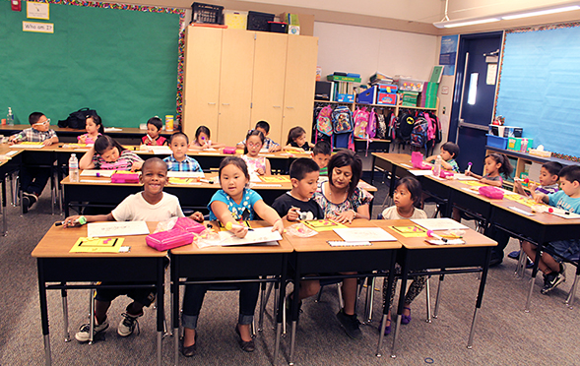

Based on the Writing for Understanding Approach, Vermont Writing Collaborative

My Class Research Project on
Tornadoes
Research Question:
What hazards can result from tornadoes, and what can we do to reduce the impact of tornadoes?

Becoming an Expert

Class Research Packet

Building Knowledge and Understanding through Research

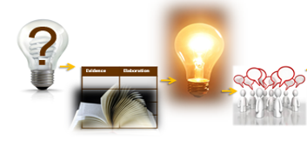

Becoming an Expert
Date Completed | Steps
 | Where Am I Going? | Text Structure
 | First Read Part 1 | Close Read Part 1
 | First Read Part 2 | Close Read Part 2
 | The Fab Five | Rolling Knowledge Journal
 | Reading for Evidence
 | Recording Evidence
 | Additional Evidence | Focus Statement
 | Working with Evidence

Research Question: What hazards can result from tornadoes, and what can we do to reduce the impact of tornadoes?

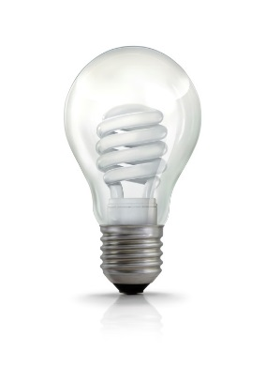
Where Am I Going?
Work with your group to answer the questions below.

?

What is your research question?
_____________________________________________

Skim your source. In one or two sentences describe what this text is mostly about.
___________________________________________________________________________________________________________________________________________________________________________

How will this source help you answer your research question?

__________________________________________________________________________________________________________________

Use the copyright information for your text to complete the section below.
Title:______________________________________________

Author:____________________________________________

Type of text: nonfiction book article website excerpt other

Publisher:____________________________________________

Publication date:_______________________
Text Structure
With a partner, answer these questions about the structure of your text.

Let’s take a look at how your source is put together.

- Look at the Table of Contents. Read the chapter titles. How many chapters are there? ________________________________
Look at the whole book. What kind of information is in the chapters
at the beginning of the book? ____________________________
What kind of information is in the middle? ___________________
What kind of information is at the end? ____________________

- Choose one chapter. Turn to the first page in that chapter. What page does the chapter start on? ____________________________
How many subheadings are there? _______________________

- Leaf through the chapter you chose from Question 2. How many pictures are there? __________________________________
What do you notice about the blue and tan boxes next to the pictures? _________________________________________
_________________________________________________

What are these blue boxes called? ______________________

- What do you notice about the bottom of most pages? _________
_________________________________________________
_________________________________________________

- Turn to a page with a bolded word. Find the glossary, look up the word, and write the word and definition here. ______________
_________________________________________________
_________________________________________________
First Read Part 1
With your group, read the text aloud.

With your group, use one of the options below to read pages 4-19 of your source aloud. Check a box to show the option you chose.

Ideas for a First Read:
- Take turns reading, have each person read a page or paragraph.
- Choose one or two people to read aloud. The rest of the group reads along silently while listening.
- Listen to a recording of your book, reading along silently while you listen.
- Another idea:____________________________________

What do you find confusing or unclear about the text? List any questions about what you have read below. Then see if the other members of your group can help you answer them. Put a star next to those you would like a teacher to help you with.
______________________________________________________________________________________________________________________________________________________
______________________________________________________________________________________________________________________________________________________
______________________________________________________________________________________________________________________________________________________

First Read Part 2
With your group, finish the rest of the book.
Use options below to read pages 20-43 of the text aloud. Check a box to show the option you chose.

Ideas for a First Read:
- Take turns reading, have each person read a page or paragraph.
- Choose one or two people to read aloud. The rest of the group reads along silently while listening.
- Listen to a recording of your book, reading along silently while you listen.
- Another idea: ____________________________________

Close Read Part 1
With a partner, reread parts of your book for
deeper understanding.

Work together to follow the directions in each box.

Reread page 5, in Chapter 1, with a partner. | Why are tornadoes the most violent storms on Earth?
Reread pages 6-9 and look at the pictures with a partner. | Draw and label the relationship between a thundercloud and a tornado.
Reread pages 16-17 and look at the pictures with a partner. | Make a list of some of the hazards (problems) caused by tornadoes.

Close Read Part 2
With a partner, reread parts of your book for deeper understanding.

Work together to follow the directions in each box.

Reread pages 20 and 24 with a partner. Look at the maps on each page. | On page 20, what do the red dots mean? On page 24, what does the red shading mean?
Reread pages 28-29 with a partner. | How do people know when to find shelter?
Look at the pictures and read the captions on pages 30-35 with a partner. | Turn and talk about what damage these tornadoes caused?
Reread pages 42-43 with a partner. | Make a list of actions you can take to stay safe when there is a tornado.

The “Fab Five”
With a partner, identify 5 important words from the text.

From your central text, chose 5 words that are important to understanding the central idea of the text.
Next use your 5 words to write about the most important idea of the text. Write one sentence for each word that shows you understand the meaning of the word.
Important Word | Sentence about the Central Idea
1.

2.

3.

4.

5.

Rolling Knowledge Journal
Keep track of all you’re learning!

- After you read each resource, stop and think about what the big learning was. What did you learn that was new and important about the topic from this resource? Write, draw, or list what you learned from the text about (topic).
- Then write, draw, or list how this new resource added to what you learned from the last resource(s). Add pages if needed.
 | Write, Draw, or List
Title | New and important learning about the topic | How does this resource add to what I learned already?
A Storm Called Katrina
Storm Warning: Tornadoes
Weather WizKids: “Tornadoes”
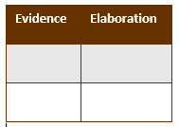
Reading for Evidence
Work as a group to gather and share information that will help you answer your research question: What hazards can result from tornadoes and what can we do to reduce the impact of tornadoes?
.

Follow these steps to complete the graphic organizer together:

- First, break into groups. Assign each group a part of the text to reread and search. Record the assignments below.

Section  (page numbers) | People responsible
Pages 4-25
Find information to add to the “Problems” and “Solutions” sections of the graphic organizer
Page 26-43
Find information to add to the “Problems” and “Ways to Reduce the Impact” sections of the graphic organizer

- As a group, look at the graphic organizer. Discuss: What is your Research Question? What kinds of information will go in each column?
- Now reread the part of the text you were assigned. When you find a part of the text that will help you answer your research question mark it with a sticky note.
If the evidence is about problems of tornadoes, mark the sticky note with a “P.” If the evidence is about solutions to the problems, mark the sticky note with an “S”.

- Repeat this process until all the important information from this section has been marked.

Recording Evidence
Share what you have found with your group to complete the graphic organizer.

Focusing Question: ____________________________________
___________________________________________________

- Meet with the full group again. Take turns sharing one piece of information you found. Talk about what words or phrases to write on the graphic organizer, then fill in the appropriate row on your own organizer. You will need notes on all the information found by the group for your final project.

- Repeat this process until all the information from this source has been recorded on your graphic organizer.

Tornadoes
Research Question: What hazards can result from tornadoes and what can we do to reduce the impact of tornadoes?
Part 1: What hazards (problems, dangers) can result from tornadoes? Why are tornadoes so dangerous?

Part 2: What can we do to reduce the impact of tornadoes and keep ourselves safe?
People can:

Scientists can:

Part 3: So What? So why is it important to learn as much as we can about tornadoes?
Sources

Additional Evidence
On your own or with a partner, add additional information to the graphic organizer.
Read one or more additional sources. Mark information that will help you answer the research question with sticky notes. Add it to your own graphic organizer. Use a different colored pencil for each source, so you will remember where your information came from.

Using the same colored pencils, list your additional sources below.

Title:
Author:
Publisher/URL:

Title:
Authors:
Publisher/URL:
--------------------------------------------------------------------------------
THE FOCUS STATEMENT!
Sum up what you have learned.
What is the “big idea”?
Look carefully at all of the evidence you have gathered. What is the “big idea” your evidence shows? Try to state what you have learned in just a sentence or two. Your teacher and classmates will help you.

Focus Statement: ______________________________________

____________________________________________________
Working with Evidence
Work with your group to better understand the information you have gathered.

To prepare for the activity:
Review your notes. Your teacher will lead you in the following activity.

Create a Scene! (a full class activity)

To begin the activity, your teacher will break you into groups. Each group will be given a set of cards with people involved in a tornado.

You will have five minutes to work with your group to determine how each person might be involved in a tornado. Then, create a scene to act this out.

Watch as each group presents their scene to the class. Following each scene, discuss the following questions:
- What did you see that was accurate?
- What do you know now that you didn’t know before?

Reflect on the scenes presented. How did planning, presenting, and watching the scenarios deepen your understanding of the hazards resulting from tornadoes and what we can do to reduce the impact of tornadoes?

Possible groupings
Group 1: meteorologist, storm spotter, child outside, parent outside, person in a car, paramedic
Group 2: radio announcer, storm spotter, woman inside with an outside storm shelter, child inside, firefighter, sibling at school

Now you are ready to write!
Use your Writing Resource Packet to write an informative explanatory piece. Put the date next to each step when you complete it

Sharing Your Expertise Record Sheet
Use this record sheet with your Writing Resource Packet to deepen your understanding and communicate what you have learned.
Date | Steps
 | Analyze a Model
 | Write an Introduction
 | Write Proof Paragraph 1
 | Write Proof Paragraph 2
 | Write a Conclusion
 | Final Revision and Editing | Add a Visual!
 | Share and Celebrate!

