Title/Author: The Salamander Room by Anne Mazer
Suggested Time to Spend: 5 Days (Five 25-minute sessions)
Common Core grade-level ELA/Literacy Standards: RL.1.1, RL.1.2, RL.1.3, RL.1.4, RL.1.7; W.1.1, W.1.8; SL.1.1, SL.1.2, SL.1.6; L.1.1, L.1.2, L.1.4
Lesson Objective:
Students will listen and discuss The Salamander Room to better understand how to construct a persuasive argument in order to write their own.
Teacher Instructions
Before the Lesson
- Read the Big Ideas and Key Understandings and the Synopsis below. Please do not read this to the students. This is a description to help you prepare to teach the book and be clear about what you want your children to take away from the work.
Big Ideas/Key Understandings/Focusing Question
Brian uses his knowledge of animal needs, persuasion, and perseverance to try and convince his mom to keep a pet salamander.
Synopsis
A young boy, Brian, finds a salamander in the woods and wants to keep it as a pet. This story follows Brian as he uses his perseverance and imagination to convince his mom that he should be able to keep the salamander.
- Go to the last page of the lesson and review “What Makes This Read-Aloud Complex.” This was created for you as part of the lesson and will give you guidance about what the lesson writers saw as the sources of complexity or key access points for this book. You will of course evaluate text complexity with your own students in mind, and make adjustments to the lesson pacing and even the suggested activities and questions.
- Read the entire book, adding your own insights to the understandings identified. Also note the stopping points for the text-inspired questions and activities. Hint: you may want to copy the questions, vocabulary words, and activities over onto sticky notes so they can be stuck to the correct pages for each day’s questions and vocabulary work.
- Consider pairing this series of lessons on The Salamander Room with a text set to increase student knowledge and familiarity with the topic. A custom text set can be found here. Note: This is particularly supportive of ELL students.

Note to teachers of English Language Learners (ELLs): Read Aloud Project Lessons are designed for children who cannot read yet for themselves. They are highly interactive and have many scaffolds built into the brief daily lessons to support reading comprehension. Because of this, they are filled with scaffolds that are appropriate for English Language Learners who, by definition, are developing language and learning to read (English). This read aloud text includes complex features which offer many opportunities for learning, but at the same time includes supports and structures to make the text accessible to even the youngest students.
This lesson includes features that align to best practices for supporting English Language Learners. Some of the supports you may see built into this, and /or other Read Aloud Project lessons, assist non-native speakers in the following ways:

- These lessons include embedded vocabulary scaffolds that help students acquire new vocabulary in the context of reading. They feature multi-modal ways of learning new words, including prompts for where to use visual representations, the inclusion of student-friendly definitions, built-in opportunities to use newly acquired vocabulary through discussion or activities, and featured academic vocabulary for deeper study.
- These lessons also include embedded scaffolds to help students make meaning of the text itself. It calls out opportunities for paired or small group discussion, includes recommendations for ways in which visuals, videos, and/or graphic organizers could aid in understanding, provides a mix of questions (both factual and inferential) to guide students gradually toward deeper understanding, and offers recommendations for supplementary texts to build background knowledge supporting the content in the anchor text.
- These lessons feature embedded supports to aid students in developing their overall language and communication skills by featuring scaffolds such as sentence frames for discussion and written work (more guidance available here) as well as writing opportunities (and the inclusion of graphic organizers to scaffold the writing process). These supports help students develop and use newly acquired vocabulary and text-based content knowledge.

The Lesson – Questions, Activities, and Tasks

Questions/Activities/Vocabulary/Tasks | Expected Outcome or Response (for each)
FIRST READING:  The pages are not numbered in the book. To make following this lesson easier, be sure to number the pages prior to reading. Page 1 is the picture of Brian finding the salamander, with page 2 being the first page of text.  Read aloud the entire book with minimal interruptions. Stop to provide word meanings or clarify only when you know the majority of your students will be confused.  After the students have heard the story, they should create Brian and Mom stick puppets to be used in subsequent lessons. | The goal here is for students to enjoy the book, both writing and pictures, and to experience it as a whole. This will give them some context and sense of completion before they dive into examining the parts of the book more carefully.  Prior to the lesson, if using the clip art (see Resources section near the end of this lesson), copy onto cardstock and cut out one Mom and one Brian for each student. Students may also draw their own versions of Mom and Brian. After they have been colored, attach them to popsicle sticks.
SECOND READING:  You will read the entire book today, focusing on dialogue and who is speaking throughout the book.  Be sure each student has two stick puppets, one of Brian and one of Mom.  Read to Page 4  (display on a document camera or projector, if possible)  QUESTIONS:  What punctuation marks tell us that someone is talking?  On Page 4  Who is talking here? Show me who is talking by holding up the correct puppet. How do you know Mom is talking?  Who is responding to Mom’s question? Show me by holding up the correct puppet. How do we know who is speaking?  Read Pages 5 and 6  As I am reading, hold up your Mom or Brian puppet when you think one of them is talking.  After reading these pages ask, “How do you know when Mom is talking?”  Read to Page 8  As I am reading, hold up your Mom or Brian puppet when you think one of them is talking.  Read to Page 13  Do you think Brian’s room really looks like this? Why did the illustrator make his room look like this?  If his room really doesn’t look like this, what is happening?  Continue to finish the entire book, having students hold up their puppets when Mom is talking and when Brian is talking. As you read, check to see which students are able to identify who is talking and which students may need additional clarification. | Students should be able to point out the quotation marks and explain that quotation marks help us, as readers, know that someone is talking.  Students respond by holding up either Brian or Mom based on who is speaking at that time. Students should make the connection that Mom is talking because it says, “his mother asked.”  Because it is not explicitly stated who is talking, help students realize Brian is talking by thinking through what is being said and thinking through who the characters are in the book.  Students respond by holding up either Brian or Mom based on who is speaking at that time.  Help students notice that we can tell that Mom is talking because she is asking questions like a mom would ask.  Students respond by holding up either Brian or Mom based on who is speaking at that time. Help students to notice cues that on Pages 4-6, Mom is asking questions, but on Page 8, she is not. Students cannot rely on only choosing Mom when a question is being asked. They must listen and think, “Which character makes sense here?”  I don’t think Brian’s room really looks like that. It’s just pretend. The illustrator wanted to show what he was imagining.  Brian is using his imagination. He is imagining that this is what his room would look like.
THIRD READING:  You will not reread the whole book today. Just read individual pages.  Today, as you read, create an anchor chart of the new vocabulary introduced. Use student friendly definitions and have pictures ready to use. Have the words on the chart prior to reading. It is also helpful to have the definition and pictures printed and ready to paste on the chart.  Read Page 2  Who knows what a salamander is?  What other animals does a salamander remind you of?  Read Page 4  Moss is a green plant that grows and covers areas. Show a picture of moss or bring an example of moss in for the students to see and feel.  Read Page 5  Brian says he is going to “carpet my room.” What does this mean? How will he “carpet” his room with leaves?  Read Page 6  Bark – I know a dog barks, but I don’t see a dog. In this case, the bark means the outside of a tree.  Boulders – Boulders are big rocks. Show a picture of a boulder.  Creep – Think about how creep is used in the text. Using context clues, can you tell me what it means to creep? Do you think it means to jump, walk slowly, or run?  Read Page 12  Multiply - Multiply means to increase in number. What is increasing in number on this page?  Read Page 14  Roost – If a bird can “roost” in a tree, what could that mean? Do you know another animal that sounds like roost?  Read Page 16  Ceiling – the ceiling is the top of a room. What did Brian do to the ceiling in his room? Why do you think he did this?  Juiciest means that something is full of juice. He is going to feed the salamander insects that are full of juice. What do you eat that is juicy? | Vocabulary Anchor Chart  Word Definition Picture  Salamander  Moss  Carpet  Bark  Boulders  Creep  Multiply  Roost  Ceiling  Juiciest  Responses should include a salamander is like a snake or a lizard, maybe even a frog.  Define moss and have a student find the word moss on the chart. Paste or write the definition on the chart and place a picture by the word.  It sounds like he is doing something. A carpet is the fuzzy stuff on your floor. But he is using leaves for the carpet. Maybe he will put them on the floor.  Just tell the meaning of bark and move on. Have students place the picture of bark and the definition on the chart.  Place the picture of a boulder on the chart.  I think creep means to go slow, like a turtle. Salamanders do not jump or run, so I don’t think creep means either of those. It means he is walking slowly over the boulders. Add creep to the chart.  The group of insects is getting increasing. Add definition and picture to the chart.  Maybe roost means to sit or sleep in a tree. Roost sounds kind of like rooster, and that is another kind of bird.  He took the ceiling off so the birds could fly and the sun and rain could make the trees grow.  Fruit can be juicy, sometimes my dad says these hamburgers are juicy, so the birds must think insects are juicy like a hamburger.
FOURTH READ:  Read Pages 4-9  What questions does the Mom ask? Make a list of the questions Mom asks.  Why is Mom asking all of these questions?  Pages 10-16  What does Brian say he will do to care for the salamander?  Create an anchor chart of Animal Needs and how Brian is going to take care of the salamander (using specific information from the text).  How do you think Brian knows what the salamander needs?  Pages 17-19 – Do you think Brian is responsible enough to take care of a pet? Why or why not? | Where will it sleep? What will it eat? What about missing his friends?  Mom is asking all of these questions because she wants to make sure Brian has thought about what the salamander needs and how he is going to provide for the salamander.  Animal Needs What Brian is going to do.  Air Take off the ceiling  Water I will make a pond for them to drink from.  Shelter Carpet the floor and make bed of moss that look like stars  Food Insects  Sample Responses: Brian knows what the salamander needs because he is familiar with salamanders and their needs. He has learned about the needs of animals in school. Brian has had a pet before and has experience taking care of a pet.  Yes, because Brian knows what the salamander needs and has a way to care for all of its needs.

FINAL DAY WITH THE BOOK - Culminating Task
- On the final day with the book, students are going to write a persuasive letter. Students are to choose an animal and write a letter to a parent/guardian as to why they should be able to keep the animal as a pet. Students are expected to use their knowledge of animal needs in their letter
Example Response from 1st Grader:
Dear Mom and Dad,
I would like a dog. I want a dog because they are cute and fun to play with. I would name him Lucky. If you let me have a dog I would make sure to feed it every day. I would make sure that his water bowl is full. I would go outside and play with him. I would let him sleep with me every night and give him lots of love.
Sincerely,
Your 1st Grader
**Your students may write more or less than this example. Everyone’s class is different, but it is important that students show you that they understand the needs of animals and are able to construct a simple persuasive argument.
Vocabulary
These words merit less time and attention  (They are concrete and easy to explain, or describe events/  processes/ideas/concepts/experiences that are familiar to your students ) | These words merit more time and attention  (They are abstract, have multiple meanings, and/or are a part  of a large family of words with related meanings. These words are likely to describe events, ideas, processes or experiences that most of your student will be unfamiliar with)
Page 5 – Carpet – floor covering  Page 6 – Creep - move carefully and slowly  Page 6 - Stump – the bottom of a tree  Page 6 – Bark – tough, outer part of a tree  Page 16 – Ceiling – top of the room  Page 16 – Juiciest – full of juice | Page 4 – Moss – a plant that lacks roots and grows in low carpets in damp habitats.  Page 6 - Boulder – large rock  Page 12 – Multiply – increase in number  Page 14 - Roost – settle for rest of sleep

Extension learning activities for this book and other useful resources
- View the book on YouTube. Search: Feature Book The Salamander Room by Kids Education. This is a piece from Reading Rainbow so you will want to start watching at 36 seconds so that students get no background information on the book.
- If your students have not studied animal needs or need a refresher, a good book to use is Animal Needs (Investigate!) by Sue Barraclough.
- To get your students ready for the culminating activity, you may pose this question to them: “Have you ever tried to convince your mom that you could take care of a pet?“ Have the students talk to a partner about this question to get them ready to write. If students haven’t tried to convince their parents ask them “What type of pet would you like? What would you say to your mom or dad so they would let you have that pet?” Note: This is particularly supportive of English Language Learners.

Resources:
Clip art (may be used to make the puppets)
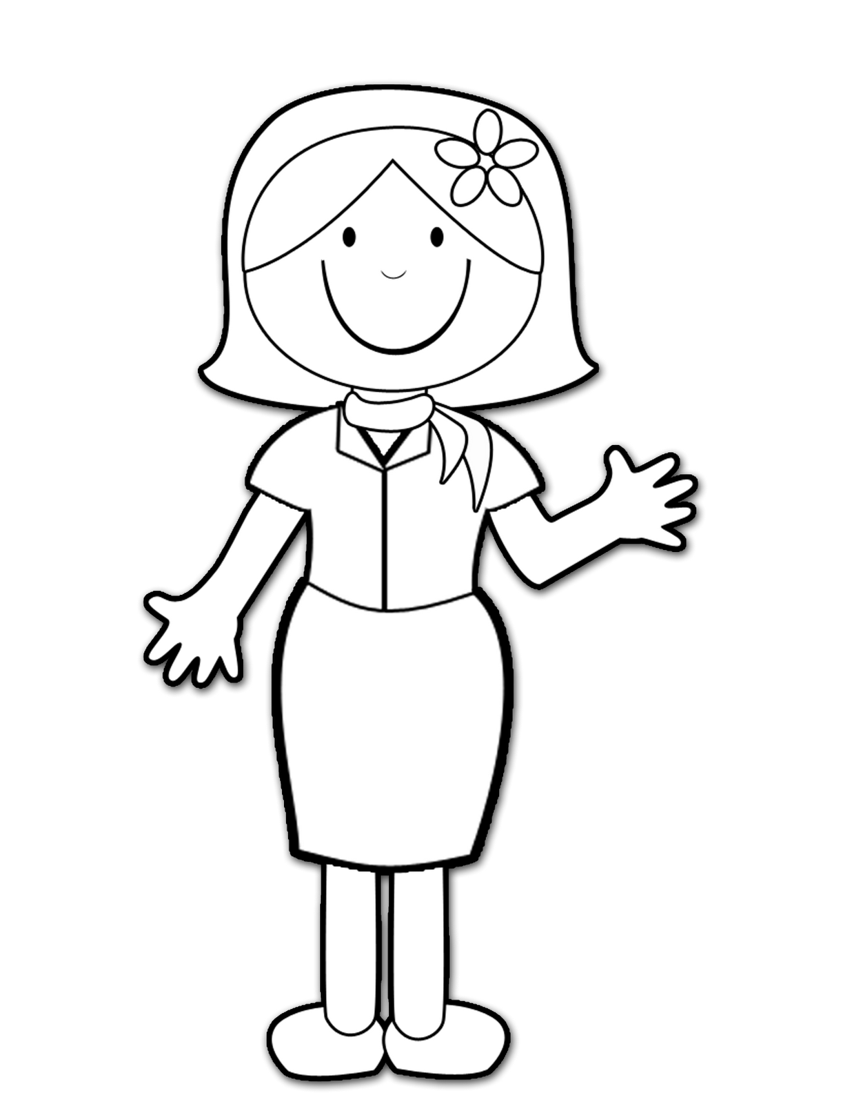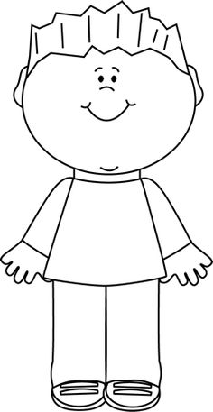

What Makes This Read-Aloud Complex?
- Quantitative Measure
Go to http://www.lexile.com/ and enter the title of your read-aloud in the Quick Book Search in the upper right of home page. Most texts will have a Lexile measure in this database.

Most of the texts that we read aloud in K-2 should be in the 2-3 or 4-5 band, more complex than the students can read themselves.
2-3 band 420-820L
4-5 band 740-1010L

AD 660L

- Qualitative Features
Consider the four dimensions of text complexity below. For each dimension*, note specific examples from the text that make it more or less complex.
This story is multi-purpose. It addresses animal needs, caring for animals, and using persuasion and imagination for problem solving.
It is important for students to understand that this book is realistic fiction and that the boy is using his imagination to come up with ideas and the illustrations are representative of his thoughts and ideas, not what is actually happening. This book also has alternating dialogue and it is not always explicit who is talking.

Some complex vocabulary with several words having multiple meanings, that students may not know.
Double meaning words: Carpet, Stump
Additional challenging vocabulary that not all students may understand: boulders, roost, moss, creep, multiply
It is important for students to have some prior background information of animal needs. These are not explicit in the text, but Brian does address all the needs of animals in his explanations.

Meaning/Purpose
Structure

Language
Knowledge Demands

*For more information on the qualitative dimensions of text complexity, visit http://www.achievethecore.org/content/upload/Companion_to_Qualitative_Scale_Features_Explained.pdf

- Reader and Task Considerations
What will challenge my students most in this text? What supports can I provide?

The alternating dialogue does not explicitly state who is talking (i.e. only one dialogue conversation
states, “said Mom.”) To help students understand the dialogue they will use puppets during the readings to show who is talking, when.

Challenging vocabulary with some words having double meanings. Provide student pictures or real life visuals of challenging words. Help students understand that some words have multiple meanings (carpet and stump). Some words should be told to students, while with others the teacher may guide the students to the meaning through using context clues. Create a chart of new vocabulary words with student friendly definitions and pictures.

How will this text help my students build knowledge about the world?

This book will help students build knowledge of animal needs, specifically what salamanders need. This book will also help students understand that it is not always clear who is talking in a story and it is important to read/listen closely to better understand. Lastly, it will help students learn to use their imagination and knowledge to construct persuasive arguments in order to get the things they want.

- Grade level
What grade does this book best belong in? 1st grade as a read-aloud

All content linked to within this resource was free for use when this resource was published in March 2018. Over time, the organizations that manage that external content may move or remove it or change the permissions. If the content is no longer available, please email info@studentsachieve.net.

