Grade 1: Unit 5, Week 22
Title: Amazing Animals
Essential Question: How do special animal body parts help them to survive?
Week 1 Comprehension
Knowledge Journal
- Read aloud the selection for the week.
- After you read, stop and think about what you learned and the questions. What did you learn that was new and important about the topic from this resource? Use large public notes (chart paper) or individual note catchers to capture student learning. Use the optional questions to prompt reflection; sample answers provided for teacher reference.

Sample Chart Responses
Title: Amazing Animals
Write, Draw, or List
Questions (optional) | New and important learning about the topic or evidence
How does the polar bear’s fur help it survive? | The polar bear’s fur helps it hide on the snow because it looks white. It also keeps the bear warm.
How does the elephant use its trunk and tusks? | The elephant uses it tusks to scrape bark off trees to eat. It uses its trunk to get drinks.
Name one of the camel’s body parts that help it live. | Camels need a hump to store food. Eyelashes keep sand out of their eyes.
Tell about the different ways a duck can move from one place to another. | A duck can walk or swim using webbed feet.
Describe how the giraffe, porcupine and turtle use their body parts to live. | A giraffe can hide with her spots. She uses her long neck to eat leaves high up in the trees. A porcupine has quills for protection. A turtle lives inside a hard shell to stay safe.
How do the dolphin’s body parts work? | The dolphin uses it tail flukes and flippers to swim and turn.
Anything else learned about the topic.
Written Response
Looking for the winner of the “Most Amazing Animal Adaptations Award.” Select an animal from the text you think should win. Submit a picture and tell why it is the MOST amazing of all! Use the information you learned from reading to tell why the animal should win.

Sample Student Response
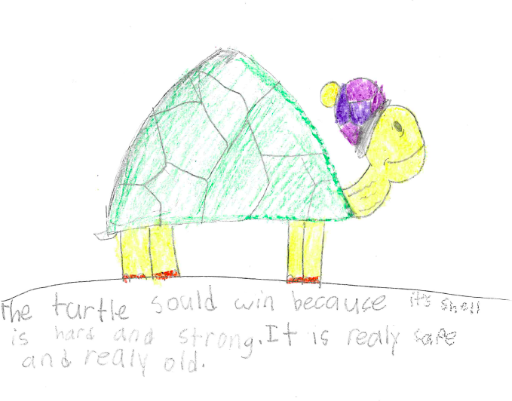
Week 2, Building Knowledge: Extending the Topic
Essential Question: How do special animal body parts help them to survive?
Cumulative Activities – The following activities could be completed and updated after reading each resource this week. The purpose of these activities is to capture knowledge building from one resource to the next and to provide a holistic snapshot of central ideas of the content covered in response to the essential question. It is recommended that the class and/or students complete one of the Cumulative Activities (Rolling Knowledge Journal or Rolling Vocabulary) for Week 2.

Rolling Vocabulary: “Fabulous Four” Sample
- Read each resource then, with students, pick 4 important words. The Rolling Vocabulary may be kept as a large public interactive chart with words and pictures or drawings.
- Collaboratively use the 4 words to write about the most important ideas of the text. You should have as many sentences as you do words.
- Continue this activity with EACH selection in the text set.
- After reading all the selections on the topic, go back and review your words.
- Now select the “Fabulous Four” words from ALL the word lists.
- Use the “Fabulous Four” words to write an interesting sentence or sentences about the topic.

Sample Student Response (with a few extra words)

Title | Four Vocabulary Words & Sentences (we listed a few extra)
Amazing Animals

Tiny Baby Kangaroos | Words: pouch, young, joey, until, families  - Baby kangaroos live in the mom’s pouch.  - Young kangaroos are as big as a fingernail.  - The joey comes out as it gets bigger.  - A joey drinks milk until it is one year old.  - Kangaroo families live together.
Baby Kangaroos | Words: pocket, protects, shares, adult, cozy, rest  - The momma kangaroo has a pocket called a pouch.  - The pouch protects the baby.  - The joey shares the pouch with a new baby sometimes.  - When the joey is one it is as big as an adult.  - The pouch is warm and cozy.  - The young kangaroo goes back in the pouch to rest.
How Animals Move | Words: begins, survive, carry, until, grow, young  - A baby giraffe begins to walk an hour after being born.  - Parents teach the young how to survive.  - Mother lions carry their babies in their mouths.  - Baby opossums ride in the pouch until they are 8 weeks old.  - Tadpoles grow legs to hop.  - Young animals learn to move from their parents.
How Animals Stay Safe | Words: protect, predator, swallow, spines  - Turtle shells protect them.  - Predators are enemies.  - Puffer fish swallow water to puff up and look big.  - Spines are like porcupine quills.
Let’s Talk About Insects | Words: beetle, sheds, abdomen, breathe, recyclers, food makers  - A beetle’s wings are like a shell for protection.  - A queen ant sheds her wings.  - Insects have abdomens in the middle of their bodies.  - Insects breathe through their abdomens.  - Ants and termites are recyclers.  - Bees are food makers.
What Do You Do With a Tail Like This? | Words: cricket, sounds, spray, ways, water strider, ledge  - Crickets hear through their ears on their knees!  - Humpback whales hear sounds hundreds of mile away.  - Skunks spray sticky spray to stay safe.  - Chameleons can look two ways at once.  - Water striders walk on water.  - Mountain goats leap from ledge to ledge.
National Geographic Kids Bird Guide of North America | Words: See Read Aloud lesson for words and definitions
Fabulous Four: protect, shells, quills, spines, predators
Summary :

Animals have body parts that protect them. Shells, quills and spines all help keep predators away.

Rolling Knowledge
- Read each selection in the set, one at a time.
- After you read each resource, stop and think what the big learning was. What did you already know about this from your other reading? Write or draw in the first box. This can be done collaboratively in small groups or individually depending on your students.
- What did you learn that was new and important about the topic from this resource? Write, draw, or list what you learned from the text about (topic).
Sample Student Response (most likely these would be drawings!)
Write, Draw, or List
Title | What I already knew from my other reading… | What I learned from reading this…
- Tiny Baby Kangaroos | Animals have body parts that protect them. | The kangaroo has a pouch to keep the baby safe.
- Baby Kangaroos | The kangaroo pouch is for the baby. | Sometimes a big baby and a new baby have to share the pouch!
- How Animals Move | Some animals keep the babies safe in pouches. | Parents teach the baby animals and keep them safe. Giraffes walk right after they are born.
- How Animals Stay Safe | Predators try to eat animals. | The spines keep the porcupine safe.
- Let’s Talk About Insects | Shells can protect animals. | The beetle’s wings are like a shell.
- What Do You Do With a Tail Like This? | Animal body parts help them survive. | Skunks spray to stay safe.
Written Response Week 2
Pretend you work at the zoo. You take a group of kids to visit different animal exhibits. Show them your favorite animal or animals from the text. What is this animal like? What body parts help it to survive in its habitat? Use information you learned from reading to describe the animal.

Sample Student Response
This is the porcupine. He has quills to keep predators away.

Picture a cute kid drawing here!

Name______________________________________ Date_______________

Title: Amazing Animals
Essential Question: How do special animal body parts help them to survive?

Title:
Write, Draw, or List
Questions | New and important learning about the topic or evidence

Writing

Looking for the winner of the “Most Amazing Animal Adaptations Award.” Select an animal from the text you think should win. Submit a picture and tell why it is the MOST amazing of all! Use the information you learned from reading to tell why the animal should win.

Drawing

______________________________________________________________________________
______________________________________________________________________________________________________________________________________________________________________________________________________________________________________________________________________________________________________________________________________________________________________________________________________
Building Knowledge: Extending the Topic
Essential Question: How do special animal body parts help them to survive?

Rolling Vocabulary
As you read each book, keep track of the new words you are learning. Collect the most important words from each book, website or video as you read and learn. Think about the words and write or draw a picture to help you remember them.

Title | Vocabulary Words & Sentences
Amazing Animals | Words:
Tiny Baby Kangaroos | Words:
Baby Kangaroos | Words:
How Animals Move | Words:
How Animals Stay Safe | Words:
Let’s Talk About Insects | Words:
What Do You Do With a Tail Like This? | Words:
National Geographic Kids Bird Guide of North America | Words:
Fabulous Four:
Summary:

Rolling Knowledge
As you read each book, keep track of what you are learning. Write and draw what you already knew in the box on the left. In the box on the right, write and draw about what you learned from this book.

Write, Draw, or List
Title | What I already knew from my other reading… | What I learned from reading this…
- Tiny Baby Kangaroos
- Baby Kangaroos
- How Animals Move
- How Animals Stay Safe
- Let’s Talk About Insects
- What Do You Do With a Tail Like This?

Written Response Week 2
Pretend you work at the zoo. You take a group of kids to visit different animal exhibits. Show them your favorite animal or animals from the text. What is this animal like? What body parts help it to survive in its habitat? Use information you learned from reading to describe the animal.

Student Response

______________________________________________________________________________
______________________________________________________________________________________________________________________________________________________________________________________________________________________________________________________________________________________________________________________________________________________________________________________________________

