GO Math! Grade 3 Chapter Test Alignment

This assessment guidance is designed as a companion to the Go Math K-5 Guidance Documents. It provides support for modifying GO Math! Chapter Tests to align to the changes recommended in the Guidance Documents. The changes include rationale, often guided by the Rule of Thumb for Assessments, provided in Part 2 of the Guidance documents:

- Eliminate any questions aligned to lessons/content that have been deleted.
- Add vetted questions aligned to lessons that have been added.
- Remove any directions in questions that require a specific strategy or model. Note: This is the only modification we will be making to questions.

In addition, the aspect(s) of rigor targeted by the standards for the chapter has been identified. Some changes to questions are based on alignment to the appropriate aspect of rigor.

Chapter 1
Based on the standards addressed in the chapter, this assessment should address the following aspects of rigor:
✓Procedural Skill/Fluency
✓Conceptual Understanding
Application

Grade 3 / Chapter 1: Addition and Subtraction
Problem # | Action (Keep/Modify/Delete) | Details for the Action | Rationale
1 | Delete |  | Guidance Document: Lesson deleted
2 | Delete |  | Guidance Document: Lesson deleted
3 | Keep
4 | Keep
5 | Keep
6 | Keep
7 | Keep
8 | Delete |  | Guidance Document: Lesson deleted
9 | Delete |  | Guidance Document: Chapter Rule of Thumb does not require students to name the properties.
10 | Modify | Add the equation: 349 + 508 = ___ under the question. | Aspects of Rigor: The standard targets fluency, but this is an application question.
11 | Modify | Add the equation: ____ = 349 - 246 under the question. | Aspects of Rigor: The standard targets fluency, but this is an application question.
12 | Keep | Question aligns to 3.OA.D.8
13 | Modify | Delete parts a-d and its corresponding directions. Add question: What is the sum? | Assessment Rule of Thumb: Question requires a specific strategy.
14 | Delete |  | Guidance Document: Lesson deleted
15 | Delete |  | Guidance Document: Lesson deleted
16 | Keep
17 | Modify | Delete the last sentence of the question and remove the bar model diagram. | Assessment Rule of Thumb: Question requires a specific strategy.
18 | Delete |  | Guidance Document: Lesson deleted
19 | Keep
20 | Keep

Questions to be added:
Added Lesson | Source | Question
1.7.1 | http://achievethecore.org/content/upload/Fluency%20Resources_G3_reduced.pdf | Use any of the addition problems from the Grade 3: Resources for Developing Grade-Level Fluency  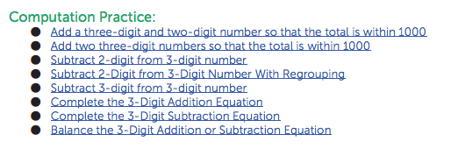
1.11.1 | http://achievethecore.org/content/upload/Fluency%20Resources_G3_reduced.pdf | Use any of the subtraction problems from the Grade 3: Resources for Developing Grade-Level Fluency
1.12.1 | http://www.carbonschools.org/webpages/msalas/files/3.oa.%208%20multi-step%20problems.pdf | 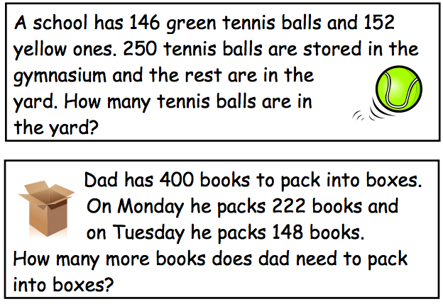

Chapter 2
Based on the standards addressed in the chapter, this assessment should address the following aspects of rigor:
✓Procedural Skill/Fluency
Conceptual Understanding
✓Application

Grade 3 / Chapter 2: Represent and Interpret Data
Problem # | Action (Keep/Modify/Delete) | Details for the Action | Rationale
1 | Delete |  | Guidance Document: Lessons deleted
2 | Delete |  | Guidance Document: Lessons deleted
3 | Keep
4 | Keep
5 | Keep
6 | Keep
7 | Keep
8 | Keep
9 | Keep
10 | Keep
11 | Keep
12 | Keep
13 | Keep
14 | Keep
15 | Keep
16 | Keep
17 | Keep
18 | Keep

Chapter 3
Based on the standards addressed in the chapter, this assessment should address the following aspects of rigor:
Procedural Skill/Fluency
✓Conceptual Understanding
✓Application

Grade 3 / Chapter 3: Understand Multiplication
Problem # | Action (Keep/Modify/Delete) | Details for the Action | Rationale
1 | Modify | Delete the last sentence. | Assessment Rule of Thumb: Question requires a specific model.
2 | Keep
3 | Delete |  | Guidance Document: Lesson deleted
4 | Keep
5 | Keep
6 | Delete |  | Guidance Document: Lesson deleted
7 | Delete |  | Aspects of Rigor: The standard targets application but this question assesses vocabulary.  See footnote on 3.OA.B.5
8 | Keep | Question aligns to 3.OA.A.3
9 | Delete |  | Guidance Document: Lesson deleted
10 | Delete |  | Guidance Document: Lesson deleted
11 | Keep
12 | Keep
13 | Modify | Delete part B. | Aspects of Rigor: The standard targets application but part B of the question assesses vocabulary.  See footnote on 3.OA.B.5
14 | Delete |  | Guidance Document: Lesson deleted
15 | Delete |  | Guidance Document: Lesson deleted
16 | Keep
17 | Keep
18 | Keep
19 | Delete |  | Guidance Document: Lesson deleted

Questions to be added:
Added Lesson | Source | Question
3.4.1 | EngageNY, Grade 3,  Module 1,  End of Module Assessment: #1a | 1. Mr. Lewis arranges all the desks in his classroom into 6 equal groups of 4. How many desks are in his classroom?  a. What does the product in your multiplication sentence represent?

Chapter 4
Based on the standards addressed in the chapter, this assessment should address the following aspects of rigor:
✓Procedural Skill/Fluency
Conceptual Understanding
✓Application

Grade 3 / Chapter 4: Multiplication Facts and Strategies
Problem # | Action (Keep/Modify/Delete) | Details for the Action | Rationale
1 | Modify | Delete second paragraph. Insert “Show or explain how you solved the problem.” | Assessment Rule of Thumb: Question requires a specific strategy.
2 | Keep
3 | Keep
4 | Modify | Add the equation: 5 x 7 = ___ under the question. | Aspects of Rigor: The standard targets procedural fluency but this is an application question.
5 | Delete |  | Guidance Document: Lessons deleted
6 | Delete |  | Question does not address a grade 3 standard; it is more closely aligned to 4.OA.B.4.
7 | Keep
8 | Modify | Add the equation: 6 x 8 = ___ under the question. | Aspects of Rigor: The standard targets procedural fluency but this is an application question.
9 | Keep
10 | Keep
11 | Keep | Question aligns to 3.OA.B.5.
12 | Delete |  | Question aligns to 3.OA.B.6 which is introduced in Chapter 6.
13 | Modify | Delete the last paragraph and the array. | Assessment Rule of Thumb: Question requires a specific model.
14 | Keep
15 | Delete |  | Guidance Document: Lesson deleted
16 | Keep
17 | Keep
18 | Keep | Question aligns to 3.OA.C.7.
19 | Keep
20 | Keep
21 | Delete |  | Guidance Document: Lesson deleted
22 | Keep
23 | Modify | Delete the question and number line. Add: “What is the product of 3 x 8?” | Assessment Rule of Thumb: Question requires a specific model.

Questions to be added:
Added Lesson | Source | Question
4.3.1 | Engage NY, Grade 3, Module 1, End of Module Assessment: #3a-b | 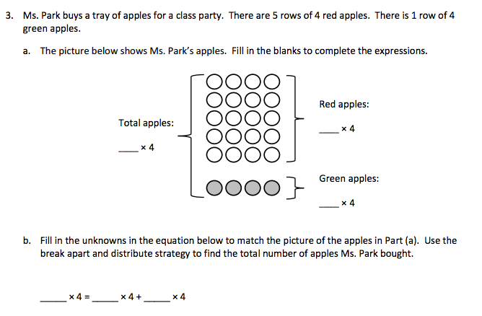  In Part B, delete the last sentence and add, “Find the total number of apples Ms. Park bought.”  NOTE: This two-part question addresses both added lessons.
4.3.2
4.9.1 | GO Math!, Chapter 3 Test, #10

Chapter 5
Based on the standards addressed in the chapter, this assessment should address the following aspects of rigor:
✓Procedural Skill/Fluency
✓Conceptual Understanding
✓Application

Grade 3 / Chapter 5: Use Multiplication Facts
Problem # | Action (Keep/Modify/Delete) | Details for the Action | Rationale
1 | Keep
2 | Delete |  | Guidance Document: Chapter Rule of Thumb does not require students to name the properties
3 | Keep
4 | Keep | Question aligns to 3.OA.B.5
5 | Keep
6 | Keep
7 | Modify | Delete “use the number line to” and the number line.  Add: 3 x 40 = ___ and “show or explain your thinking.” | Assessment Rule of Thumb: Question requires a specific model.  Aspects of Rigor: The standard targets procedural skill but this is an application question.
8 | Keep
9 | Keep
10 | Modify | Add the equation: 3 x 2 x 20 = ___ | Aspects of Rigor: The standard targets procedural skill but this is an application question.
11 | Keep
12 | Keep
13 | Keep
14 | Keep
15 | Modify | Change the last sentence of the first paragraph to “Use the equation to help you find how many boxes, n, he needs.”  Add the equation: n x 30 = 180  Delete the first sentence of the last paragraph. | Aspects of Rigor: The standard targets procedural skill but this is an application question.
16 | Modify | Delete the last paragraph. The grid can be optional. Add: Explain or show the strategy you used to solve. | Assessment Rule of Thumb: Question requires a specific strategy.
17 | Keep
18 | Keep

Questions to be added:
Added Lesson | Source | Question
5.5.1 | GO Math!, Chapter 5 Test, #1, 3, 6 | Questions from lesson 5.2 are already included in the assessment.

Chapter 6
Based on the standards addressed in the chapter, this assessment should address the following aspects of rigor:
✓Procedural Skill/Fluency
✓Conceptual Understanding
✓Application
Grade 3 / Chapter 6: Understand Division
Problem # | Action (Keep/Modify/Delete) | Details for the Action | Rationale
1 | Keep
2 | Keep
3 | Modify | Delete the last paragraph and the grid. | Assessment Rule of Thumb: Question requires a specific model.
4 | Modify | Delete the last paragraph and the picture. | Assessment Rule of Thumb: Question requires a specific model.
5 | Keep | Delete the bar model. | Assessment Rule of Thumb: Question requires a specific model.
6 | Keep | Question aligns to 3.OA.A.3
7 | Delete |  | Guidance Document: Lesson deleted
8 | Keep
9 | Keep
10 | Keep
11 | Keep
12 | Modify | Delete the bar model. | Assessment Rule of Thumb: Question requires a specific model.
13 | Keep
14 | Keep
15 | Delete |  | Guidance Document: Lesson deleted
16 | Keep | Question aligns to 3.OA.A.3
17 | Modify | Delete the second paragraph and the box for student drawings. | Assessment Rule of Thumb: Question requires a specific model.
18 | Keep
19 | Keep
20 | Keep | Delete “show your work.” Leave the 6 circles as optional. | Assessment Rule of Thumb: Question requires a specific model.

Chapter 7
Based on the standards addressed in the chapter, this assessment should address the following aspects of rigor:
✓Procedural Skill/Fluency
Conceptual Understanding
✓Application

Grade 3 / Chapter 7: Division Facts and Strategies
Problem # | Action (Keep/Modify/Delete) | Details for the Action | Rationale
1 | Keep
2 | Keep | Question aligns to 3.OA.1.2
3 | Keep
4 | Keep
5 | Modify | Delete the repeated subtraction model. In the last sentence delete, “to represent the repeated subtraction.” | Assessment Rule of Thumb: Question requires a specific model.
6 | Keep
7 | Keep
8 | Delete |  | Guidance Document: Lesson deleted
9 | Keep
10 | Delete |  | Assessment Rule of Thumb: Question requires a specific model.
11 | Keep | Question aligns to 3.OA.A.3
12 | Keep
13 | Keep
14 | Delete |  | Guidance Document: Lesson deleted
15 | Keep | Question aligns to 3.OA.A.3
16 | Keep | Part A of question aligns to 3.OA.4.9
17 | Keep
18 | Keep
19 | Keep | Question aligns to 3.OA.A.3
20 | Modify | Delete the last sentence of Part B. | Guidance Document: Order of Operations is not in the Grade 3 standards.

Questions to be added:
Added Lesson | Source | Question
7.9.1 | A and C:  https://www.illustrativemathematics.org/content-standards/3/OA/A/3/tasks/365  B:  https://www.illustrativemathematics.org/content-standards/3/OA/A/3/tasks/344 | 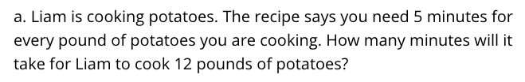  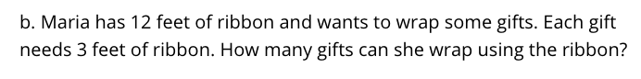  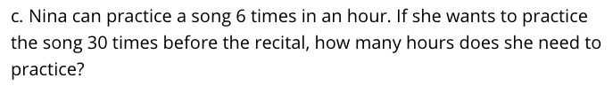
7.9.2 | http://www.cpalms.org/Public/PreviewResourceAssessment/Preview/41309 | 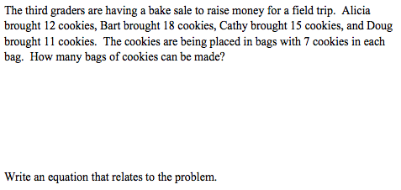
Chapter 8
Based on the standards addressed in the chapter, this assessment should address the following aspects of rigor:
Procedural Skill/Fluency
✓Conceptual Understanding
Application

Grade 3 / Chapter 8: Understand Fractions
Problem # | Action (Keep/Modify/Delete) | Details for the Action | Rationale
1 | Delete |  | Guidance Document: Lesson deleted
2 | Keep
3 | Keep
4 | Keep
5 | Delete |  | Guidance Document: Lesson deleted
6 | Delete |  | Guidance Document: Lesson deleted
7 | Delete |  | Guidance Document: Lesson deleted
8 | Keep
9 | Delete |  | Guidance Document: Lesson deleted
10 | Keep
11 | Delete |  | Guidance Document: Lesson deleted
12 | Delete |  | Guidance Document: Lesson deleted
13 | Keep
14 | Delete |  | Guidance Document: Lesson deleted
15 | Delete |  | Guidance Document: Lesson deleted
16 | Delete |  | Guidance Document: Lesson deleted
17 | Keep
18 | Keep
19 | Keep

Questions to be added:
Added Lesson | Source | Question
8.1.1 | http://www.cpalms.org/Public/PreviewResourceAssessment/Preview/43394 | 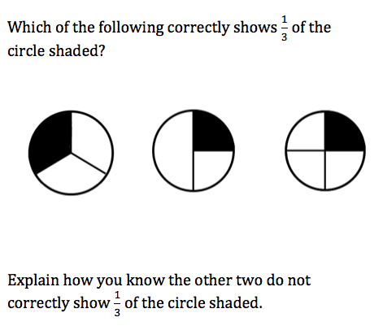
8.5.1 | EngageNY, Grade 3, Module 5, End of Module Assessment: #1 | 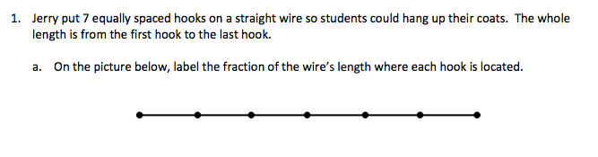
8.5.2 | EngageNY, Grade 3, Module 5, End of Module Assessment: #4a | 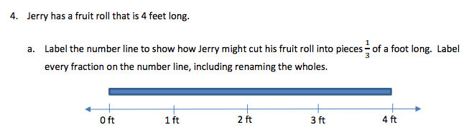

Chapter 9
Based on the standards addressed in the chapter, this assessment should address the following aspects of rigor:
✓Procedural Skill/Fluency
✓Conceptual Understanding
Application

Grade 3 / Chapter 9: Compare Fractions
Problem # | Action (Keep/Modify/Delete) | Details for the Action | Rationale
1 | Keep
2 | Keep
3 | Keep
4 | Delete |  | Guidance Document: Lesson deleted
5 | Delete |  | 3.NF.A.3d addresses comparison of fractions with the same numerator or denominator.
6 | Keep
7 | Keep
8 | Modify | Delete the last sentence. Add, “Explain how you know the fractions are equivalent.” | Assessment Rule of Thumb: question requires a specific model.
9 | Delete |  | 3.NF.A.3d addresses comparison of fractions with the same numerator or denominator.
10 | Keep
11 | Keep
12 | Delete |  | Guidance Document: Lesson deleted
13 | Delete |  | Guidance Document: Lesson deleted
14 | Delete |  | Guidance Document: Lesson deleted
15 | Delete |  | Guidance Document: Lesson deleted
16 | Delete |  | Guidance Document: Lesson deleted
17 | Delete |  | Guidance Document: Lesson deleted
18 | Keep
19 | Delete |  | Guidance Document: Lesson deleted
20 | Keep

Questions to be added:
Added Lesson | Source | Question
9.4.1 | https://www.illustrativemathematics.org/content-standards/3/NF/A/3/tasks/871 | 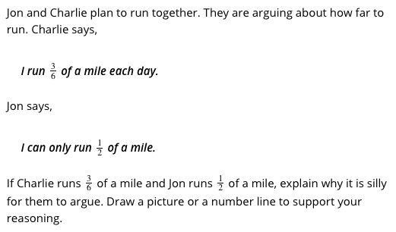  Modify the last sentence to, “Support your reasoning with pictures, numbers, and/or words.”
9.4.2 | From Howard County, Quarter 2, Assessment Task 6:  https://hcpss.instructure.com/courses/97/pages/3-dot-nf-dot-3-assessment-tasks?module_item_id=16861 | 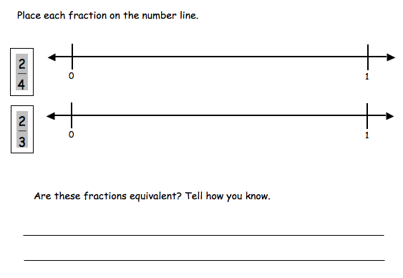
9.4.3 | https://www.illustrativemathematics.org/content-standards/3/NF/A/3/tasks/1356 | 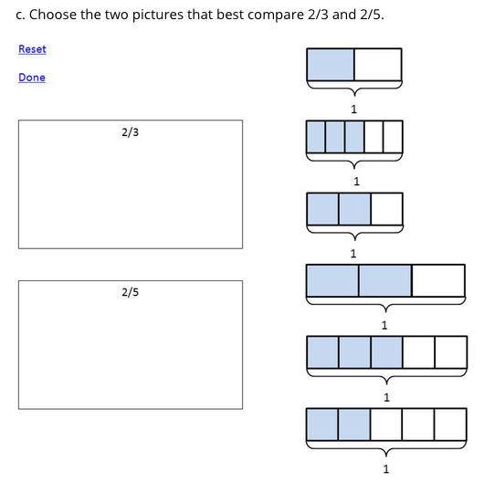  This task can also be done online.
9.7.1 | Engage NY, Grade 3, Module 5, End of Module Assessment: #2 | 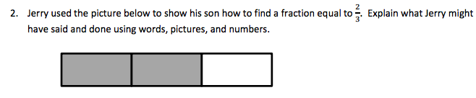  Add, “Write an equivalent fraction to ⅔.”
9.7.2 | From Howard County, Grade 3, Quarter 2, Assessment 4 Tasks:  https://hcpss.instructure.com/courses/97/pages/3-dot-nf-dot-3-assessment-tasks?module_item_id=16861 | 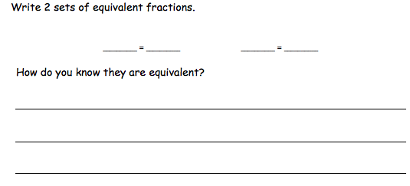

Chapter 10
Based on the standards addressed in the chapter, this assessment should address the following aspects of rigor:
✓Procedural Skill/Fluency
Conceptual Understanding
✓Application

Grade 3 / Chapter 10: Time, Length, Liquid Volume and Mass
Problem # | Action (Keep/Modify/Delete) | Details for the Action | Rationale
1 | Modify | Change “26 minutes” to “20 minutes.” | Guidance Document: 3.MD.A.1 does not require students to solve problems involving crossing the hour.
2 | Keep
3 | Delete |  | Guidance Document: 3.MD.A.1 does not require students to solve problems involving crossing the hour.
4 | Delete |  | Guidance Document: Lesson deleted
5 | Keep
6 | Delete |  | Guidance Document: Lesson deleted
7 | Modify | Change “8:05” to “8:00.” | Guidance Document: 3.MD.A.1 does not require students to solve problems involving crossing the hour.
8 | Keep
9 | Keep
10 | Keep
11 | Keep
12 | Delete |  | Guidance Document: Lesson deleted
13 | Keep | Question aligns to 3.OA.D.8
14 | Keep
15 | Modify | Change 3 hours and 16 minutes to 24 minutes. | 3.MD.A.1 limits to time intervals in minutes
16 | Keep
17 | Keep
18 | Keep

Questions to be added:
Added Lesson | Source | Question
10.9.1 | Engage NY, Grade 3, Module 2, End of Module Assessment: #5d | 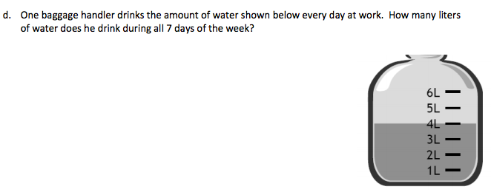

Chapter 11
Based on the standards addressed in the chapter, this assessment should address the following aspects of rigor:
✓Procedural Skill/Fluency
✓Conceptual Understanding
✓ Application

Grade 3 / Chapter 11: Perimeter and Area
Problem # | Action (Keep/Modify/Delete) | Details for the Action | Rationale
1 | Keep
2 | Keep
3 | Keep
4 | Keep
5 | Keep
6 | Keep
7 | Keep
8 | Keep
9 | Keep
10 | Keep
11 | Keep
12 | Delete |  | Guidance Document: Lesson deleted
13 | Keep
14 | Keep
15 | Keep
16 | Delete |  | Guidance Document: Lesson deleted

Questions to be added:
Added Lesson | Source | Question
11.7.1 | Engage NY, Grade 3, Module 4, Mid-Module Assessment: #3
11.7.2 | Task 2:  http://3-5cctask.ncdpi.wikispaces.net/3.MD.5-3.MD.7 | 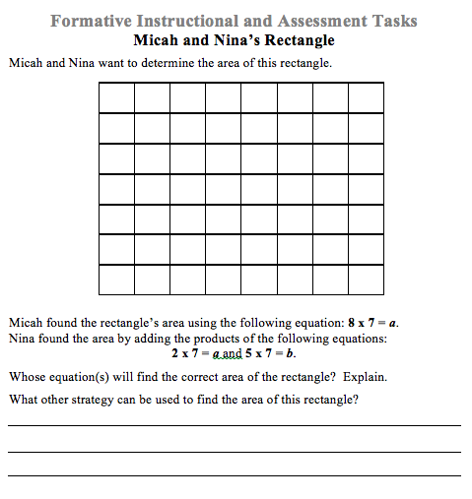
11.8.1 | http://www.cpalms.org/Public/PreviewResourceAssessment/Preview/46897 | 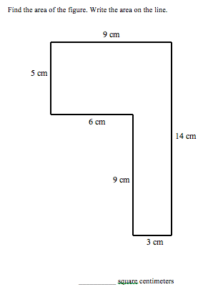
11.10.1 | Task 2:  http://3-5cctask.ncdpi.wikispaces.net/3.MD.8 | 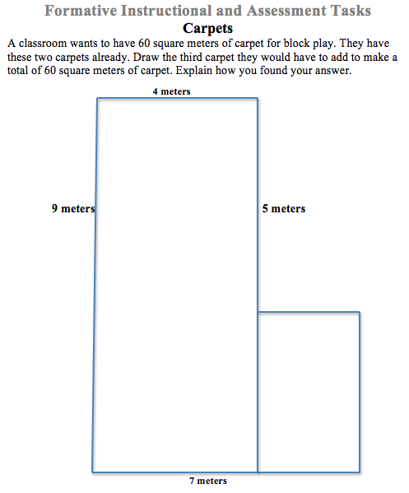
Chapter 12
Based on the standards addressed in the chapter, this assessment should address the following aspects of rigor:
✓Procedural Skill/Fluency
✓Conceptual Understanding
Application

Grade 3 / Chapter 12: Two-Dimensional Shapes
Problem # | Action (Keep/Modify/Delete) | Details for the Action | Rationale
1 | Keep
2 | Keep
3 | Delete |  | Guidance Document: Lesson deleted
4 | Delete |  | Guidance Document: Lesson deleted
5 | Delete |  | Guidance Document: Lesson deleted
6 | Delete |  | Guidance Document: Lesson deleted
7 | Keep
8 | Keep
9 | Delete |  | Guidance Document: Lesson deleted
10 | Delete |  | Guidance Document: Lesson deleted
11 | Keep
12 | Delete |  | Guidance Document: Lesson deleted
13 | Keep
14 | Keep
15 | Keep
16 | Delete |  | Guidance Document: Lesson deleted
17 | Keep
18 | Delete |  | Guidance Document: Lesson deleted

