Title/Author: Ox-Cart Man by Donald Hall
Suggested Time to Spend: Days 4 days-60 minutes per day
Common Core grade-level ELA/Literacy Standards: RL.2.1, RL.2.2, RL.2.3, RL.2.7, RL.2.10; W.2.8; SL.2.1, SL.2.2, SL.2.6; L.2.1, L.2.2
Lesson Objective:
Students will listen to a literary text read aloud and use literacy skills (reading, writing, discussion, and listening) to understand and compare life in the 19th Century to modern day.

Teacher Instructions
Before the Lesson
- Read the Big Ideas and Key Understandings and the Synopsis below. Please do not read this to the students. This is a description to help you prepare to teach the book and be clear about what you want your children to take away from the work.
Big Ideas/Key Understandings/Focusing Question
Students come to understand how life changes over time and identify some of the causes of those changes. Students also come to understand that life works in a continuous cycle.
Synopsis
The story begins in the 1900s with the ox-cart man and his family loading his cart with goods they produced over the year. He journeyed to the market to sell these things, including his ox and cart. He also purchased a few items to take back to his family. After he returned home the family began their cycle of producing goods that will be sold at the market the next year. The economic survival of the farmer is dependent upon the condition of each season.
- You will of course evaluate text complexity with your own students in mind, and make adjustments to the lesson pacing and even the suggested activities and questions.
- Read the entire book, adding your own insights to the understandings identified. Also note the stopping points for the text-inspired questions and activities. Hint: you may want to copy the questions vocabulary words and activities over onto sticky notes so they can be stuck to the right pages for each day’s questions and vocabulary work.
- Consider pairing this series of lessons on Ox-Cart Man with a text set to increase student knowledge and familiarity with the topic. A custom text set can be found here. Note: This is particularly supportive of ELL students.

Note to teachers of English Language Learners (ELLs): Read Aloud Project Lessons are designed for children who cannot read yet for themselves. They are highly interactive and have many scaffolds built into the brief daily lessons to support reading comprehension. Because of this, they are filled with scaffolds that are appropriate for English Language Learners who, by definition, are developing language and learning to read (English). This read aloud text includes complex features which offer many opportunities for learning, but at the same time includes supports and structures to make the text accessible to even the youngest students.
This lesson includes features that align to best practices for supporting English Language Learners. Some of the supports you may see built into this, and /or other Read Aloud Project lessons, assist non-native speakers in the following ways:

- These lessons include embedded vocabulary scaffolds that help students acquire new vocabulary in the context of reading. They feature multi-modal ways of learning new words, including prompts for where to use visual representations, the inclusion of student-friendly definitions, built-in opportunities to use newly acquired vocabulary through discussion or activities, and featured academic vocabulary for deeper study.
- These lessons also include embedded scaffolds to help students make meaning of the text itself. It calls out opportunities for paired or small group discussion, includes recommendations for ways in which visuals, videos, and/or graphic organizers could aid in understanding, provides a mix of questions (both factual and inferential) to guide students gradually toward deeper understanding, and offers recommendations for supplementary texts to build background knowledge supporting the content in the anchor text.
- These lessons feature embedded supports to aid students in developing their overall language and communication skills by featuring scaffolds such as sentence frames for discussion and written work (more guidance available here) as well as writing opportunities (and the inclusion of graphic organizers to scaffold the writing process). These supports help students develop and use newly acquired vocabulary and text-based content knowledge.

The Lesson – Questions, Activities, and Tasks

Questions/Activities/Vocabulary/Tasks | Expected Outcome or Response (for each)
DAY ONE  PRE-READING:  Lead a brief class discussion in which students answer questions such as,  “What do you know about life in the past?  How is it different than the way we live?  Where did people live?  How did they get food/clothes?”  Show the front cover of The Ox-Cart Man. Ask students, “What details do you see on the front cover that show the setting of the text?”  “Do you think the setting of this story is in the past or present?” | They didn’t have grocery stores or department stores.  They couldn’t just go and buy everything they needed.  They didn’t have easy access to goods and services.  Today we have easy access to goods and services and we do not have to make these items for ourselves.  People lived in more rural areas (country).  They had to grow food and/or make/sew their clothes.  Details on Front cover: They do not have cars. They use a wagon pulled by an ox.  We see that it’s a farm because we see the barn.  It is fall. We know this because of the leaves on the ground.  It is in the past because of the wagon and the way the ox-cart man is dressed.
DAY ONE  FIRST READING:  Pull the students together or use a document camera so that all can enjoy the illustrations. Read aloud the entire book (or chapter) with minimal interruptions. Stop to provide word meanings or clarify only when you know the majority of your students will be confused.  After the first read, build a vocabulary display on the wall that can be used throughout the unit that students can rely on in their writings.  - Prompt students to identify words related to the unit focus (e.g. ox, wool, loom, yarn, linen, shingles, birch, barrel, flax) and words from word families or those with related or multiple meanings (e.g., sheared, spun/spinning, split, tapped, tucked, stitching, whittling, embroidered).  - Class discussion on the word wall. If time allows, split students in groups and assign each group a word or two (depends on group), have them discuss their meaning of the word within the groups, and then have each group share out. As each group shares out, add the synonyms to the wall.  - Class Discussion: As a class, ask and answer questions about the text so students can demonstrate understanding of key details. Encourage students to ask questions by providing question stems or conversation starters and developing a routine to ensure that all students are participating in the question asking and answering. | The goal here is for students to enjoy the book, both writing and pictures, and to experience it as a whole. This will give them some context and sense of completion before students read the book themselves.  Conversation starters-  - Sample questions for The Ox-Cart Man:  - Where is the ox-cart man going? Why? (RL.2.7)  - What does the ox-cart man do at the market? Why is the market important to the family’s survival? Why is the oxcart man important to the market? (RL.2.3, RL.2.7)  - What does the family do during the winter, spring, and summer to prepare for the fall market?
  wool | sheep’s hair
  ox | adult male from bovine family
  yarn | thread
  linen | fabric
DAY TWO  Second Reading:  - Review vocabulary display using one of the following strategies: cheerleading vocabulary, vocabulary charades, word mapping, mix, freeze, pair, etc.  - On the first page of the book discuss the illustration using Turn and Talk and having students share out what they discussed. After discussing the illustration, use cloze reading to read the text on the following page. Continue reading the entire book using this process.  - How would you describe the farmer and his family? What type of people are they? How do you know?  - How does each member of the family contribute to the way they make their living?  - How does the climate of each season affect the work of a farmer?  - What problems interfere with a farmer’s ability to do his/her job? What does a farmer do to solve his/her problems? | First Illustration-Season is fall. There is a barn and there is wood cut and stored. Ox-cart man is dressed to go to the market.  - These are hardworking people because they all help with the chores.  - Daughter sews; son whittles with his knife; father carved a yoke, sawed planks and split shingles. Everyone made candles, and tapped the trees for maple. They all sheared and planted crops.  - Each climate of each season determines which product can be produced. For example, in winter products that can be made indoors are produced: creating a yoke and wagon; creating linen, carving brooms and making candles. This is also the season when sugar maple trees are tapped. In spring, the family shears the sheep, spun yarn, and planted crops.  - Problems that a farmer might face are harsh weather may keep him from planting. Sheep may get sick and may not be able to be sheared. Plowing is a hard tedious job. He solves his problems by adapting to the weather and using things he has made to help him plow and uses an ox to help him. He also has his whole family to help him.
DAY THREE

THIRD READING:

- Read the text again using the choral reading strategy
- Present students with a power point of farming of then and now allowing students to partner talk about each slide. Might want to include the following types of pictures: a plow on an animal vs. a tractor, a wagon vs. a truck, a stove to an open fire, etc. After each slide students will partner talk about the similarities/differences between then and now.
- Create a class then and now chart out of bulletin paper
THEN | NOW | PURPOSE OF CHANGE
OX/PLOW | TRACTOR | Easier to use  Takes less time

Then allow students time to finish the chart with a partner using the book as a resource.
- Using the students’ examples allow time to finish the class chart. Class chart will remain up for future activities.

FINAL DAY WITH THE BOOK - Culminating Task
Day Four
FOURTH AND BEYOND:
- Review vocabulary using a fun and engaging strategy.
- Students read the book a fourth time using paired reading.
- Review the chart discussing the purpose of change. Have students respond to the following prompt: “Write a letter to the ox-cart man explaining to him how life has changed since he was alive. Use events from the story and current-day examples. Explain some of the causes for why life is different now. Make sure to use a proper greeting and closing.” Demonstrate command of proper grammar, usage, punctuation, and spelling, and use grade-appropriate words and phrases.

Teacher Notes: Sample response to culminating task:

Dear Mr. OX-Cart Man,
Life has really changed since you were alive. Your family had to grow food on the farm to eat and sell at market, but we now can go buy our groceries at a store. Travel in your day was by ox-cart and took up to ten days to go to market. We can drive by car to stores in a few minutes. Because we have stores and can get there quickly, our clothes can be bought at the mall or Walmart. But your family had to make the fabric from sheep’s wool using a loom. Life is easier today because of many creations throughout the years. I think you would appreciate our modern-day inventions.
Sincerely yours,
(Second Grade Student)

• Students are asked to identify what is the same and what is different between life now and the setting and events of The Ox-Cart Man. (RL.2.1, RL.2.2, RL.2.3, RL.2.7, W.2.2)
They should include examples to support the differences they chose, and use a proper greeting and closing for the letter. (L.2.2b)
The completed writing should use words from the word display. (L.2.6)
• Students should write in complete sentences, using adjectives and adverbs properly. (L.2.1e, f)
The writing should demonstrate grade-appropriate grammar and usage, capitalization, punctuation, and spelling. (L.2.1a-d, L.2.2c-e)
• Use teacher conferencing and small-group work to target student weaknesses and improve student writing ability. (W.2.5)
• If time allows, help students publish their letters using technology. (W.2.6)

Vocabulary
These words merit less time and attention  (They are concrete and easy to explain, or describe events/  processes/ideas/concepts/experiences that are familiar to your students) | These words merit more time and attention  (They are abstract, have multiple meanings, and/or are a part  of a large family of words with related meanings. These words are likely to describe events, ideas, processes or experiences that most of your student will be unfamiliar with)
Page 3 wool - fine, soft, curly hair of a sheep  Page 2 ox – the adult male of the bovine family  Page 3 yarn – thread used for knitting and weaving Page 5 linen – fabric woven from yarn  Page 5 shingles – a thin piece of wood to cover roofs | Page 3 loom - hand operated tool for weaving fabrics  Page 5 birch – a tree  Page 5 flax – a plant where fibers are turned into linen

Extension learning activities for this book and other useful resources
- Help students build background knowledge about farming by watching informational videos or reading informational texts. Note: This is particularly supportive of English Language Learners
  - https://www.youtube.com/watch?v=TgoYoc8oBFw
  - A Year on the Farm by Holly Dufek

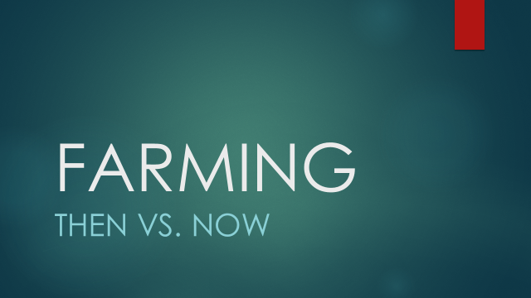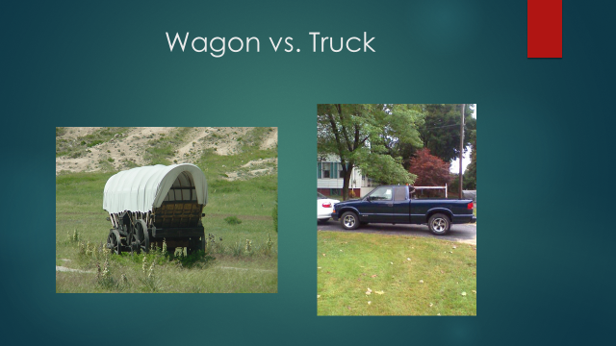

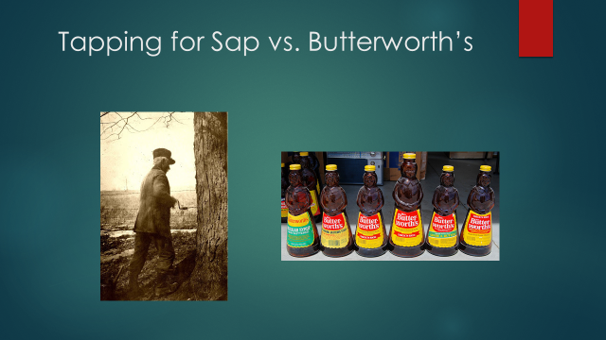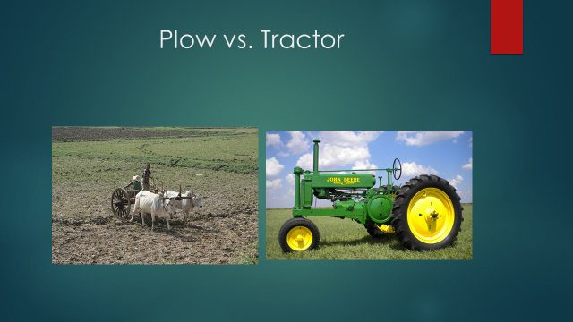

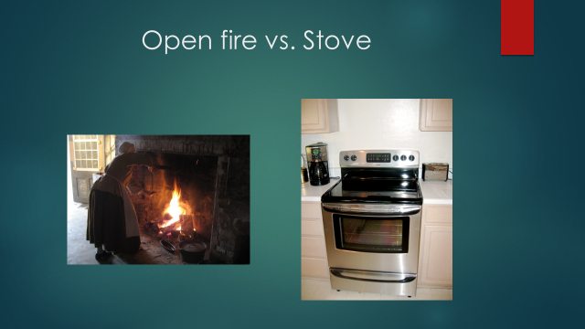
What Makes This Read-Aloud Complex?
- Quantitative Measure
Go to http://www.lexile.com/ and enter the title of your read-aloud in the Quick Book Search in the upper right of home page. Most texts will have a Lexile measure in this database.

1130
Most of the texts that we read aloud in K-2 should be in the 2-3 or 4-5 band, more complex than the students can read themselves.
2-3 band 420-820L
4-5 band 740-1010L

- Qualitative Features
Consider the four dimensions of text complexity below. For each dimension*, note specific examples from the text that make it more or less complex.

This story depicts an early farm family’s way of life in the 19th century explain the economic living in this period.

The book begins at the end and then shows us how he and his family got to that point. It shows the cycle of the seasons. There are illustrations for each page to help students visualize the time period.

The vocabulary is relevant to the 1900s:
(Whittling, yoke, loom, Barlow knife, sap)
Figurative language:
“Dropping feathers as soft as clouds”

Some students will need background on farming and market use in the 1900s. They should understand how children had important jobs around the home at that time.

Meaning/Purpose
Structure

Language
Knowledge Demands

*For more information on the qualitative dimensions of text complexity, visit http://www.achievethecore.org/content/upload/Companion_to_Qualitative_Scale_Features_Explained.pdf

- Reader and Task Considerations
What will challenge my students most in this text? What supports can I provide?

The vocabulary will be challenging.

How will this text help my students build knowledge about the world?
The support is the powerpoint and the illustrations.

- Grade level
What grade does this book best belong in?
As a read-aloud, this book is best used in second grade.

All content linked to within this resource was free for use when this resource was published in March 2018. Over time, the organizations that manage that external content may move or remove it or change the permissions. If the content is no longer available, please email info@studentsachieve.net.

