Title/Author: The Fisherman and His Wife by the Brothers Grimm
Suggested Time to Spend: 3 days (Recommendation: 1 hour a day for 3 days)
Common Core grade-level ELA/Literacy Standards: RI.1.1, RI.1.2, RI.1.3; W.1.1, W.1.8; SL.1.1, SL.1.2, SL.1.4, SL.1.6; L.1.1, L.1.2, L.1.4
Lesson Objective:
Students will describe how the wife’s greed caused her and her husband to lose everything they were given by the enchanted fish.

Teacher Instructions
- Read the Big Ideas and Key Understandings and the Synopsis below. Please do not read this to the students. This is a description to help you prepare to teach the book and be clear about what you want your children to take away from the work.
Focus question
What is greed? Which character showed greediness? One key takeaway is that greed is a selfish desire to have more of something. The wife was the greedy character because she is never happy with what she was granted and wanted more from the fish.
Synopsis
There once was a poor fisherman and his wife who lived in a pigsty by the seaside. The fisherman goes fishing one day and comes across a fish who was actually an enchanted prince. The fisherman went home to tell his wife about the fish and his wife insisted he go back and ask the fish for something. First she sent the husband to ask for a snug cottage. They were granted the cottage. The wife wasn’t happy enough with the cottage so she then sent her husband to ask for a castle. The wife continually isn’t happy with what she is granted and continues to send the husband to ask for better/more glorious things. In the end the husband and wife return home to the original pigsty they began with because the wife was too greedy and upset the enchanted fish.
- Go to the last page of the lesson and review “What Makes This Read-Aloud Complex.” This was created for you as part of the lesson and will give you guidance about what the lesson writers saw as the sources of complexity or key access points for this book. You will of course evaluate text complexity with your own students in mind, and make adjustments to the lesson pacing and even the suggested activities and questions.
- Read the entire book, adding your own insights to the understandings identified. Also note the stopping points for the text-inspired questions and activities. Hint: you may want to copy the questions, vocabulary words and activities over onto sticky notes so they can be stuck to the right pages for each day’s questions and vocabulary work.

Note to teachers of English Language Learners (ELLs): Read Aloud Project Lessons are designed for children who cannot read yet for themselves. They are highly interactive and have many scaffolds built into the brief daily lessons to support reading comprehension. Because of this, they are filled with scaffolds that are appropriate for English Language Learners who, by definition, are developing language and learning to read (English). This read aloud text includes complex features which offer many opportunities for learning, but at the same time includes supports and structures to make the text accessible to even the youngest students.
This lesson includes features that align to best practices for supporting English Language Learners. Some of the supports you may see built into this, and /or other Read Aloud Project lessons, assist non-native speakers in the following ways:

- These lessons include embedded vocabulary scaffolds that help students acquire new vocabulary in the context of reading. They feature multi-modal ways of learning new words, including prompts for where to use visual representations, the inclusion of student-friendly definitions, built-in opportunities to use newly acquired vocabulary through discussion or activities, and featured academic vocabulary for deeper study.
- These lessons also include embedded scaffolds to help students make meaning of the text itself. It calls out opportunities for paired or small group discussion, includes recommendations for ways in which visuals, videos, and/or graphic organizers could aid in understanding, provides a mix of questions (both factual and inferential) to guide students gradually toward deeper understanding, and offers recommendations for supplementary texts to build background knowledge supporting the content in the anchor text.
- These lessons feature embedded supports to aid students in developing their overall language and communication skills by featuring scaffolds such as sentence frames for discussion and written work (more guidance available here) as well as writing opportunities (and the inclusion of graphic organizers to scaffold the writing process). These supports help students develop and use newly acquired vocabulary and text-based content knowledge.

The Lesson – Questions, Activities, and Tasks

Questions/Activities/Vocabulary/Tasks | Expected Outcome or Response (for each)
FIRST READING - read the entire fairy tale for the students’ enjoyment.  For the 2nd – 4th reading, have a child act out the fish and what he says to the fisherman. Have some children act out with her expressions when the wife is talking and have other children act out his expressions when the fisherman is talking. It would also be fun to have a student act out the sea and how it changed throughout the tale.  SECOND READING: paragraphs 1-9  1. Why did the fisherman let the fish go?  2. If the fisherman and his wife live in a pigsty, what does this tell us about them?  3. Why did the wife want her husband to go back to the fish?  4. How do you know from the story that the fish granted the wife’s wish?  5. What does it mean that the fisherman’s “heart was very heavy” as he went to ask the fish for another favor?  6. What did the wife think of her new castle?  7. What does “sleep upon it” mean? | 1. He was scared of the fish. The fish talks.  2. They live in a messy or dirty home.  3. The wife wanted the husband to go back to the fish to ask for a cottage. She wanted to take advantage of what a magic fish could possibly give them.  4. When the husband returned home, there stood a cottage.  5. The fisherman was worried that the fish would be angry if he asked for something more.  6. She thought it was grand.  7. The wife wants to sleep and wait until the morning to decide if she is happy with the castle.
THIRD READING: Paragraphs 10-17  - How did the wife feel about her new castle? What clues in the story tell us?  - Why did the wife send the fisherman back to the fish?  - 3. How did the wife feel about being king?  - What does the husband think will be the outcome of asking to be emperor? How is he feeling?  - Describe the sea as the fisherman approaches to ask the fish for his wife to be emperor. What feeling does this description create?  - How does the wife feel about being emperor? What words does she use to let us know this? | - She liked the castle, but it still didn’t make her happy. She wanted more.  - She sent him back to ask to be king.  - She liked being king, but not for long. She thought she would get tired of being king and wanted to be emperor.  - He thinks asking the fish to be emperor will come to be no good. The fisherman is very worried that the fish will be upset.  - The water was black and muddy. The waves were rolling about. The fisherman is nervous and worried feeling as though they will be sorry for continuously going about wanting more.  - Now she wants to be pope, so she wasn’t satisfied being emperor.
FOURTH Reading: Paragraphs 18-end  - As the fisherman goes back to the fish to ask if his wife can be Pope, why was he dreadfully frightened? After students have answered the question, reread paragraph 18 and have students act out how the fisherman was feeling.  - Why is the wife not satisfied being Pope?  - If she is Lord of the sun and moon, what will she be able to control?  - Has the weather around the fish and sea changed since the fisherman asked for her to be pope? Describe it.  - How is the fisherman feeling as he is approaching the fish? How do you know?  - Why do you think the fisherman returned home to the original pigsty that they lived in? | - He was frightened because there were big waves, there wasn’t much blue sky but instead it was red, and there was a storm coming. He was trembling.  - She feels as though she needs full control over everything including the universe.  - She will be able to control the rising of the sun and the moon. She will control all things.  - There is still a storm and the trees and rock shook. The sea has great black waves swelling up like mountains.  - He is still scared because he was shivering as he approached the fish.  - The fish took everything away from the wife. The fish was trying to teach the wife a lesson about being greedy. People need to be happy with what they have or appreciate what they have and not always want better things.

FINAL DAY WITH THE BOOK - Culminating Task
Students create a flow map (from “thinking maps”) to depict the timeline of events and what the wife wished for each time she sent her husband to the fish. They may write a sentence describing the wish or draw a picture of the wish (depends on their level). In the last box of the flow map, students will see that her last wish did not come true. Then, students fill in the blank for the last sentence.
Fourth she wished to be ….
Emperor
Third she wished to be ….
king
Second she wished for……
castle
First the wife wished for…..
cottage

Lastly, the wife returned to her same hut that she had before her wishes were granted.

Sixth the wife wished to be…..
Lord of the sun and moon

Fifth the wife wished to be…..
Pope

The wife wanted something better each time she was granted a wish. The wife was showing greed.

Vocabulary
These words merit less time and attention | These words merit more time and attention
Hath (para. 4) – and old-fashioned word meaning “has”  Boon (para 4) – an old-fashioned word meaning a favor  Prince-a male member of a royal family  Castle-a large building usually with high, thick walls and towers that was built in the past to protect against attack  King-a male ruler of a country who usually inherits his position and rules for life  Dame – a woman  Pigsty-a dirty or messy place  Maiden – a young girl or woman who is not married  Duke - a man of high ranking  Emperor – a ruler over many countries  Pope – the highest church ruler | Enchanted- to attract, hold the attention of by being pretty or interesting  Darted – to move quickly  Wretchedly- very unhappy, ill, etc.  Seashore (para 3) –The land next to the sea or ocean  Cottage- a small house especially in the country  Easy (para 6) – feeling pleased or satisfied  Willingly-not refusing to do something , ready  Grand – impressive because of size or importance  Dolefully-very sad  Sorrowful – feeling or showing sadness  Emperor-a man who rules an empire  Greedy - having or showing a selfish desire to have more of something

Fun Extension Activities for this book and other useful Resources
- Watch a video version of The Fisherman and his Wife to reinforce comprehension. Note: This is particularly supportive of English Language Learners.
  - Example: https://www.youtube.com/watch?v=o4c9DwC2rX8
- Students can also practice comparing and contrasting with the video version. A tree map could be used to depict the differences in the wishes from the video and the wishes from the one read. See below.

The Fisherman and His Wife

Wishes from Brothers Grimm Wishes from the video told by someone else

What Makes This Read-Aloud Complex?
- Quantitative Measure
Go to http://www.lexile.com/ and enter the title of your read-aloud in the Quick Book Search in the upper right of home page. Most texts will have a Lexile measure in this database.

Most of the texts that we read aloud in K-2 should be in the 2-3 or 4-5 band, more complex than the students can read themselves.
2-3 band 420-820L
4-5 band 740-1010L

580 L

- Qualitative Features
Consider the four dimensions of text complexity below. For each dimension*, note specific examples from the text that make it more or less complex.
Why does this woman continually want more or better things?
Can a prince turn into a fish? What is the reality of that?
Lesson- understanding how to be happy with what you have.

Sleep upon it.
Trembled that his knees knocked together.
Why is this happening? Why is the wife continuously sending the husband back to the fish?
The story includes some archaic language which makes the text more complex.
Willingly Hearken to me
Dolefully
Muttered
*For more information on the qualitative dimensions of text complexity, visithttp://www.achievethecore.org/content/upload/Companion_to_Qualitative_Scale_Features_Explained.pdf

Understand the role of a king/emperor. Some people have government and others have royalty to rule.
Understand who lives in castles when reading a fairy tale.
Can fish really talk?

Meaning/Purpose
Structure

Language
Knowledge Demands

*For more information on the qualitative dimensions of text complexity, visit http://www.achievethecore.org/content/upload/Companion_to_Qualitative_Scale_Features_Explained.pdf

- Reader and Task Considerations
Students will be vocabulary specific to kingdoms/royalty. For example, prince, maiden, king, castle and emperor. The teacher can have photos of these to share with students. This will allow them to put a picture with a definition.
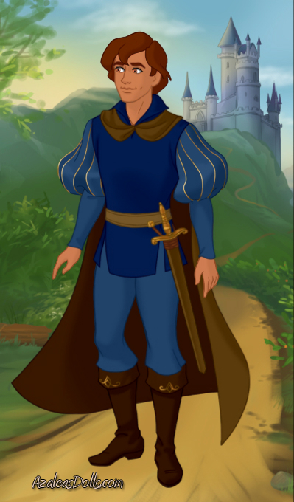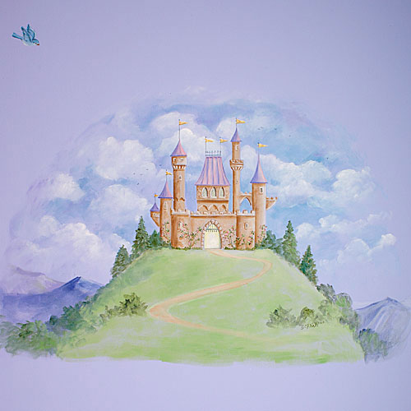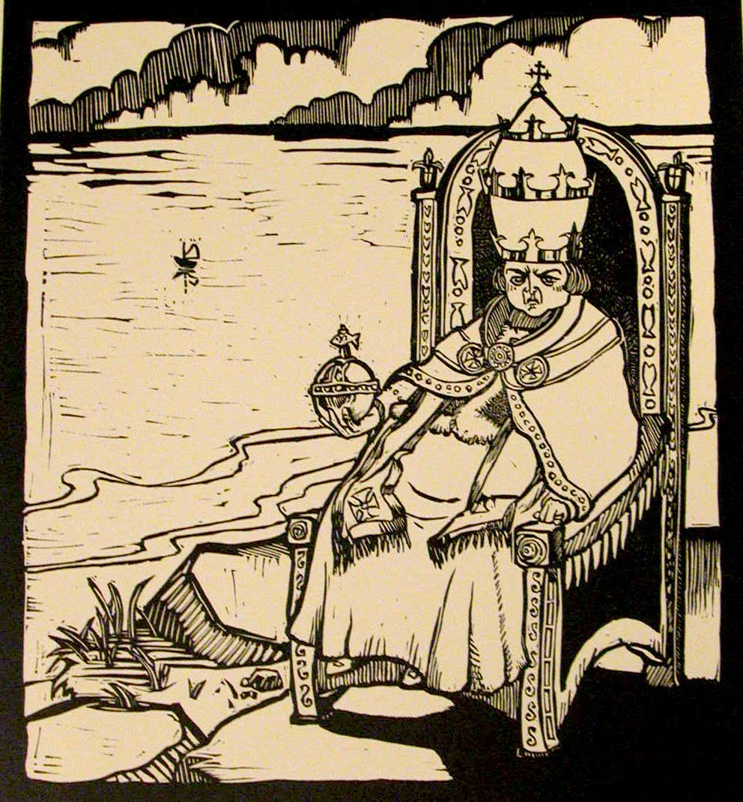

- Grade-level: 1st

All content linked to within this resource was free for use when this resource was published in March 2018. Over time, the organizations that manage that external content may move or remove it or change the permissions. If the content is no longer available, please email info@studentsachieve.net.

