Grade 2, Topic 1: Fluently Add and Subtract within 20
Standards addressed | Primary in this topic:  2.OA.B.2: Fluently add and subtract within 20 using mental strategies. By the end of Grade 2, know from memory all sums of two one-digit numbers.  Secondary in this topic:  2.OA.A.1: Use addition and subtraction within 100 to solve one- and two-step word problems involving situations of adding to, taking from, putting together, taking apart, and comparing, with unknowns in all positions, e.g., by using drawings and equations with a symbol for the unknown number to represent the problem.
Aspects of Rigor targeted by the standards | Primary in this topic:  Procedural Skill and Fluency  Secondary in this topic:  Application
Applicable information from the progression documents | The deep extended experiences students have with addition and subtraction in Kindergarten and Grade 1 culminate in Grade 2 with students becoming fluent in single-digit additions and the related subtractions using the mental Level 2 and 3 strategies as needed [emphasis added].  (See p. 18 in the OA Progressions.)  By the end of the K–2 grade span, students have sufficient experience with addition and subtraction to know single-digit sums from memory; as should be clear from the foregoing, this is not a matter of instilling facts divorced from their meanings, but rather as an outcome of a multi-year process that heavily involves the interplay of practice and reasoning.  (See p. 19 in the OA Progressions.)
Essential Question(s) | How do you decide which strategy to use to add and subtract quickly and accurately within 20?

Anchor Tasks
Task | Explanation
1-2 Visual Learning Bridge | This strategy is de-emphasized in grade 1 and there is a strong connection to Topic 2 work on evens/odds.
1-3 Intervention Activity | Use of unifix cubes, rather than the ten frame, is a better lead in to work with place value models.
1-8 Solve and Share | A good culmination to re-emphasize high leverage strategy relationship between addition and subtraction.
Add: Additional practice for addition and subtraction within 20 | Students need more practice with straightforward problems that reflect the central concern of standard 2.OA.B.2.

Topic Rules of Thumb
Rule | Why?
Formatively assess students’ fluency with facts within 20 throughout this topic. Monitor students’ fluency using a fluency tracker for individual students. | 2.OA.B.2 requires students to know all sums of two one-digit numbers from memory by the end of grade 2. Collecting formative data on where students begin the year will allow teachers to base instructional choices on identified needs and strengths of students.
When strategies are suggested or required, tell students to use them only when they are helpful for figuring out problems they don’t already know OR only use problem sets that don’t require specific strategies. (For example, if students already know 5+9, do not require them to fill out a ten frame to show the sum.) | To eliminate work that repeats the expectations from grade 1 in 1.OA.B.3, 1.OA.B.4 & 1.OA.C.6; to allow students to self-select strategies or simply give answers (where strategies are not needed) to known sums/differences to better align to 2.OA.B.2.
Wherever possible, replace directions on student facing pages to mirror those on page 48: “Add or subtract. Use any strategy.” | To eliminate work that repeats the expectations from grade 1 in 1.OA.B.3, 1.OA.B.4 & 1.OA.C.6; allows students to self-select strategies or simply give answers to known sums/differences to better align to 2.OA.B.2.
For word problems, remove directions that require a specific strategy or representation. | MP1 requires students to make sense of problems, and 2.OA.A.1 does not require students to use specific strategies or representations.

Assessment Guidance, Topic 1
Topic Assessment
- Performance Assessment
Item #/Action | Why?
Use enVisionmath 2.0 Performance Assessment (As Is) in conjunction with an external assessment for fluency within 20, such as:  Addition and Subtraction within 20 Mini-Assessment | 2.OA.B.2 has a procedural skill and fluency focus; assessment  should align to this aspect of rigor.

Grade 2, Topic 2: Work with Equal Groups
Standards addressed | Primary in this topic:  2.OA.C.3: Determine whether a group of objects (up to 20) has an odd or even number of members, e.g., by pairing objects or counting them by 2s; write an equation to express an even number as a sum of two equal addends.  2.OA.C.4: Use addition to find the total number of objects arranged in rectangular arrays with up to 5 rows and up to 5 columns; write an equation to express the total as a sum of equal addends.  Secondary in this topic:  2.OA.A.1: Use addition and subtraction within 100 to solve one- and two-step word problems involving situations of adding to, taking from, putting together, taking apart, and comparing, with unknowns in all positions, e.g., by using drawings and equations with a symbol for the unknown number to represent the problem.  2.OA.B.2: Fluently add and subtract within 20 using mental strategies. By end of Grade 2, know from memory all sums of two one-digit numbers.
Aspects of Rigor targeted by the standards | Primary in this topic:  Conceptual Understanding  Secondary in this topic:  Procedural Skill and Fluency, Application
Applicable information from the progression documents | 2.OA.C.3 relates doubles additions up to 20 to the concept of odd and even numbers and to counting by 2s (the easiest count-by in Level 2) by pairing and counting by 2s the things in each addend. 2.OA.C.4 focuses on using addition to find the total number of objects arranged in rectangular arrays (up to 5 by 5).  (See p. 25 in the OA Progressions.)
Essential Question(s) | N/A

Assessment Guidance, Topic 2
Topic Assessment
➔Performance Assessment
Item #/Action | Why?
- As Is
- As Is
- As Is
- As Is
- As Is

Grade 2, Topic 3: Add within 100 using Strategies
Grade 2, Topic 4: Fluently Add Within 100
Order of Lessons for Merged Topics 3 & 4:  4-1, 3-4, 3-1, 3-2, 3-3, 3-5, 3-6, 3-7, 3-8, 3-9, 4-2, 4-3, 4-4, 4-5, 4-6. 4-7, 4-8 | Rationale for merging and reordering:  Strategies should be grounded in place value understanding, so the lessons have been re-ordered to provide this foundation first, followed by decomposition (a natural extension of place value understanding), then strategies that lead to mental computation, such as using a hundreds chart.
Standards addressed | Primary in this topic:  2.NBT.B.5: Fluently add and subtract within 100 using strategies based on place value, properties of operations, and/or the relationship between addition and subtraction.  2.NBT.B.9: Explain why addition and subtraction strategies work, using place value and the properties of operations.  Secondary in this topic:  2.NBT.B.6: Add up to four two-digit numbers using strategies based on place value and properties of operations.  2.OA.A.1: Use addition and subtraction within 100 to solve one- and two-step word problems involving situations of adding to, taking from, putting together, taking apart, and comparing, with unknowns in all positions, e.g., by using drawings and equations with a symbol for the unknown number to represent the problem.
Aspects of Rigor targeted by the standards | Primary in this topic:  Procedural Skill and Fluency, Conceptual Understanding  Secondary in this topic:  Application
Applicable information from the progression documents | N/A
Essential Question(s) | How can you decompose a one- or two-digit number that you are adding to make it easier to add?  How can you decide which strategy is best for different sums within 100?

Anchor Tasks
Task | Explanation
4-1 Solve and Share (Present without equation.) | Place value blocks help keep the content grounded in the place value understanding called for by 2.NBT.B.5 and provide a foundation for the other strategies so they don’t become disconnected from the concept of place value.
4-1 Intervention Activity | Additional exposure to place value blocks for conceptual understanding.
3-4 Solve and Share (Present without equation.) | Breaking apart (decomposing) numbers; no regrouping; good transition from work with physical place value blocks.
3-4 Visual Learning Bridge | Breaking apart (decomposing) with regrouping, based on place value of tens and ones.
3-1 Solve and Share | Connect all of the place value understanding to the physical representation in the hundreds chart.
3-5 Solve and Share (Present without equation.) | The decomposition and regrouping shown in 3-5 allow students to connect the concepts of the place value blocks and hundreds chart toward more abstract representations of place value.
3-5 Visual Learning Bridge
3-7 Solve and Share (Present without equation.) | At this point, students have a fair number of strategies and this Solve and Share allows students to select and teachers to formatively assess.
4-2 Visual Learning Bridge | The vertical structure begins to build towards the algorithm.
4-3 Visual Learning Bridge | Pictorial quick representation of the work grounded in place value blocks; moves students away from concrete manipulatives, ensuring progress toward meeting the goals of the standards.
4-5 Visual Learning Bridge (only the addition problem; no directions) | Students should apply the strategies that they have been using throughout the chapter and apply them to four two-digit numbers without scaffolding/direction to preserve coherence of the standards.
4-6 Solve and Share | Provide opportunity for students to add more than two 2-digit numbers in an applied problem.

Topic Rules of Thumb
Rule | Why?
Emphasize place value representation to help students understand other strategies, primarily: break apart (decompose) & regrouping; hundreds chart. Do not require students to use the open number line (3-2 and 3-3) and compensation (3-6); students should be encouraged to use them, only when they make sense to the student. | The NBT standards and the NBT progression do not mention number lines or compensation.
Avoid overly complex organizational structures that may interfere with the mathematical understandings (e.g., tens and ones charts from 4-1) in favor of simpler formats setups (e.g., the partial sums shown on Leveled Assignment in 4-1) or no structure setup. Where the structures appear in student work pages, instruct students them to use them only if useful. | 2.NBT.B.5 does not require specific organizational structures for recording conceptual understanding.
Provide distributed practice on addition problems within 100 throughout Topics 3 and 4. | 2.NBT.B.5 requires students to move toward fluency.
Present problems without given models intended to scaffold, such as bar models. | MP1 requires students to make sense of problems; giving specific models allows students to do the word problem without reading it.

Assessment Guidance, Topics 3 & 4
➔Topic Assessment
Performance Assessment

Note: The primary focus of these topics is the conceptual understanding and procedural skill and fluency required by 2.NBT.B. Because of this, the large majority of problems should not be presented in context.
Item #/Action | Why?
Topic 3 Assessment
- As Is
- Modify: Write in number sentence “44+25=___” | Item requires Application.
- Delete | Item requires a specific model.
- Delete | Item requires a specific model.
- Modify: Delete text “Break apart the numbers to solve.” Write in number sentence “27+65=____” | Item requires Application. Item requires a specific strategy.
- Delete | Item requires a specific model.
- Delete | Item requires a specific model.
- As Is
9. Delete | Item requires Application.
10. Modify: Write in number sentence “33+57=___” | Item requires Application.
11. As Is
12. Modify: Delete hundred chart. | Item requires a specific model.
13. As Is
- Delete | Item requires a specific strategy.
- Modify: Delete text: “Write an equation to solve each part of the two-step problem.” Delete equations. | Format of the item does not allow for different methods for solving the problem.
16. Modify: Delete text “Show two different ways to find.” Use only the expression and ask students to solve. | Item requires students to have multiple ways to compute.
Topic 4 Assessment
1. As Is
2. As Is
3. Delete | Does not align to the central concern of 2.NBT.B.5 or 2.NBT.B.9.
4. Delete | Does not align to the central concern of 2.NBT.B.5 or 2.NBT.B.9.
5. Delete | Item requires Application.
6. As Is
7. As Is
8. As Is
9. Modify: Delete Part B | Does not align to the central concern of 2.NBT.B.9.
10. Delete | Item requires Application.
11. As Is
12. As Is
13. Delete | Item requires Application. Item requires a specific model.

Grade 2, Topic 5: Subtract within 100 using Strategies
Topic 6: Fluently Subtract within 100
Standards addressed | Primary in this topic:  2.NBT.B.5: Fluently add and subtract within 100 using strategies based on place value, properties of operations, and/or the relationship between addition and subtraction.  2.NBT.B.9: Explain why addition and subtraction strategies work, using place value and the properties of operations.  Secondary in this topic:  2.NBT.B.6: Add up to four two-digit numbers using strategies based on place value and properties of operations.  2.OA.A.1: Use addition and subtraction within 100 to solve one- and two-step word problems involving situations of adding to, taking from, putting together, taking apart, and comparing, with unknowns in all positions, e.g., by using drawings and equations with a symbol for the unknown number to represent the problem.
Aspects of Rigor targeted by the standards | Primary in this topic:  Procedural Skill and Fluency, Conceptual Understanding  Secondary in this topic:  Application
Applicable information from the progression documents | First graders are not expected to compute differences of two-digit numbers other than multiples of ten. Deferring such work until Grade 2 allows two-digit subtraction with and without decomposing to occur in close succession, highlighting the similarity between these two cases.  (See p. 7 in the NBT Progressions.)
Essential Question(s) | How can you decompose a one- or two-digit number that you are subtracting to make it easier to subtract?  How can you decide which strategy is best for finding differences within 100?

Anchor Tasks
Task | Explanation
5-1 Solve and Share | Since Topics 3 & 4 gave students a good foundation in place value, it is fine to start off with the hundreds chart in Topic 5, but do not require it.
5-5 Solve and Share | This task shows connections to place value and making a decade number (an extension of grade 1 and Topic 1 work on “making a 10”).
5-5 Visual Learning Bridge | Makes an explicit connection to choosing a decomposition that takes advantage of multiples of 10 (an extension of grade 1 and Topic 1 work on “making a 10”).
5-6 Solve and Share | Good task for explicitly connecting place value understanding to the hundreds chart. Also allows students to subtract either the ones or tens first, potentially building low level understanding of the commutative property.
5-8 Solve and Share | Nice start unknown problem to connect the work students have been doing in NBT to the OA expectations for problem solving.
6-7 Solve and Share | Drives toward essential question, ensuring that students are able to choose and use a strategy to subtract within 100.
6-8 Solve and Share  (Remove direction to write two equations.) | Highlights the need to incorporate two-step problems into the work of grade 2.

Topic Rules of Thumb
Rule | Why?
Connect all strategies to place value to help students understand the other strategies, primarily: break apart (decompose) & regrouping; hundreds chart | 2.NBT.B.5 requires strategies based on place value.
Avoid overly complex organizational structures that may interfere with the mathematical understandings (e.g., multiple boxes for recording decompositions in 5-6) in favor of simpler, student-selected setups. Where the structures appear in student work pages, instruct them to use them only if useful and remove any directions requiring them.  Alternative way to record regrouping(s) from Topic 6. | 2.NBT.B.5 does not require specific organizational structures for recording conceptual understanding.
Provide distributed practice on subtraction problems within 100 throughout Topics 5 and 6, with some practice that includes unknown addend problems (such as 57 + ? = 86). | 2.NBT.B.5 requires students to move toward fluency and highlights the relationship between addition and subtraction.
Use problems from open number line (5-2 and 5-4) and compensation lessons (5-7), but do not require students to use these strategies. Make the strategies optional. | The NBT standards and the NBT progression do not mention number lines or compensation.
Present problems without given models intended to scaffold, such as bar models and fill in the blank equations showing two steps. | MP1 requires students to make sense of problems; giving specific models allows students to do the word problem without reading it.
Skip Lesson 6-1. | MP6 requires students to attend to precision. This lesson uses the question “Do you need to regroup?” In the previous topic, students learned that the answer to this is always “no.” So the mathematics is not accurate.
Use Lessons 6-2 and 6-3 only as needed to review Topic 5 content for students who need additional work on place value understanding in 6-4 and beyond. | 2.NBT.B.5 requires students to be able to fluently subtract within 100.
Assessment Guidance, Topics 5 & 6
➔ Topic Assessment
Performance Assessment

Note: The primary focus of these topics is the conceptual understanding and procedural skill and fluency required by 2.NBT.B. Because of this, the large majority of problems should not be presented in context.
Item #/Action | Why?
Topic 5 Assessment
- Modify: Write in the number sentence “54-26=__” | Item requires Application.
- Delete | Item requires a specific model.
- Modify: Delete hundred chart. Write in number sentence “78-25=___” | Item requires Application.
- Delete | Item requires a specific model.
- As Is
- As Is
- Modify: Delete text “Break apart 39 to solve.” | Item requires a specific strategy.
- Delete | Item requires a specific strategy.
- Delete | Item requires a specific model.
- Modify: Delete text “Use the open number line to find the difference.” | Item requires a specific model.
- Delete | Item requires Application.
- Delete | Item requires a specific model.
- Delete | Item requires a specific strategy.
- As Is
Topic 6 Assessment
- Delete | Does not align to central concern of 2.NBT.B.5.
- Modify: Delete frame. Write number sentence “62-28=__” | Item requires a specific model. Item requires Application.
- As Is
- Delete | Repeats content from item #3.
- Delete | Does not align to central concern of 2.NBT.B.5.
- As Is
- Modify: Delete text “Use the frame to help you.” Delete frame. | Item requires a specific model.
- Delete | Repeats content from item #2.
- Delete | Does not align to central concern of 2.NBT.B.5.
- As Is
- Modify: Delete text “write the missing part in the diagram.” Delete bar diagram. | Item requires a specific model.
- Delete | Item requires Application.
- Delete | Item requires a specific strategy.
- As Is

Grade 2, Topic 7: More Solving Problems Involving Addition and Subtraction
Standards addressed | Primary in this topic:  2.OA.A.1: Use addition and subtraction within 100 to solve one- and two-step word problems involving situations of adding to, taking from, putting together, taking apart, and comparing, with unknowns in all positions, e.g., by using drawings and equations with a symbol for the unknown number to represent the problem.
Aspects of Rigor targeted by the standards | Primary in this topic:  Application  Secondary in this topic:  Procedural Skill and Fluency
Applicable information from the progression documents | Grade 2 students build upon their work in Grade 1 in two major ways. They represent and solve situational problems of all three types which involve addition and subtraction within 100 rather than within 20, and they represent and solve two-step situational problems of all three types.  (See p. 18 in the OA progressions.)  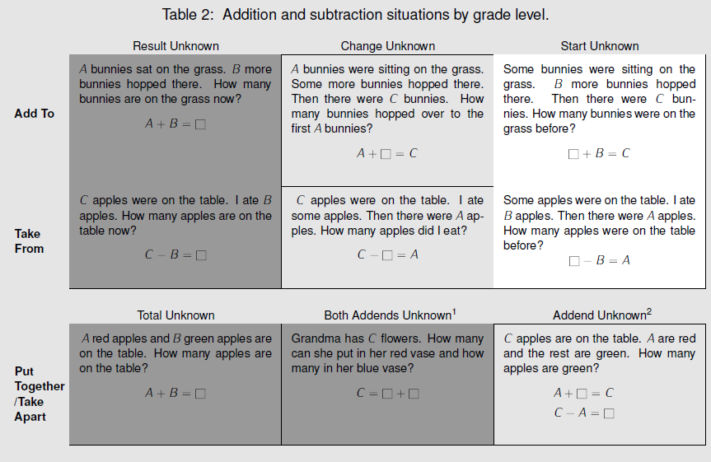  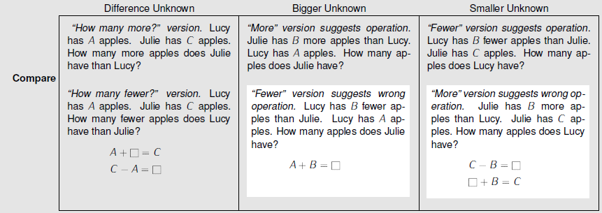  Darker shading indicates the four Kindergarten problem subtypes. Grades 1 and 2 students work with all subtypes and variants. Unshaded (white) problems are the four difficult subtypes or variants that students should work with in grade 1 but need not master until grade 2. Adapted from CCSS, p. 88, which is based on Mathematics Learning in Early Childhood: Paths Toward Excellence and Equity, National Research Council, 2009, pp. 32–33.  (See p. 9 of the OA Progressions.)
Essential Question(s) | How can I represent and solve problems involving addition and subtraction within 100?
Anchor Tasks
Task | Explanation
7-2 Solve and Share | This task does not require the use of any strategy nor does it indicate with scaffolds what operation is taking place and use “take from/change unknown” format (C - ___ = A).
7-3 Solve and Share | Task allows for choice of strategy in the “compare/smaller unknown” format (C-B = ___).
7-5 Solve and Share | Task allows for choice of strategy for a two-step problem that calls for both addition and subtraction to solve for the smaller unknown.

Topic Rules of Thumb
Rule | Why?
Present problems without given models intended to scaffold, such as bar models, open number lines, fill in the blank equations, and answer blanks with units already indicated. | MP1 requires students to make sense of problems; giving specific models allows students to do the word problem without reading it.

Assessment Guidance, Topic 7
➔Topic Assessment
Performance Assessment
Item #/Action | Why?
- Modify: Delete everything after the first paragraph. | Item requires a specific model.
- As Is
- As Is
- As Is
- Modify: Delete everything after the first paragraph. | Item requires a specific strategy.
- As Is
- As Is

Grade 2, Topic 8: Work with Time and Money
Standards addressed | Primary in this topic:  2.MD.C.7: Tell and write time from analog and digital clocks to the nearest five minutes, using a.m. and p.m.  2.MD.C.8: Solve word problems involving dollar bills, quarters, dimes, nickels, and pennies, using $ and ¢ symbols appropriately. Example: If you have 2 dimes and 3 pennies, how many cents do you have?  Secondary in this topic:  2.NBT.A.2: Count within 1000; skip-count by 5s, 10s, and 100s.  2.OA.A.1: Use addition and subtraction within 100 to solve one- and two-step word problems involving situations of adding to, taking from, putting together, taking apart, and comparing, with unknowns in all positions, e.g., by using drawings and equations with a symbol for the unknown number to represent the problem.
Aspects of Rigor targeted by the standards | Primary in this topic:  Application, Conceptual Understanding  Secondary in this topic:  Procedural Skill and Fluency
Applicable information from the progression documents | N/A
Essential Question (s) | N/A

Assessment Guidance, Topic 8
➔ Topic Assessment
Performance Assessment
Item #/Action | Why?
- As Is
- As Is
- As Is
- As Is
- As Is
- As Is
- As Is
- As Is
9. Delete | Item requires specific vocabulary.
10. Delete | Aligns to 3.MD.A.1 (elapsed time).
11. As Is
12. As Is
13. As Is
14. As Is

Grade 2, Topic 9: Numbers to 1,000
Standards addressed | Primary in this topic:  2.NBT.A.1: Understand that the three digits of a three-digit number represent amounts of hundreds, tens, and ones; e.g., 706 equals 7 hundreds, 0 tens, and 6 ones. Understand the following as special cases:  a. 100 can be thought of as a bundle of ten tens — called a “hundred.”  b. The numbers 100, 200, 300, 400, 500, 600, 700, 800, 900 refer to  one, two, three, four, five, six, seven, eight, or nine hundreds (and 0 tens and 0 ones).  2.NBT.A.4: Compare two three-digit numbers based on meanings of the hundreds, tens, and ones digits, using >, =, and < symbols to record the results of comparisons.  Secondary in this topic:  2.NBT.A.2: Count within 1000; skip-count by 5s, 10s, and 100s.  2.NBT.A.3: Read and write numbers to 1000 using base-ten numerals, number names, and expanded form.  2.NBT.B.8: Mentally add 10 or 100 to a given number 100–900, and mentally subtract 10 or 100 from a given number 100–900.
Aspects of Rigor targeted by the standards | Primary in this topic:  Conceptual Understanding  Secondary in this topic:  Procedural Skill and Fluency
Applicable information from the progression documents | A major task for Grade 2 is learning the counting sequence from 100 to 1,000. As part of learning and using the base-ten structure, students count by ones within various parts of this sequence, especially the more difficult parts that “cross” tens or hundreds.  Building on their place value work, students continue to develop proficiency with mental computation. They extend this to skip-counting by 5s, 10s, and 100s to emphasize and experience the tens and hundreds within the sequence and to prepare for multiplication.  Comparing magnitudes of two-digit numbers uses the understanding that 1 ten is greater than any amount of ones represented by a one-digit number. Comparing magnitudes of three-digit numbers uses the understanding that 1 hundred (the smallest three-digit number) is greater than any amount of tens and ones represented by a two-digit number. For this reason, three-digit numbers are compared by first inspecting the hundreds place (e.g. 845 > 799; 849 < 855). Drawings help support these understandings.  (See p. 8 in the NBT Progressions.)  For more information, also see http://achievethecore.org/content/upload/Thinking_About_Place_Value_in_Grade_Two.pdf.
Essential Question(s) | How does place value help me record numbers and understand their value?  How do you use place value understanding to compare numbers within 1000?

Anchor Tasks
Task | Explanation
9-1 Visual Learning Bridge (De-emphasize the thousand and its representation.) | The progressions suggest moving very quickly into showing that 10 tens is 100, and showing the representation of that (i.e., with a flat). Since students in grades 2-3 only work within 1000, it is not critical for students to understand the representation for 1000 yet.
9-2 Solve and Share | Good progression up from the introductory work in 9-1.
9-2 Intervention Activity | This activity is good as core instruction for all students because it connects written numbers to the underlying place value structure.
9-5 Solve and Share and/or  9-5 Intervention Activity | Students are directed to represent a three-digit number in two different ways using place value blocks which encourages practice in bundling/unbundling hundreds, tens and ones. Intervention activity builds towards the formulation of an expanded form representation.
Making 124  and/or  Regrouping  and/or  Bundling and Unbundling | Extends the work of 9-5 to reach the depth of cluster 2.NBT.A
One, Ten and One Hundred More or Less | Adding/subtracting ones, tens, and hundreds to connect the work of Topic 9 to the work of Topics 10 and 11.
9-8 Solve and Share (Present without place value chart.) | Good formative assessment to see how students use what they know about place value to compare numbers prior to instruction on the topic.

Topic Rules of Thumb
Rule | Why?
Enhance tasks and discussions to ensure that students represent numbers in different ways, especially those that show different ways to bundle base ten units (e.g., 4 hundreds + 3 tens = 3 hundreds + 13 tens) and that reinforce properties of operations (e.g., 3 hundreds + 4 tens = 4 tens + 3 hundreds). | The cluster level of 2.NBT.A requires students to “understand” place value. Also, to support coherence for addition and subtraction, students must understand how base ten units can be bundled differently and still produce the same number.
Assessment Guidance, Topic 9
➔ Topic Assessment
Performance Assessment
Item #/Action | Why?
- As Is
- As Is
- As Is
- As Is
- Delete | Emphasis is on vocabulary, rather than mathematical concepts.
- Delete | Emphasis is on vocabulary, rather than mathematical concepts.
- Delete | Emphasis is on vocabulary, rather than mathematical concepts.
Replace deleted items with #2, 7, 10 and
11 from page 4 of Thinking About Place Value in Grade 2
- As Is
9. As Is
10. As Is
11. As Is
12. As Is
13. Delete | Item requires Application.
14. As Is
15. As Is
16. As Is
17. As Is
18. As Is

Grade 2, Topic 10: Add within 1,000 Using Models and Strategies
Standards addressed | Primary in this topic:  2.NBT.B.7: Add and subtract within 1000, using concrete models or drawings and strategies based on place value, properties of operations, and/or the relationship between addition and subtraction; relate the strategy to a written method. Understand that in adding or subtracting three-digit numbers, one adds or subtracts hundreds and hundreds, tens and tens, ones and ones; and sometimes it is necessary to compose or decompose tens or hundreds.  Secondary in this topic:  2.NBT.B.8: Mentally add 10 or 100 to a given number 100–900, and mentally subtract 10 or 100 from a given number 100–900.  2.NBT.B.9: Explain why addition and subtraction strategies work, using place value and the properties of operations.
Aspects of Rigor targeted by the standards | Primary in this topic:  Conceptual Understanding  Secondary in this topic:  Procedural Skill and Fluency
Applicable information from the progression documents | 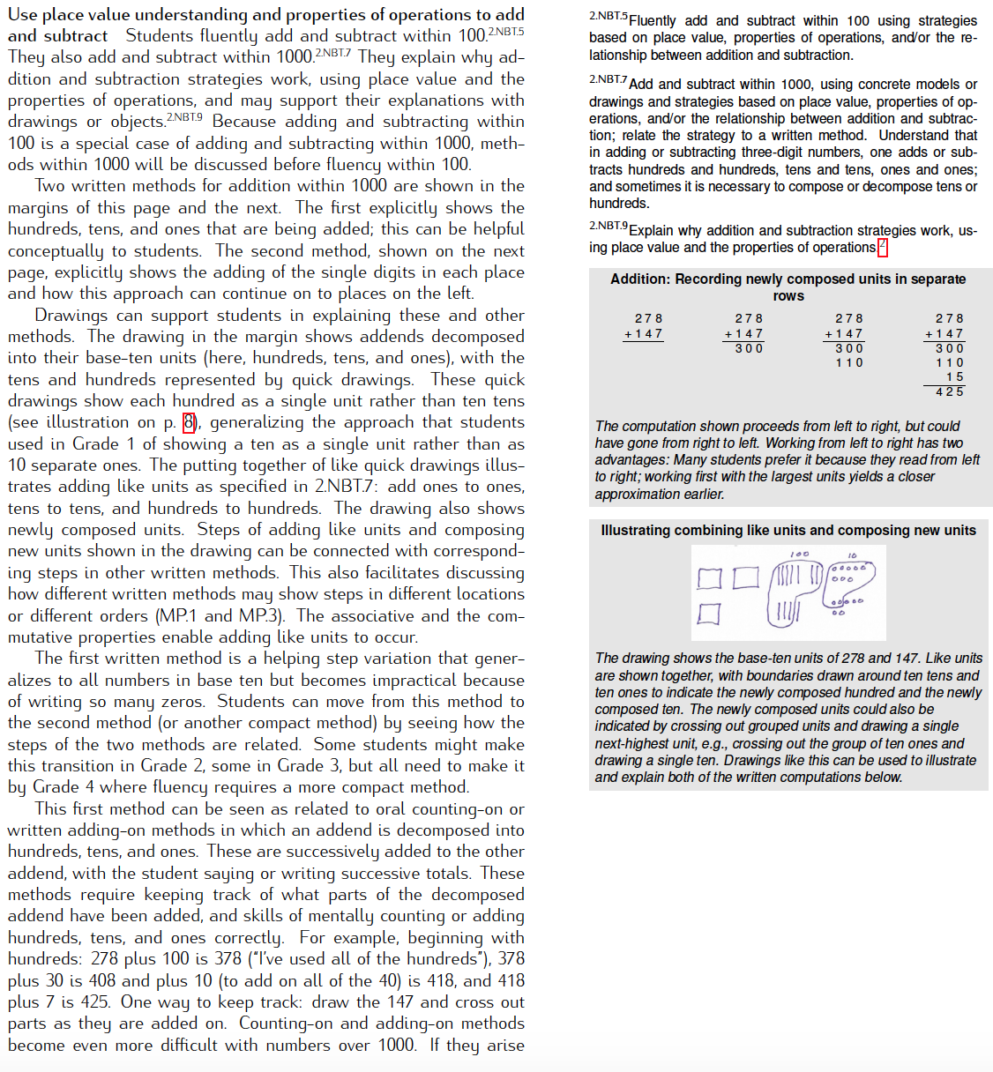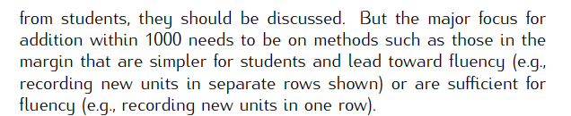  (See p. 9 in the NBT Progressions.)
Essential Question(s) | How can use place value understanding and properties of operations to add within 1000?

Anchor Tasks
Task | Explanation
Many Ways to Do Addition 2 | Extends the work of adding two 2-digit numbers to adding two 3-digit numbers.
10-3 Solve and Share | Allows students to solve using any strategy. Reinforces and extends previous work with strategies.
10-3 Intervention Activity | The intervention activity relates the concepts of place value to addition.
10-6 Solve and Share | Allows students to solve using any strategy. Reinforces and extends previous work with strategies.

Topic Rules of Thumb
Rule | Why?
Continue to use place value blocks to help students understand why the other strategies work. | 2.NBT standards require work to be based on place value understanding.
Connect all strategies to place value: add using partial sums. | 2.NBT.B.7 states that in adding three-digit numbers one adds hundreds and hundreds, tens and tens, ones and ones
Use problems from open number line (10-2) but make the use of the model itself optional. | The NBT standards and the NBT progression do not mention number lines.
Avoid overly complex organizational structures that may interfere with the mathematical understandings (models from 10-5). Where the structures appear in student work pages, instruct them to use them only if useful. | 2.NBT.B.7 does not require specific organizational structures for recording conceptual understanding.
Skip Lesson 10-7. | MP8 requires students to look for and express regularity in repeated reasoning. The process of adding partial sums reinforces the standard which requires students to add hundreds and hundreds, tens and tens, ones and ones. This is an inaccurate interpretation of MP8.

Assessment Guidance, Topic 10
➔ Topic Assessment
Performance Assessment
Item #/Action | Why?
- Delete | Item requires Application.
- Delete | Item requires Application.
- Modify -- Delete everything except the number sentence “438+240=___” | Item requires a specific model.
- As Is
- As Is
- As Is
- As Is
- As Is
- Delete | Item requires Application.

Grade 2, Topic 11: Subtract within 1,000 Using Models and Strategies
Standards addressed |  | Primary in this topic:  2.NBT.B.7: Add and subtract within 1000, using concrete models or drawings and strategies based on place value, properties of operations, and/or the relationship between addition and subtraction; relate the strategy to a written method. Understand that in adding or subtracting three-digit numbers, one adds or subtracts hundreds and hundreds, tens and tens, ones and ones; and sometimes it is necessary to compose or decompose tens or hundreds.  Secondary in this topic:  2.NBT.B.8: Mentally add 10 or 100 to a given number 100–900, and mentally subtract 10 or 100 from a given number 100–900.  2.NBT.B.9: Explain why addition and subtraction strategies work, using place value and the properties of operations.
Aspects of Rigor targeted by the standards |  | Primary in this topic:  Conceptual Understanding  Secondary in this topic:  Procedural Skill and Fluency
Applicable information from the progression documents | 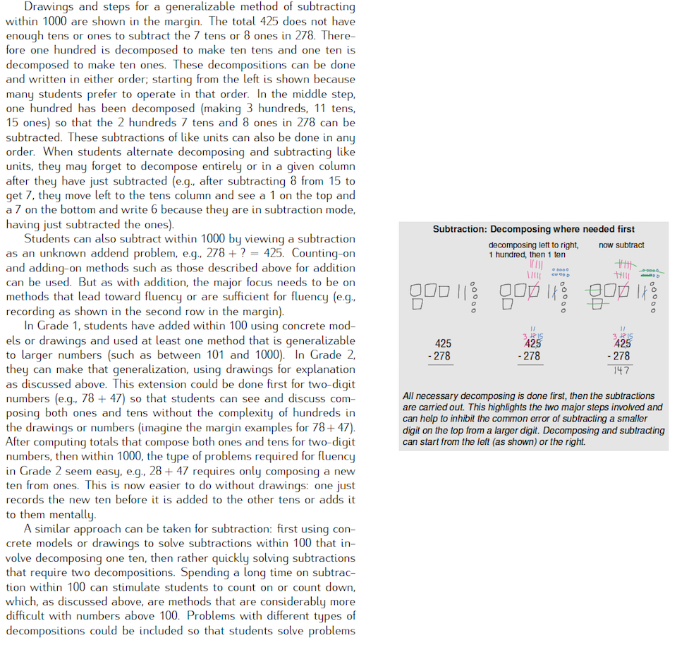  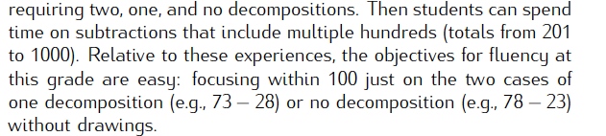  (See p. 10 in the NBT Progressions.)
Essential Question(s) |  | How can use place value understanding and properties of operations to subtract within 1000?

Anchor Tasks
Task | Explanation
11-1 Intervention Activity & Leveled Assignment | The intervention activity can be used as the teacher model and the leveled assignment can be used for practice.
11-4 Solve and Share | Allows students to solve using any strategy. Reinforces and extends previous work with strategies.
11-6 Solve and Share | Allows students to solve using any strategy. Reinforces and extends previous work with strategies.

Topic Rules of Thumb
Rule | Why?
Connect all strategies to place value to help students understand the other strategies, primarily: break apart (decompose) & regrouping. | 2.NBT.B.5 requires strategies based on place value.
Present problems without given models intended to scaffold, such as bar models, open number lines, fill in the blank equations (11-4), and answer blanks with units already indicated. | MP1 requires students to make sense of problems; giving specific models allows students to do the word problem without reading it.
Use problems from open number line (11-2 and 11-3) but do not require students to use this strategy. Make strategies optional. Same understanding with 11-6. | The NBT standards and the NBT progression do not mention number lines.
Avoid overly complex organizational structures that may interfere with the mathematical understandings (models from 11-5). Where the structures appear in student work pages, instruct them to use them only if useful. | 2.NBT.B.7 does not require specific organizational structures for recording conceptual understanding.

Assessment Guidance, Topic 11
➔ Topic Assessment
Performance Assessment
Item #/Action | Why?
- As Is
- Delete | Item requires a specific model.
- Modify: Delete text: “Use different strategies to subtract.” | Item requires students to use multiple strategies.
- As Is
- Modify: Delete text; only give number sentence “610-380= ___” | Item requires a specific model.
- Delete | Item requires a specific model.
- Modify: Delete text; only give number sentence “392-128=___” | Not aligned to the central concern of 2.NBT.B.7.

Grade 2, Topic 12: Measuring Length
Standards addressed | Primary in this topic:  2.MD.A.1: Measure the length of an object by selecting and using appropriate tools such as rulers, yardsticks, meter sticks, and measuring tapes.  Secondary in this topic:  2.MD.A.2: Measure the length of an object twice, using length units of different lengths for the two measurements; describe how the two measurements relate to the size of the unit chosen.  2.MD.A.3: Estimate lengths using units of inches, feet, centimeters, and meters.  2.MD.A.4: Measure to determine how much longer one object is than another, expressing the length difference in terms of a standard length unit.  2.MD.B.5: Use addition and subtraction within 100 to solve word problems involving lengths that are given in the same units, e.g., by using drawings (such as drawings of rulers) and equations with a symbol for the unknown number to represent the problem.
Aspects of Rigor targeted by the standards | Primary in this topic:  Application, Conceptual Understanding  Secondary in this topic:  Procedural Skill and Fluency
Applicable information from the progression documents | 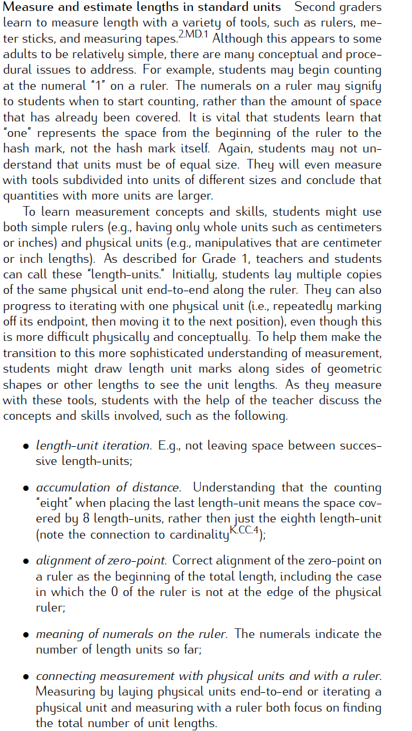  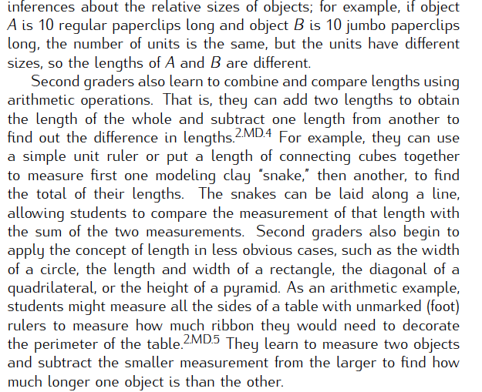  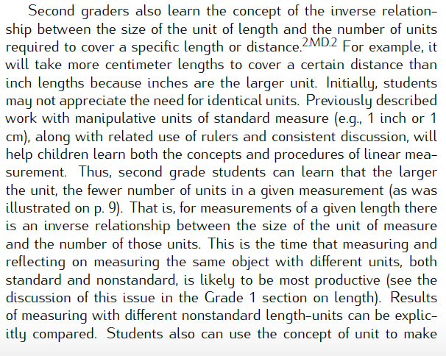  (See pp. 12-14 in MD Progressions.)
Essential Question(s) | What are ways to measure length?

Anchor Tasks
Task | Explanation
12-1 Solve and Share | This task provides a good reference for students allowing them to use one of their own body parts as a measurement referent and aligns well to the estimation expectation of 2.MD.A.3.
12-2 Solve and Share | Consistent with the suggestion in the progressions, using an object of length 1 inch instead of a ruler can help build students understanding of the measurement unit prior to introducing formal measurement tools.
12-3 Solve and Share | This task builds a strong conceptual foundation for understanding the size of different measurement units. This is a good way to introduce the idea of selecting specific units for specific purposes.
12-4 Solve and Share | This task moves students nicely to the initial understanding that more iterations of smaller units are required to measure an object than if one were to choose larger units.
12-6 Solve and Share | This task allows students to see the relationship between centimeters and meters, moving them from the customary US measurement system in earlier lessons to the metric system.
12-7 Solve and Share | This task provides a nice contrast of the “smaller” units in the customary and metric systems, allowing students to further explore relationships between different-sized units while also noticing that objects will always measure more centimeters than they do inches.
12-9 Solve and Share | This task provides students with an opportunity to measure an object that doesn’t have a neat linear shape. This is an important aspect of MP.4 which states that mathematically proficient students are comfortable making approximations.

Topic Rules of Thumb
Rule | Why?
There are no topic-specific Rules of Thumb.

Assessment Guidance, Topic 12
➔ Topic Assessment
Performance Assessment
Item #/Action | Why?
- As Is
- As Is
- As Is
- As Is
- As Is | Note: “about” is not well defined here; consider telling students that this means closer to 4 cm than to 5 cm or 3 cm.
- As Is
- As Is
- As Is
9. As Is
10. As Is
11. As Is
12. As Is
13. Delete | Repeats content from previous items.
14. As Is
15. As Is
16. As Is

Grade 2, Topic 13: More Addition, Subtraction and Length
Standards addressed | Primary in this topic:  2.MD.B.5: Use addition and subtraction within 100 to solve word problems involving lengths that are given in the same units, e.g., by using drawings (such as drawings of rulers) and equations with a symbol for the unknown number to represent the problem.  Secondary in this topic:  2.MD.B.6: Represent whole numbers as lengths from 0 on a number line diagram with equally spaced points corresponding to the numbers 0, 1, 2, ..., and represent whole-number sums and differences within 100 on a number line diagram.  2.OA.A.1: Use addition and subtraction within 100 to solve one- and two-step word problems involving situations of adding to, taking from, putting together, taking apart, and comparing, with unknowns in all positions, e.g., by using drawings and equations with a symbol for the unknown number to represent the problem.
Aspects of Rigor targeted by the standards | Primary in this topic:  Application  Secondary in this topic:  Procedural Skill and Fluency
Applicable information from the progression documents | N/A
Essential Question(s) | How can I use what I know about addition and subtraction to find and compare lengths of objects?

Anchor Tasks
Task | Explanation
13-2 Intervention Activity | This activity appropriately introduces the concept of measurement as additive without the complexity of some of the perimeter problems in 13-1.
13-3 Solve and Share (Remove direction: “Draw a picture and write an equation to solve.”) | This problem quickly moves students into the idea of subtraction and what it means from a measurement perspective. Removing the direction to “Draw a picture and write an equation to solve” allows students to represent the problem in ways that make the most sense to them and allows the teacher to examine a variety of approaches to support student learning.

Topic Rules of Thumb
Rule | Why?
De-emphasize “distance around” problems. | Perimeter is part of 3.MD.D and thus not a grade 2 expectation. Students often have a hard time seeing perimeter as a linear measurement so keeping it close to the concept of “area” to show that distinction is an important part of the progression of learning.

Assessment Guidance, Topic 13
→ Topic Assessment
Performance Assessment
Item #/Action | Why?
- Delete | Aligns to 3.MD.D (perimeter).
- As Is
- As Is
- As Is
- As Is
- As Is
- As Is
- Modify: Only use Part A. | Does not align to the central concern of 2.MD.B or 2.OA.A.1.

Grade 2, Topic 14: Graphs and Data
Standards addressed | Primary in this topic:  2.MD.D.9: Generate measurement data by measuring lengths of several objects to the nearest whole unit, or by making repeated measurements of the same object. Show the measurements by making a line plot, where the horizontal scale is marked off in whole-number units.  2.MD.D.10: Draw a picture graph and a bar graph (with single-unit scale) to represent a data set with up to four categories. Solve simple put together, take-apart, and compare problems using information presented in a bar graph.  Secondary in this topic:  2.MD.A.1: Measure the length of an object by selecting and using appropriate tools such as rulers, yardsticks, meter sticks, and measuring tapes.
Aspects of Rigor targeted by the standards | Primary in this topic:  Application  Secondary in this topic:  Conceptual Understanding, Procedural Skill and Fluency
Applicable information from the progression documents | Students in Grade 2 draw a picture graph and a bar graph (with single-unit scale) to represent a data set with up to four categories. They solve simple put-together, take-apart, and compare problems using information presented in a bar graph.  (See p. 6 in the MD Progressions.)
Essential Question(s) | N/A

Assessment Guidance, Topic 14
→ Topic Assessment
Performance Assessment
Item #/Action | Why?
- As Is
- As Is
- As Is
- As Is
- As Is
- As Is
- As Is
- As Is
- As Is

Grade 2, Topic 15: Shapes and Their Attributes
Standards addressed | Primary in this topic:  2.G.A.1: Recognize and draw shapes having specified attributes, such as a given number of angles or a given number of equal faces. Identify triangles, quadrilaterals, pentagons, hexagons, and cubes.  2.G.A.3: Partition circles and rectangles into two, three, or four equal shares, describe the shares using the words halves, thirds, half of, a third of, etc., and describe the whole as two halves, three thirds, four fourths. Recognize that equal shares of identical wholes need not have the same shape.  Secondary in this topic:  2.G.A.2: Partition a rectangle into rows and columns of same-size squares and count to find the total number of them.
Aspects of Rigor targeted by the standards | Primary in this topic:  Conceptual Understanding
Applicable information from the progression documents | 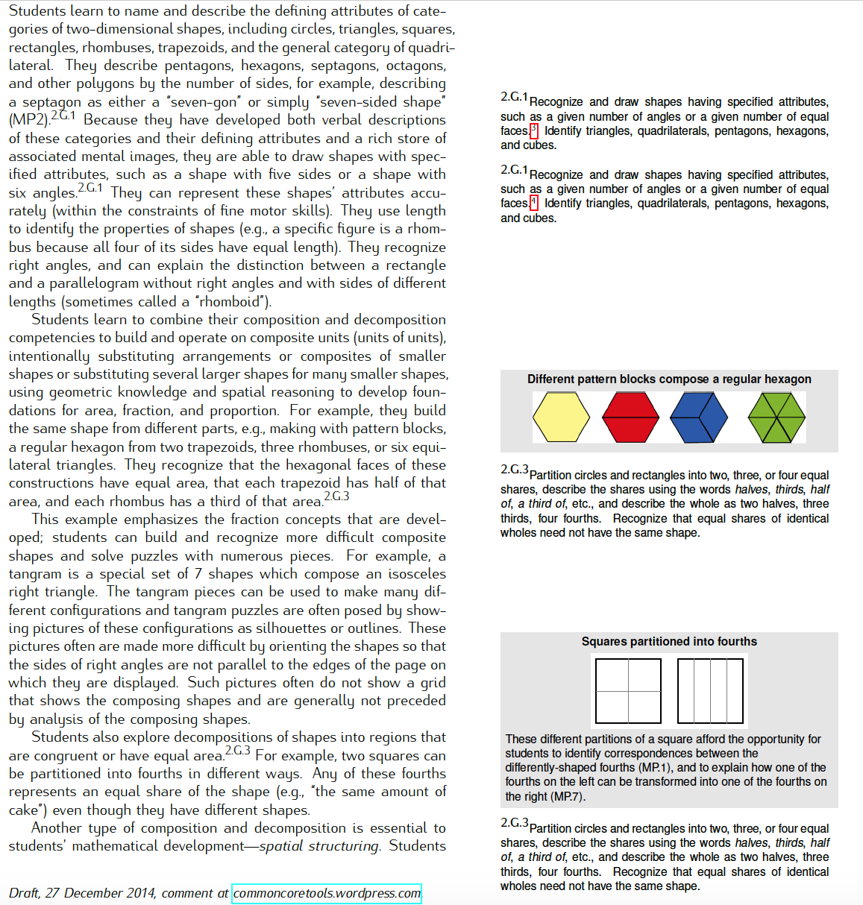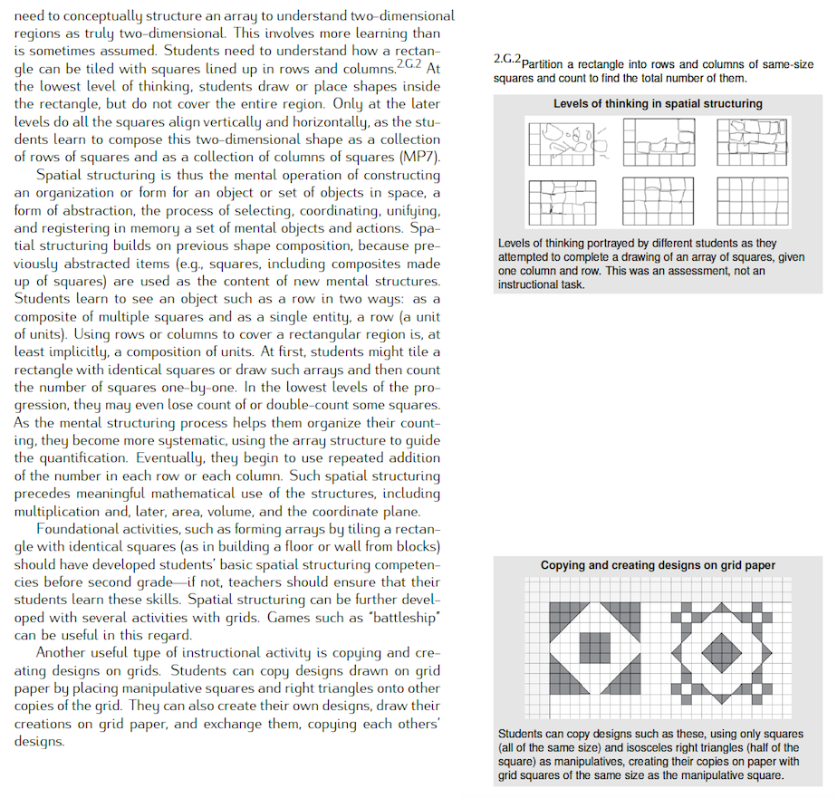  (See pp.10–11 in G Progressions.)
Essential Question(s) | N/A
Assessment Guidance, Topic 15
→ Topic Assessment
Performance Assessment
Item #/Action | Why?
- As Is
- As Is
- As Is
- As Is
- As Is
- As Is
- As Is
- As Is
- As Is
- As Is
- As Is
- As Is
- As Is
- As Is
- As Is
- As Is

