Unit 4/Week 2
Title: Hottest, Coldest, Highest, Deepest
Suggested Time: 5 days (45 minutes per day)
Common Core ELA Standards: RI.3.1, RI.3.2, RI.3.4, RI.3.7; W.3.2, W.3.4; SL.3.1; L.3.1, L.3.2

Teacher Instructions
Refer to the Introduction for further details.
Before Teaching
- Read the Big Ideas and Key Understandings and the Synopsis. Please do not read this to the students. This is a description for teachers, about the big ideas and key understanding that students should take away after completing this task.
Big Ideas and Key Understandings
Earth is one of a kind. Earth’s unique, fascinating natural features are found across continents.
Synopsis
“Hottest, Coldest, Highest, Deepest” takes the reader on a journey around the world to various continents found on Earth that contain unique natural features. Whether the features are the hottest temperatures found on Earth or the highest mountain. Through the use of text and illustrations, readers are able to grasp the unique diversities found on Earth.
- Read entire main selection text, keeping in mind the Big Ideas and Key Understandings.
- Re-read the main selection text while noting the stopping points for the Text Dependent Questions and teaching Vocabulary.

During Teaching
- Students read the entire main selection text independently.
- Teacher reads the main selection text aloud with students following along. (Depending on how complex the text is and the amount of support needed by students, the teacher may choose to reverse the order of steps 1 and 2.)
- Students and teacher re-read the text while stopping to respond to and discuss the questions and returning to the text. A variety of methods can be used to structure the reading and discussion (i.e.: whole class discussion, think-pair-share, independent written response, group work, etc.)

Text Dependent Questions
Text-dependent Questions | Evidence-based Answers
Reread page 42. Use information on this page to determine what type of records the author is speaking about. | The text states that “there are deserts that haven’t seen rain for hundreds of years and jungles where it pours almost every day.” The text goes on to ask “where are the very hottest and coldest, windiest and snowiest, highest and deepest places on Earth?” The author thus, is speaking of nature’s record holders rather than human record holders.
The Amazon River, in South America is not considered to be the longest river, but is considered to be mightier than the other rivers in the world. Why is the Amazon River considered to be mightier than the others? (Pg. 43) | “It is considered mightier because it carries half of all the river water in the world.”
Look at the illustration of the world in the bottom left hand corner on page 43. What does the pink dot represent and what information does this provide? | The pink dot represents the location of the Nile River, which is located in the continent of Africa. The author gives this information on the title, “The Nile, in Africa, is the longest river in the world. It is 4,145 miles long.”
Compare the Nile and the Amazon rivers. Why are these two rivers both noted as being record holders? (Pg. 43) | The Nile river is 4,145 miles long and the Amazon River is 4,007 miles long. They are both two of the longest rivers in the world.
On page 44, the author writes about two different lakes, Lake Baikal, in Russia and Lake Superior, in North America. Using the information and evidence given in the text briefly compare and contrast these two lakes. | Both lakes set a natural record. Lake Baikal is the oldest and deepest freshwater lake in the world, and Lake Superior is the largest freshwater lake in the world. In contrast, Lake Baikal contains more water than Lake Superior because of its depth. “In one spot it is 5,134 feet deep.”
According to the text what mountain is the tallest mountain in the world, if we were not considering sea level measurements? (Pg. 45) | Mauna Kea, in Hawaii. It is 33,476 feet tall. Most of the mountain is located underwater, with only 13,796 feet showing above the water.
Look at the illustrations on page 45. How do these illustrations enhance the information given in the text? Use evidence from the text on page 45 to support your response. | The illustrations give the reader a better visual picture of what the mountains look like in terms of the sea level measurements. Mount Everest being the tallest mountain in the world, because it is 29,028 feet about sea level. The illustration shows Mount Everest with snow on its top peak. Whereas, Mauna Kea is considered to be the tallest mountain in the world when it is measured from its base, which is on the floor of the ocean to its top (above sea level). The illustration allows the reader to see Mauna Kea partially under water.
Look at the chart on page 46. What information is given on this chart? How does the information on the chart help you better understand Al Aziziyah? | The chart on page 46 gives the reader information about various temperatures, such as the temperature in which water freezes, a human’s body temperature, the average room temperature, and the temperature found at Al Aziziyah. The chart organizes these temperatures from coldest to hottest.  The text states that Al Aziziyah has had temperatures of 136’F recorded. The chart allows the reader to see just how very hot 136’F is in relationship to other common temperatures. (freezing water, body temp., etc.)
On pages 46 and 47, the author writes about three very different regions found on Earth. Al Aziziyah, Libya found in the Sahara, Vostok, Antarctica, and Tutunendo, Colombia. Find key words and/or phrases from the text on pages 46 and 47 that contrast these three regions. | Al Aziziyah is the hottest place on the planet, it has temperatures recorded over 136*F. Vostok, Antartica is the coldest place on the planet, it has temperatures of 129*F below zero. Tutunendo, Columbia is the wettest place on the plant, it receives an average of 463 inches of rain fall a year.
Reread 46 and page 48. Looking at the illustrations as well as the information stated in the text, what can be stated about deserts in general? | (p.46 and 48) Deserts can be very hot and dry places, with little to no plant life or rain fall. The text on page 46, states that Al Aiziyah, which is found in the Sahara can reach temperatures of up to 136*F. The illustration on page 46 also shows lots of sand and very little plant life. On page 48 the text states that Atacama Desert, in Chile, is the driest place with no rain fall for the past 400 years. The illustration on page 48 also shows no plant life.
Look at the chart on page 48. It shows the height of an adult man, desert precipitation, as well as Death Valley’s average annual precipitation. According to the information found in the text and the information show on the chart, what does precipitation and annual mean? | Precipitation means rain fall. Annual means yearly. It states in the text “no rain has fallen for 400 years”, it also states that “less than 10 inches of precipitation a year is considered a desert”, and “rain fall every year”.
In this passage, the author states that the Himalayan mountains have peaks that reach the jet stream. What is a jet stream? Explain what a jet stream looks like or feels like in your own words. (Pg. 49) | A jet stream is a narrow, strong air current that is found above 28,000 feet. A student may say that a jet stream is a bunch of air all moving together.
The author states the windiest spot on Earth is atop Mount Washington, in New Hampshire, but the author goes on to give information about the world’s highest mountains, the Himalayans. Why did the author include information about the world’s highest mountains with the world’s windiest spot on Earth? (Pg. 49) | The author writes about the Himalayan mountains, the highest mountains in the world because these mountains may not be the windiest spot on Earth, but the mountains do have peaks that reach the jet stream. This gives the two mountains something in common, in terms of wind speeds.
Look at the illustration on page 51 of the deepest spot in the ocean, the Marianas Trench. Does this illustration help and/or enhance the evidence stated in the text? | It is 36,202 feet deep which means it would be very dark that far down in the ocean, just as the illustration shows darkness.
Vocabulary
 | KEY WORDS ESSENTIAL TO UNDERSTANDING | WORDS WORTH KNOWING  General teaching suggestions are provided in the Introduction
TEACHER PROVIDES DEFINITION  not enough contextual clues provided in the text | Page 47 - average  Page 42 - natural  Page 43 - mightier  Page 44 - contains | Page 51 - regularly  Page 43 - considered  Page 44 - contains  Page 44 - combined  Page 49 - narrow
STUDENTS FIGURE OUT THE MEANING  sufficient context clues are provided in the text | Page 42 - pours  Page 45 - peak  Page 51 - depth  Page 51 - active  Page 42 - trench | Page 53 - formed  Page 51 - shore  Page 52 - extreme  Page 52 - overtake
Culminating Task
- Re-Read, Think, Discuss, Write
- The author takes the reader too many different continents and locations throughout the text to discover the unique, fascinating places found on Earth. Create a list of all the places/locations, and interesting facts the author states. Select some of the locations listed to help you write a paragraph that addresses how the Earth is unique and how the author shows this through the text of the story.
Answer: (Note: students may make a list or fill in the map below.)

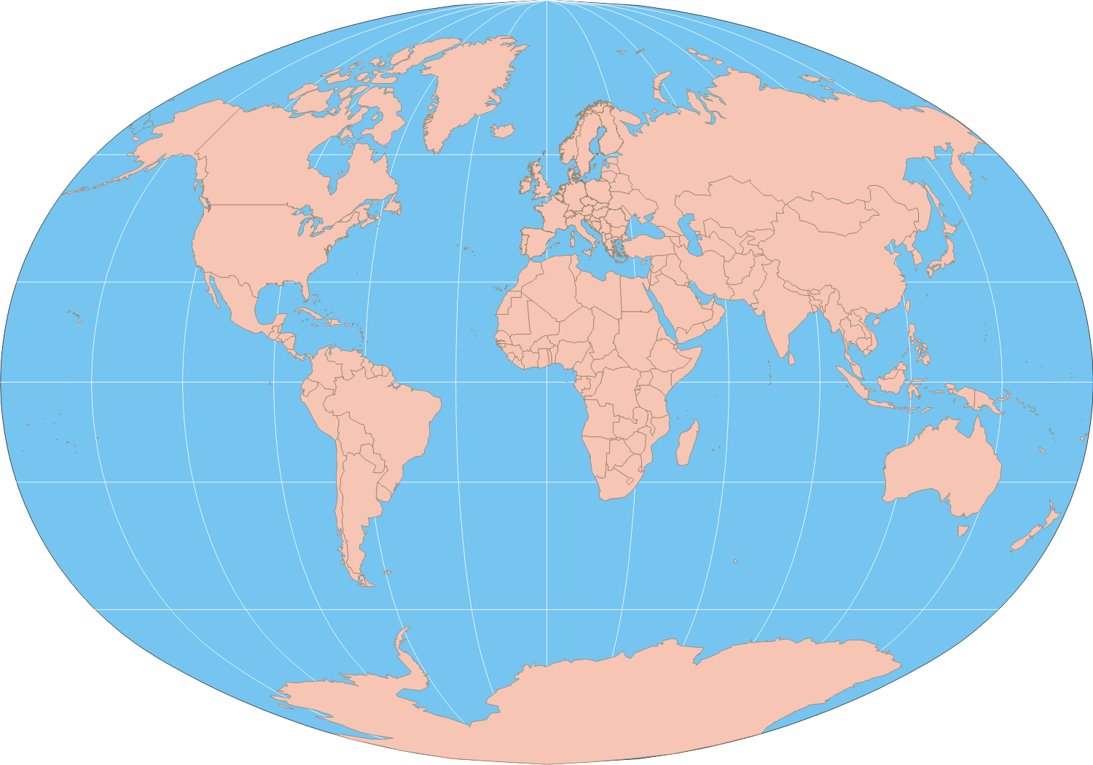
Bay of Fundy, Nova Scotia, Canada: most extreme tides
Mount Rainier, Washington State: snowiest place
Marianas Trench, Philippines: deepest ocean spot
Sangay, Ecuador: most active volcano
Angel Falls, Venezuela: highest waterfall
Mount Washington, New Hampshire: windiest
Al Aziziyah, Libya: hottest
Atacama Desert, Chile: driest
Tutundo, Columbia: wettest
Vostok, Antarctica: Coldest

Mauna Kea, Hawaii: tallest mountain base to top.

Mount Everest, Asia: highest mountain-above sea level
Lake Baikal, Russia: oldest, deepest lake
Nile River, Africa: longest river

Answer: This story discusses many different locations around the world. The author takes you on a journey to some of the windiest, driest, and coldest places on Earth. One such place is Mount Washington, New Hampshire. It is noted as being the windiest place on Earth. Another record holder is Vostok, Antarctica, it is considered to be the coldest place in the world. Throughout the entire story the author address some of the unique qualities found around the world, these diverse locations is what makes our Earth so very unique and interesting.

Additional Task
- Science Connection: Using the world map from the culminating activity, draw the equator and prime meridian on the map. Discuss the regions identified on the map in terms of their relationship and proximity to the equator. See if students can make a generalization or hypothesis about these regions and their climate that are close in proximity to the equator.
Answer: Regions that have a close proximity to the equator tend to have higher temperatures than other regions.

Supports for English Language Learners (ELLs) to use
with Basal Alignment Project Lessons
When teaching any lesson, it is important to make sure you are including supports to help all students. We have prepared some examples of different types of supports that you can use in conjunction with our Basal Alignment Project Lessons to help support your ELLs. They are grouped by when they would best fit in a lesson. While these supports reflect research in how to support ELLs, these activities can help ALL students engage more deeply with these lessons. Note that some strategies should be used at multiple points within a lesson; we’ll point these out. It is also important to understand that these scaffolds represent options for teachers to select based on students’ needs; it is not the intention that teachers should do all of these things at every lesson.
Before the reading:
- Read passages, sing songs, watch videos, view photographs, discuss topics (e.g., using the four corners strategy), or research topics that help provide context for what your students will be reading. This is especially true if the setting (e.g., 18th Century England) or topic (e.g., boats) is one that is unfamiliar to the students.

- Provide instruction, using multiple modalities, on selected vocabulary words that are central to understanding the text. When looking at the lesson plan, you should note the Tier 2 words, particularly those words with high conceptual complexity (i.e., they are difficult to visualize, learn from context clues, or are abstract), and consider introducing them ahead of reading. For more information on selecting such words, go here. You should plan to continue to reinforce these words, and additional vocabulary, in the context of reading and working with the text. (See additional activities in the During Reading and After Reading sections.)
Examples of Activities:
- Provide students with the definition of the words and then have students work together to create Frayer models or other kinds of word maps for the words.
- When a word contains a prefix or suffix that has been introduced before, highlight how the word part can be used to help determine word meaning.
- Keep a word wall or word bank where these new words can be added and that students can access later.
- Have students create visual glossaries for whenever they encounter new words. Then have your students add these words to their visual glossaries.
- Create pictures using the word. These can even be added to your word wall!
- Create lists of synonyms and antonyms for the word.
- Have students practice using the words in conversation. For newcomers, consider providing them with sentence frames to ensure they can participate in the conversation.
  - Practice spelling the words using different spelling practice strategies and decoding strategies. Students could take turns spelling with a partner.

- Use graphic organizers to help introduce content.

Examples of Activities:
- Have students fill in a KWL chart about what they will be reading about.
- Have students research setting or topic using a pre-approved website and fill in a chart about it. You could even have students work in groups where each group is assigned part of the topic.
- Have students fill in a bubble map where they write down anything that they find interesting about the topic while watching a video or reading a short passage about the topic. Then students can discuss why they picked the information.

During reading:

- Read the text aloud first so that ELLs can hear the passage read by a fluent reader before working with the text themselves.

- Allow ELLs to collaborate in their home languages to process content before participating in whole class discussions in English. Consider giving them the discussion questions to look over in advance (perhaps during the first read) and having them work with a partner to prepare.

- Encourage students to create sketch-notes or to storyboard the passage when they are reading it individually or with a partner. This will help show if they understand what they are reading as they are reading it.

- Ask questions related to the who, what, when, why, and how of the passage. For students that may need a little more help, provide them with sentence stems.

- Continue to draw attention to and discuss the words that you introduced before the reading.
Examples of Activities:
- Have students include the example from the text in their glossary that they created.
- Create or find pictures that represent how the word was used in the passage.
- Practice creating sentences using the word in the way it was using in the passage.
- Have students discuss the author’s word choice.

- Use graphic organizers to help organize content and thinking.
Examples of Activities:
- Have students fill in a chart to keep track of their 5ws while they read to help them summarize later and figure out the central idea of a passage.
- It may again be beneficial to have somewhere for students to store new words that they encounter while reading the text. Students could use a chart to keep track of these new words and their meanings as they read.
- If you had students fill in a KWL, have them fill in the “L” section as they read the passage.
- Utilize any illustrations or text features that come with the story or passage to better understand the reading.
- Compare/contrast the passage with what the illustrations convey about the passage. Have students consider if the illustrations look the way they visualized the passage in their own minds or if the passage matches their predictions based on the illustrations.
- Identify any text features such as captions and discuss how they contribute to meaning.

After reading:
- Present directions for any post-reading assignments orally and visually; repeat often; and ask English Language Learners to rephrase.

- Allow ELLs to use English language that is still under development. Students should not be scored lower because of incorrect spelling or grammar (unless the goal of the assignment is to assess spelling or grammar skills specifically). When grading, be sure to focus on scoring your students only for the objective(s) that were shared with students.

- Scaffold questions for discussions so that questioning sequences include a mix of factual and inferential questions and a mix of shorter and more extended responses. Questions should build on each other and toward inferential and higher-order-thinking questions. There are not many factual questions already listed in the lesson instructions, so you will need to build some in as you see fit. More information on this strategy can be found here.

- Reinforce new vocabulary using multiple modalities

Examples of activities:
- Using the words that you had students work with before reading, have students write sentences in reference to the passage that you just finished reading.
- Require students to include the words introduced before reading in the culminating writing task.
- For newcomers, print out pictures that represent the words that you focused on and have students match the words to the pictures.
- Based on different features of the words, have the students sort them into different categories and explain their choices. For example, the students could sort the words by prefixes, suffixes, connotation, etc.

- After reading the passage, continue to examine important sentences (1–2) in the text that contribute to the overall meaning of the text. Guide students to break apart these sentences, analyze different elements, and determine meaning. More information on how to do this, including models of sentence deconstruction, can be found here.

- Provide differentiated scaffolds for writing assignments based on students’ English language proficiency levels.

Examples of Activities:
- For all students, go over the prompt in detail, making sure to break down what the prompt means before having the students get to work. Then have the students explain the directions back to you.
- Have students create an evidence tracking chart during reading, then direct them to look back over their evidence chart and work with a group to see if their evidence matches what the rest of the class wrote down. If some of the chart does not match, students should have a discussion about why.
- For students who need more support, model the proper writing format for your students and provide them with a properly formatted example for reference.
- For newcomers, you may consider creating sentence or paragraph frames to help them to write out their ideas.
- To further discussion about the passage, have students create their own who, what, when, where, why, and how questions related to the passage to ask each other and have students pair up and practice asking each other the questions. If available, pair students of the same home language to support the use of language still under development.

