Close Reading: How We Read - A Graphic Guide to Literacy

Lesson Overview
Focus Question: How does understanding the way the brain functions for reading influence how I define myself as a reader? As a learner?

Key Understandings:
- Students will identify the parts of the brain and the functions that support effective reading instruction.
- Students will describe and understand instructional practices that led to insufficient reading habits and development. Students will understand that these practices do not work because they are not based on brain function and science.
- Students will name and understand best instructional practices and the benefits of learning to read based on brain function and science.
- Students will understand that the parts of the brain and functions that support effective beginning reading instruction are not the parts related to intelligence, and, therefore, problems with reading do not reflect a lack of intelligence.

Language Objectives:
- Receptive Language: Identify the key details about brain functions and instructional practices that support or hinder effective reading habits that benefit readers
- Productive Language: Explain in discussions and written expressions their experiences of learning to read and its relevance to personal experiences beyond the classroom

Culminating Task:
- Using text-based information about brain functions and instructional practices that do or do not support reading, students will express in writing their personal connections to reading in and out of the school setting.

Standards:
- CCSS.ELA-LITERACY.RI.9-10.1: Cite strong and thorough textual evidence to support analysis of what the text says explicitly as well as inferences drawn from the text.

Note for Teachers
The lessons below are intended to be the reading content for a full week of lessons during the literacy portion of the humanities block. A suggested structure for each lesson is provided below. However, the intent of the HAC model is to be flexible and structured to best meet the needs of the teachers and students in the classroom. Further, there is no one right way to do close reading. Because of this, the outline included below is truly a suggestion, and it likely will need modification each day to best meet the customized needs of the learning community. We do suggest that teachers follow the sequence of Close Reading questions, as they are specifically structured to build knowledge and understanding of the text.

Throughout this week, there are several opportunities for classroom conversations that can foster students' examination of their own development as readers and students. Teachers can contribute to this community development by modeling vulnerability and sharing their own experiences as it is appropriate and relates to the content.

Finally, each day we suggest engaging in an opening and closing. Openers should be designed around the course tenets and should support classrooms in building a community of shared learning. This may include a review of the previous day’s content, getting to know you activities, etc. Links for opening/closing routines can be found in the Suggested Daily Structure below.

For more guidance in understanding and implementing close reading lessons, please see the Framework for Preparing, Implementing, and Assessing Close Reading.

Materials
Handouts (available to all students, either electronically or hard copy)
- Text—A Graphic Guide To Literacy

Suggested Daily Structure
- Opener
- Set a purpose for reading based on the content of the day.
- First Read: Teacher reads aloud text (providing a model of fluent reading).
- Second Read: Provide students with an opportunity to read the text a second time.
  - During or after this second read, students should address the close reading questions which are provided prior to reading.
  - Each day’s organization should be chosen based on the needs of the students in the room. Consider allowing students to work independently, with a partner, or in small- or whole-group structures.
  - Encourage students when working in pairs or groups to read aloud when they feel it is necessary to build oral reading fluency.
- Provide time to review answers to the close reading questions and clarify any misunderstandings that may be present.
- Closing
Day 1: Pages 1–7

Today’s Panels
Start | End
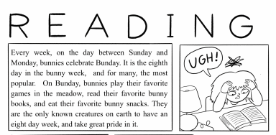 | 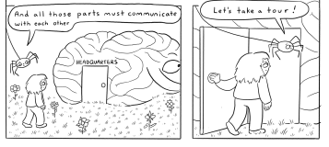

Close Reading Questions
Page # | Question | Text-based Answer
Prior to the 2nd read | Have you ever had a frustrating experience with reading similar to the girl in the book? If so, what was the context or situation for you? | n/a
4–5 | On pages 4 and 5, the spider’s words are underlined and in capitals. Why do you think the author did this? | Emphasize two important points in the book: reading is not natural, and all of us can do it, with work
6 | Why do you think talking is “wired” or natural for humans, but reading is not? | The text does not directly address this question. However, students may note that we listen, absorb, and mimic talking to communicate.
6 | Look at the development of Bea’s ability to ask for berries in the bottom three frames of page 6. How can you tell it’s the same person in each drawing? How does the artist make her look different? What information is being transmitted by the pictures themselves? | The color of the shirt and her hair remains the same.  The drawings suggest that Bea has gone through the evolution described by the words, emphasizing that this is a process that humans go through naturally as they develop.
After the 2nd read | What do you now understand about your early experiences with reading? | n/a
Implementation Notes
As this is the students first experience with the text, it may be beneficial to allow students 3–5 minutes to independently flip through before the first read.

Relevant Background Knowledge
- By studying fossils, scientists know that human beings have been on earth for about 300,000 years, but the first writing anyone has found is only from about 3,000 years ago (as the book will note on page 12). So, if reading and writing were natural, they would not have taken that long to emerge.
- The book will address this idea again, and they’ll get a better understanding of it then. This is a good example of how important concepts, often abstract or complex, can be learned about because an author builds on these concepts through the course of a text.

Day 2: Pages 8–10

Today’s Panels
Start | End
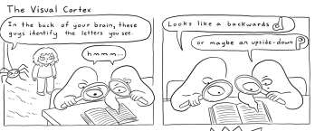 | 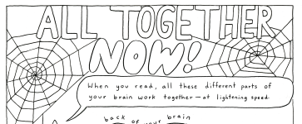

Close Reading Questions
Page # | Question | Text-based Answer
8–11 | In your own words, explain what role in reading each part of the brain plays:  - Visual cortex  - Auditory cortex  - Angular gyrus  - Inferior frontal cortex | The visual cortex identifies the letters in the written word.  The auditory cortex recognizes and takes apart or segments the sounds that each letter represents or symbolizes.  The angular gyrus blends all the sounds together to make the complete sound of the word.  The inferior frontal cortex connects the sight and sound of the word to its meaning.
Implementation Notes
Whole-Class Application Activity
- After the students work together to answer the close reading question, it will likely be helpful to engage students in an activity where they discuss how the parts of the brain work together to decode. A sample of how this can be done is provided below:
  - Here are two examples going from simpler to slightly more complex.
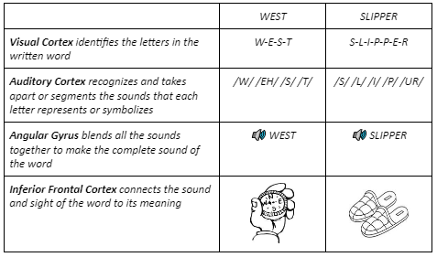
  - Assign student pairs to do the four-step activity you modeled with two words: FUN - FUNCTION
    - As a class, go over the work a few pairs of students did with these two words.
      - Point out how each syllable is done the same way as if it was one word and is then blended together. This is an example of the way students who need more work with decoding will be taught to blend the syllables in a word together. Point out that -tion is weird but very common in English. It turns other parts of speech into nouns and is always pronounced /SH//U//N/. For example, “act” is a verb, action is a noun; “digest” is a verb, “digestion” is a noun.
  - Optional Discussion Extension:
    - Which step, or part of the brain, do you think your brain would have trouble with for the word MUKTUK?
      - Point out here that probably few of us know the meaning of this word, a food made from the skin of a whale, so the inferior frontal cortex would have trouble connecting it to meaning because the meaning of the word is not in our brain.
    - Which part(s) of the brain we’ve read about is involved in deeply understanding what a book says (finding the main idea, comparing characters in a story, understanding an author’s choice to skip backwards in time)?
      - This is a trick question since none of them are. The goal in asking it is for students to begin to see that comprehension skills and understanding text are NOT addressed by the parts of the brain involved in beginning reading. Problems with beginning reading have to do with these mechanics and have nothing to do with intelligence or comprehension (except, of course, that if you can’t read the words, you can’t comprehend).

Day 3: Pages 11–13

Today’s Panels
Start | End
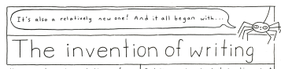 | 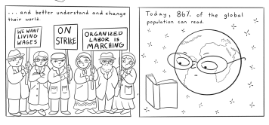

Close Reading Questions
Page # | Question | Text-based Answer
11 | Most of the time people invent things and come up with ideas to solve problems. What problem did the invention of writing help to solve? | The Sumerians wanted a system to record information about the goods that they were trading.
11–12 | How many years were people talking before they started writing? Why do you think it took so long? | Humans have been talking for about 200,000 years.  May infer that literacy was a skill reserved for the powerful few or that the initial limited availability of paper may have been a hindrance.
 | Why were they writing on clay tables instead of paper? | Paper was not invented yet
11 | The bottom of page 11 represents a huge shift in the history of writing and reading. What was this shift? Why was it such a big deal?  Scaffolding question to support students in making this inference: (Use as needed.)  - What problems do you think people would have if this shift had not been made? | The shift was from signs or symbols representing pictures of objects to signs and symbols representing a sound.  We would need thousands of pictures to represent objects or ideas that people would have to memorize.
12 | What does it mean on the top of page 12 when it says writing systems “developed independently” in other civilizations?  Why do you think they developed independently? | Writing helped solve the problem of trading and transactions. Since trading and transactions were developing across the world, it makes sense that diverse writing systems would slowly develop, with trade partners perhaps slowly passing the idea on to each other.
12 | The text notes “for most of human history literacy was reserved for the people in power.” Why is this an important idea? What is your response to this? | From this section of the comic, students can infer that literacy was power, and those who could read benefited from it. In other words, the people in power could and did use literacy to stay in power and keep those not in power out of power.
12 | The Fun Fact says “most of humanity's first readers read out loud.” Why do you think that was? | No one really knows for sure; students’ answers may vary. As a note: historians of reading surmise that people were used to talking to each other. As such, the first response to reading was to “talk to yourself” or to read to others who couldn’t read. Both those practices were far more common then than it is now in many cultures.
13 | What parts of this page, if any, did you not understand? | Clarify questions as they come up. Note that noticing what you don’t understand fully is one of the trademarks of a solid reader. Skipping over what you don’t understand dooms you to never understanding what you’re reading.
13 | How did the spread of literacy help with the problem of the imbalance of power discussed on page 12? Do you think it solved the problem for everybody? Explain why or why not. | More people were able to spread and share new ideas, to better understand and change their world.  (See Extension Activity below.)
Implementation Notes
Relevant Background Knowledge
- Vocabulary
  - Sumer: ancient civilization (4500–4000 B.C.) in the Mesopotamia region
  - Scribes: a person who documents information
- Since writing was invented in response to trade, some may infer that for the first 200,000 years there may not have been as much trade. This is one of the reasons why writing was not invented earlier. In early human history, we gathered fruits and nuts, hunted or bartered, and didn’t need this type of record keeping
- Paper was invented in China about 100 A.D. and did not make it to places where clay tablets were used for about 1,000 years.

Implementation Notes
- Extension Activity (for pages 12–13)
  - Have students identify markers of power in the comic and discuss how the people using writing in these images served people in power. Who had power and who did not? Who benefited and who did not?
  - Have students discuss how literacy relates to power in the modern world.

Day 4: Pages 14–17

Today’s Panels
Start | End
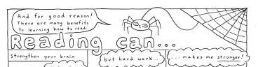 | 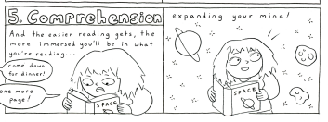

Close Reading Questions
Page # | Question | Text-based Answer
14–15 | What is a “benefit”?  How many benefits of reading are there according to these pages? Can you think of any others you would add?  Which of these benefits…  - Relates most to your life and you as a reader?  - Do you think are not connected to your life?  - Don’t you understand or don’t you believe are really true? | Benefit: an advantage, something that makes you better  The text lists the following 8 benefits:  - Strengthen your brain  - Build vocabulary  - Expand your mind  - Reduce stress  - Improve focus  - Improve writing  - Increase empathy  - Increase engagement
16–17 | Do you recall in kindergarten or first grade if some students learned to read faster than others?  Do you recall if you learned quickly or not?  How did you feel? How do you think your classmates who took longer than you felt? | Answers will vary depending upon student experience.
17 | Which parts of the brain would be involved in each frame? Why? | Phonemic Awareness ⇒ Auditory Cortex  Phonics ⇒ Visual Cortex and Auditory Cortex  Vocabulary ⇒ Interior Frontal Cortex  Fluency ⇒ Auditory Cortex, Visual Cortex, and Interior Frontal Cortex
Implementation Notes
Relevant Background Knowledge
- Phonemic Awareness. This connects to the auditory cortex, which tells the sounds in words apart.
- Phonics. Connects the sounds in words to their written letter. So, this involves the visual cortex and the auditory cortex.
- Vocabulary. Connects to the inferior frontal cortex. That takes the combined information from the visual and auditory cortex, and connects that information to the part of the brain where word meanings are stored.
- Fluency. Involves all three parts. This is because words we have learned, or even words we have heard and can pronounce but don’t know the meaning of, are now represented in our brain. This makes it easier to read the words and to read the sentences and paragraphs the words are in.
- Comprehension: Comprehension grows out of everything we have addressed so far. The most recent research about vocabulary growth says students learn the meaning of 3,000–4,000 words a year. Students can’t learn that many words from vocabulary instruction alone! Therefore, reading is the most efficient way to grow vocabulary as well as knowledge, and knowledge is also closely connected to comprehension. Unfortunately, you are far less likely to read if you aren’t a fluent reader, which leads to struggle with comprehending texts and a compounding difference between less-fluent readers and proficient readers. The difference is completely unrelated to intelligence. This is the central idea in the Launch Module: to shift beliefs so that students understand if they struggle with reading, it does not reflect their intelligence, therefore making it more likely that they will make the effort to grow as a reader.

Implementation Notes
- Since pages 14–17 are primarily focused on students’ individual connections to their own lives, today might be a day to engage in a whole-group discussion to build a shared community and allow students to get to know one another’s experience.
- Pages 16–17 contain a difficult section. It may be beneficial to create a printable worksheet with each frame labeled for students to fill out with a partner or in a small group.
Day 5: Pages 18–23

Today’s Panels
Start | End
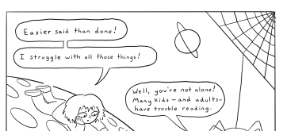 | 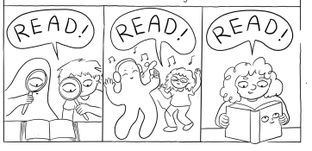

Close Reading Questions
Page # | Question | Text-based answer
18–19 | How many different ways does the book say that learning to read can be a struggle? | The text lists 7 reasons that reading can be a struggle:  - Trouble recognizing sounds in words  - Needing help sounding out written words  - New to books and magazines  - English is not a first language  - Dyslexia  - Not understanding school reading  - Not seeing oneself in books
19 | Do any of these apply to you or someone you know? If so, which ones? | Answers will vary.
19 | Do you have any ideas now about what schools can do to help someone in these situations | Answers will vary.
20 | Using what you know about the functions of the parts of the brain we use to read, why are the methods described on this page the wrong way to teach reading? | All of these methods do not help students learn to read. The methods on this page are wrong because they do not connect letters to sounds in order to recognize a word. These methods do not do that—they help students learn to guess.
20 | What do you remember about your own experience learning to read? | Answers will vary.
20 | What do you think the last frame means when it says “a bad habit that’s hard to break”? | If you continue to use pictures, rhyming sounds, or other clues instead of trying to decode the words, guessing can become a habit that is hard to break. However, this habit was developed over time because you were asked to do this, but you can develop new habits with new understanding about reading and the brain.
21 | Using what you’ve learned from the Guide to Reading, explain why frames 1 and 2 are in fact the best practices based on the science of reading and the brain. Refer to the earlier pages as you need to in order to use the terms you’ve learned for the ideas and the parts of the brain. | This will help the brain use all of the parts involved (visual cortex, auditory cortex, angular gyrus, and inferior frontal cortex) to go through the process of recognizing sounds, matching them to corresponding letters and connecting to meaning. This process is reading, not memorizing or guessing.  This will help activate all parts of the brain that we use for reading to help us pathways for learning and remembering.
21 | How will “befriending books” help us learn to read better? | As readers read, the connection between letters and the sounds those letters represent get stronger and stronger in their brains. This allows them to read fluently. Reading fluently allows them to learn the meaning of more words (remember, reading is the most effective and efficient way to do this) and get more knowledge. Thus, their reading ability grows by reading. This does not happen if the connections we have been studying do not get made, however, nor does it happen if they can read but avoid it anyway.
22–23 | In your years in school, do you remember having access to the books (relevant, interesting, and fun), resources (people & programs) and supports described on page 22?  Did this help you? Why or why not? | Answers will vary.
Implementation Notes
Relevant Background Knowledge
- Vocabulary
  - Dyslexia: a reading disorder that affects areas of the brain that process language and affects identifying speech sounds and decoding. It is important to understand there are many students who have this problem and are not identified as dyslexic. There are also many famous people who were dyslexic and were still able to learn to read (Steven Spielberg, Whoopi Goldberg, Danny Glover, among others).

Implementation Notes
- Ensure that students have clarity around the definition of ESL teachers and their roles in supporting language development.
- Ensure that students also have clarity around what is a culturally inclusive learning environment.
- Today includes many opportunities to discuss personal experiences with school and reading. It may be beneficial to discuss these questions as a whole group to build community. The teacher may choose to model vulnerability by sharing their own experience with school and reading.

Day 6: Pages 23–27

Today’s Panels
Start | End
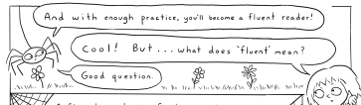 | 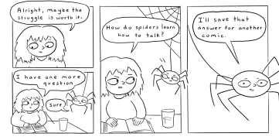

Close Reading Questions
Page # | Question | Text-based answer
23–24 (first frame only) | This section contains two very important ideas. What are they? Why are they so important? Use evidence from the book and our discussions. | Parts of the brain work together to recognize words. With practice and enough repetition, over time this produces fluency.  To become fluent, you need to first learn to slowly sound out written words.  This is important because fluent reading makes it easier to learn new words. (See Comprehension in the Implementation Notes from Day 4.)
24–25 | Using evidence from the book and what we have been discussing, explain how reading comic books can help you become a better reader. | Comic books and other graphic works help teach us about the world. That learning makes us better readers. And the pictures in comics help motivate us to want to read them and deepen our understanding.
24–25 | What do you think the philosopher Paolo Friere meant when he said, “We learn to read the world before we learn to read words”? | Answers will vary. Most student answers should center on the importance of learning about people, places, events, and ideas before they learn to read (because being illiterate is not the same as being ignorant).
26–27 | Why do you think the author chose a spider to lead us through these ideas? | Page 26 notes that “learning to read is like building a web—making connections between different parts of your brian so that you can connect with the rest of the world.” Spiders build webs, so this choice allows the author to make the idea of connections come through more clearly.
26–27 | Explain how reading is like building a web or bridge. Be sure to use evidence from the book and our discussions and lessons. | In the brain, different connections happen during reading. This allows us to make connections between sounds and letters; connect the sequences of sounds and letters to turn them into words; and finally connect the words to objects and ideas that make sense to us.
27 | Page 27 says reading helps us “navigate a chaotic world.” What does this mean? Do you agree with this idea? Say why or why not. | Answers will vary. Student answers should show a sense of the importance of reading to understand our world.
27 | Some people say reading is no longer as important as it used to be because you can learn so much from online videos and podcasts. Do you think this is true? Say why or why not. | Answers will vary.  Note: Many careers require reading texts, whether they are online, on a screen, or on paper (mechanics, builders, teachers, doctors, lawyers, engineers, etc.). Equally important is the difficulty of efficiently presenting multiple perspectives in media other than text.
Implementation Notes
Relevant Background Knowledge
- Vocabulary
  - Immersed: to be deeply involved in an activity or interest
  - Navigate: to find one’s way on, in, or across; to move in, on, over, or through
- Paolo Freire: Freire is famous for how he used the real world and real lives of Brazilian farmers to teach them how to read. He valued and utilized all that his students learned about the world before they learned to read.

Culminating Task
Writing Prompt: Consider what you have learned about why some students learned to read easily and some struggled. Now imagine if learning to read in the early grades was aligned with how our brains read. What would be different for you if you and all students had been taught to read in the early grades based on how the brain works? How would your experience in school and out of school change if all kids, everywhere you went, could read well? What implications might this have had on your future and the future of others you know or knew?

Implementation Notes
Consider partnering students to discuss and brainstorm their answers before they start writing. Students can share their own experience, imagined future, etc.

