Alignment Criterion 1D: Materials should reflect the text characteristics and genres called for in the Standards.

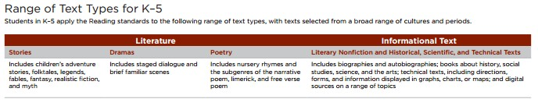
(This chart if from page 31 of CCSS K-5)
Work with a colleague and read through the Reading Standards for Literature and the Reading Standards for Informational Text for your grade level. Identify the text characteristics that are specifically required by the standards at your grade level. This list will be useful to you as you review for AC 1D.
My Grade Level

Are there any specific texts mentioned in your grade level standards?

If yes, what are they?

Are there any specific grade-level characteristics for your grade level?

If yes, what are they?

