Title/Author: Samuel Eaton’s Day by Kate Waters
Suggested Time to Spend: 5 Days (Recommendation: two sessions per day, at least 20 minutes per day)
Common Core grade-level ELA/Literacy Standards: RL.1.1, RL.1.2, RL.1.3, RL.1.4, RL.1.7, RL.1.10; W.1.2, W.1.8; SL.1.1, SL.1.2, SL 1.3; L.1.1, L.1.2, L 1.4
Note: Even though the information in this text is factual, the lesson uses literary standards since the text is narrative fiction and contains narrative elements.
Lesson Objective:
The objective of this lesson is to help children understand what life was like on Plimoth Plantation long ago. Students will learn how the Pilgrim people made do with the resources that they had and overcame obstacles. They will begin to understand other cultures and life before modern conveniences. Through reading this book, we can also work on building support for finding context clues.
Teacher Instructions
Before the Lesson
- Read the Big Ideas and Key Understandings and the Synopsis below. Please do not read this to the students. This is a description to help you prepare to teach the book and be clear about what you want your children to take away from the work.
Big Ideas/Key Understandings/Focusing Question
Life on Plimoth Plantation was much different than our lives today. The people worked for everything that they had – food, clothing, farming, daily supplies. Nothing was easy. Everyone worked together and each job was important. Even the children had chores throughout the day that contributed to the family. Education was important but it was not a full day activity like we have today.

Synopsis
This is an historical fiction text that shares the daily life of one family in Plimoth Plantation. Young Samuel Eaton lives with his father, mam and younger sister in a village. Throughout the book, Samuel walks us through a day in his life sharing about his responsibilities and the family’s way of life. Through reading this story, we can understand the relationships, attitudes, resources and hardships faced by a family in Plimoth.
This book invites readers to follow a typical day in the life of a young Pilgrim boy. The photographs were taken at Plimouth Plantation, a living history museum in Plymouth, Massachusetts.
- Go to the last page of the lesson and review “What Makes This Read-Aloud Complex.” This was created for you as part of the lesson and will give you guidance about what the lesson writers saw as the sources of complexity or key access points for this book. You will of course evaluate text complexity with your own students in mind, and make adjustments to the lesson pacing and even the suggested activities and questions.
- Read the entire book, adding your own insights to the understandings identified. Also note the stopping points for the text-inspired questions and activities. Hint: you may want to copy the questions, vocabulary words, and activities over onto sticky notes so they can be stuck to the right pages for each day’s questions and vocabulary work.
- Consider pairing this series of lessons on Samuel Eaton’s Day with a text set to increase student knowledge and familiarity with the topic. A custom text set can be found here. Note: This is particularly supportive of ELL students.

Note to teachers of English Language Learners (ELLs): Read Aloud Project Lessons are designed for children who cannot read yet for themselves. They are highly interactive and have many scaffolds built into the brief daily lessons to support reading comprehension. Because of this, they are filled with scaffolds that are appropriate for English Language Learners who, by definition, are developing language and learning to read (English). This read aloud text includes complex features which offer many opportunities for learning, but at the same time includes supports and structures to make the text accessible to even the youngest students.
This lesson includes features that align to best practices for supporting English Language Learners. Some of the supports you may see built into this, and /or other Read Aloud Project lessons, assist non-native speakers in the following ways:

- These lessons include embedded vocabulary scaffolds that help students acquire new vocabulary in the context of reading. They feature multi-modal ways of learning new words, including prompts for where to use visual representations, the inclusion of student-friendly definitions, built-in opportunities to use newly acquired vocabulary through discussion or activities, and featured academic vocabulary for deeper study.
- These lessons also include embedded scaffolds to help students make meaning of the text itself. It calls out opportunities for paired or small group discussion, includes recommendations for ways in which visuals, videos, and/or graphic organizers could aid in understanding, provides a mix of questions (both factual and inferential) to guide students gradually toward deeper understanding, and offers recommendations for supplementary texts to build background knowledge supporting the content in the anchor text.
- These lessons feature embedded supports to aid students in developing their overall language and communication skills by featuring scaffolds such as sentence frames for discussion and written work (more guidance available here) as well as writing opportunities (and the inclusion of graphic organizers to scaffold the writing process). These supports help students develop and use newly acquired vocabulary and text-based content knowledge.

The Lesson – Questions, Activities, and Tasks

Questions/Activities/Vocabulary/Tasks | Expected Outcome or Response (for each)
FIRST READING:  Read aloud the entire book (or chapter) with minimal interruptions. Stop to provide word meanings or clarify only when you know the majority of your students will be confused. | The goal here is for students to enjoy the book, both writing and pictures, and to experience it as a whole. This will give them some context and sense of completion before they dive into examining the parts of the book more carefully.
SECOND READING (This can be done over multiple days):  Reread page 3: “From whose point of view is the story being told? How do we know?  Review pictures: “Where does this story take place”?  Show pages 4 and 5 to the students. “What does Samuel Eaton’s home/village looks like? How is it different from our homes/villages”? Note: the part of the chart about My Home/Village will vary depending on where students live.  Page 5 – “Who created the village?”  Reread pages 6 and 7 – “How are Samuel’s clothes the same and different from your clothes?”  Page 6 – “What do you think the word ‘eager’ means? Why do you think Samuel was eager?”  Reread page 8 – Tell students what aiding, gammy, and labor mean. Have them work with a partner to act out this page using modern language, with one student being Samuel and one being Sarah.  Page 9 – “Use the pictures and words on page 9 to explain to a partner what ‘game’ and ‘snare’ mean.”  Page 10 – “How is Samuel helping his mother? Why does she need his help?”  Page 14 – Tell students what “dally”, “stores”, “naught”, and “slack” mean. Model what it might sound like in modern language. Have students take turns with a partner saying that paragraph in modern language.  Page 15 – “How does the deal that Father made with the neighbor benefit both Father and Robert Bartlett?”  Page 16 – “How long will it take to harvest the rye? How does Samuel help?”  Page 18 – Tell students what “gammy”, “narry”, “folly”, and “bootless” mean. . Model what it might sound like in modern language. Have students take turns with a partner saying that paragraph in modern language.  Page 19-21 – “How is Samuel feeling on these pages?”  Page 22 – Model how this might be read in modern language. Have students practice with a partner.  Page 27 – 30 – “How is Samuel feeling about his day now that he’s home? Why does he feel this way?” | Students should respond by stating “Samuel Eaton”. “We know because he states his name”.  Students will respond, “Plimoth Plantation or the pilgrims village” and at a time in history a long time ago. 1620’s.  Sample:  Samuel’s Home/Village My Home/Village  Dirt around the house Very few, tiny windows Roofs are lower to ground Fence made out of branches Grass around the house Lots of windows and bigger windows Roofs higher Fence made out of lumber  Samuel’s father helped build the village. He is a carpenter.  Samuel’s Clothes My Clothes  Stockings Garters Breeches Doublet Shoes Points Hat Socks Socks stay up by themselves Pants Shirt Shoes Belt Hat  Eager means excited. Samuel was eager because he was excited to be going to work with the men.  Samuel: “Sarah, I’m excited about helping the men with the harvest today but I’m worried that I’ll be clumsy.”  Sarah: “Samuel, you’re not a baby anymore, you are big and strong enough to help the men.”  Game means an animal that is hunted for food, and a snare is a trap for catching those animals.  Samuel is collecting firewood so his mother won’t run out while he is away with the men. She needs his help because she is expecting a baby.  “We have to hurry up in case it starts to storm. We don’t have much food left and we need to harvest all that we can before the birds get it so we have enough to eat this winter.”  The neighbor will help with the harvest and Father will share the grain with him. This helps Robert Bartlett because he only has one acre of his own so he can’t grow as much grain as he needs. It helps Father because it would be hard for him to do all the harvesting himself.  It will take a few days. Samuel follows behind Father and Robert Bartlett and gathers up the rye and ties it together.  “When I am first learning to tie the rye I’m clumsy because it is so hard. And the rough straw makes my hands burn and itch and my neck is getting sunburned. But I won’t complain because it won’t do any good.”  Samuel is hungry and sore and he is feeling discouraged because the work is so hard. He feels like crying.  Mother – “Let’s soak your hands in cool water so they’ll feel better. Are you okay, Samuel? Do you want to come home with me?”  Samuel – “I’m tired but I really want to stay and help”. I’m glad that Mam doesn’t keep pushing and I know she won’t tell Father.  Samuel is proud of himself. Both Father and Robert Bartlett told him he did a good job.
THIRD READING:  “Say: Today, we will retell the story as a group using the pictures and yesterday’s chart as a prompt to guide discussions.”  Students will work in partners to create a circle map or flow map of Samuel’s day. (Please see attached examples of flow/sequencing maps). | Students will verbally retell the story.  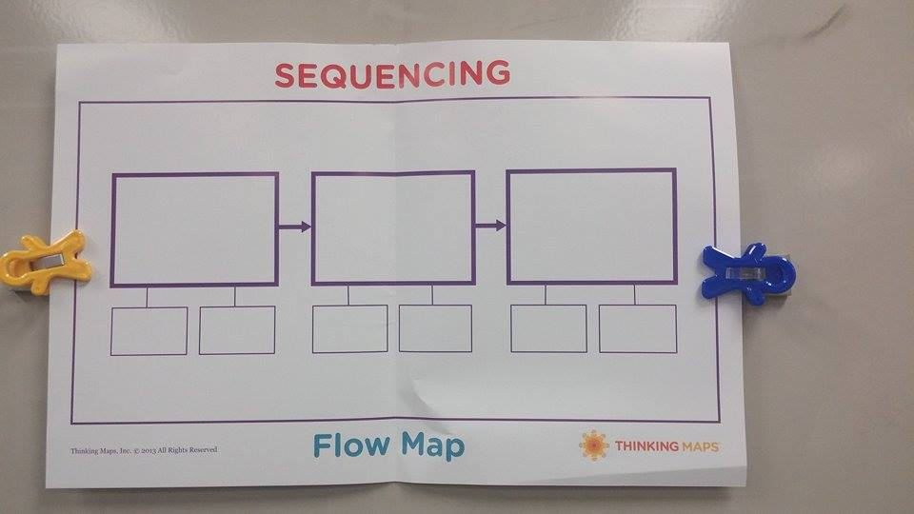  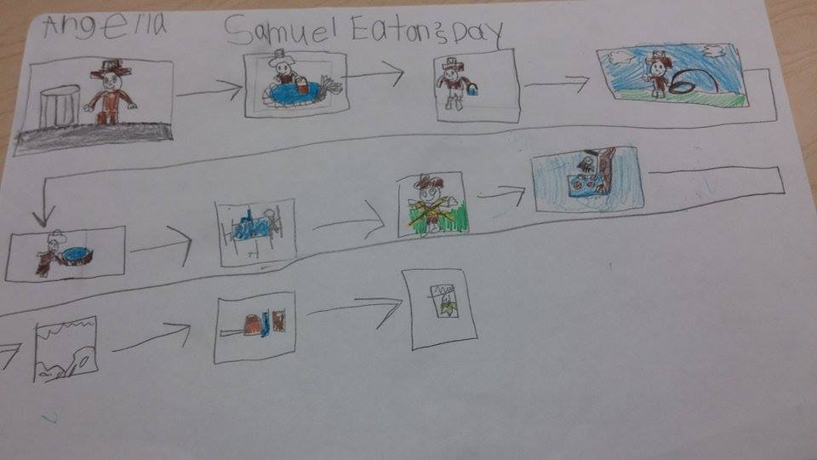  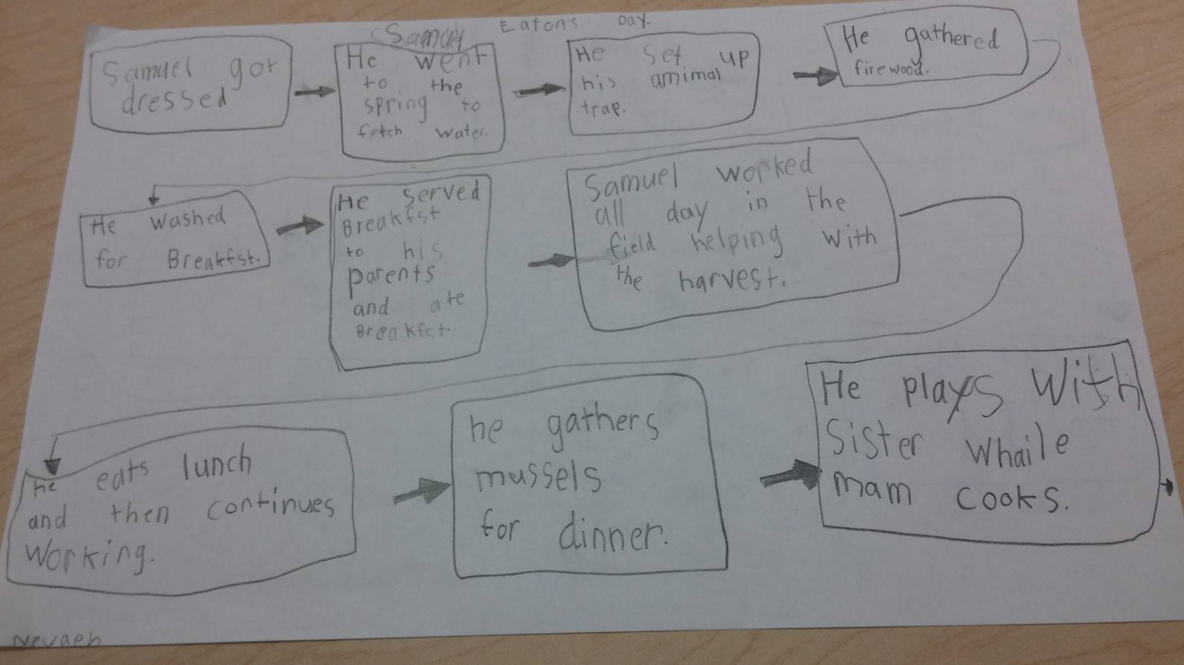  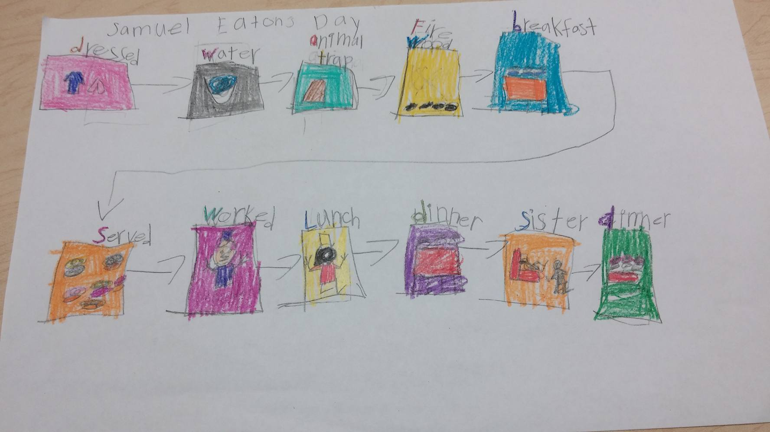  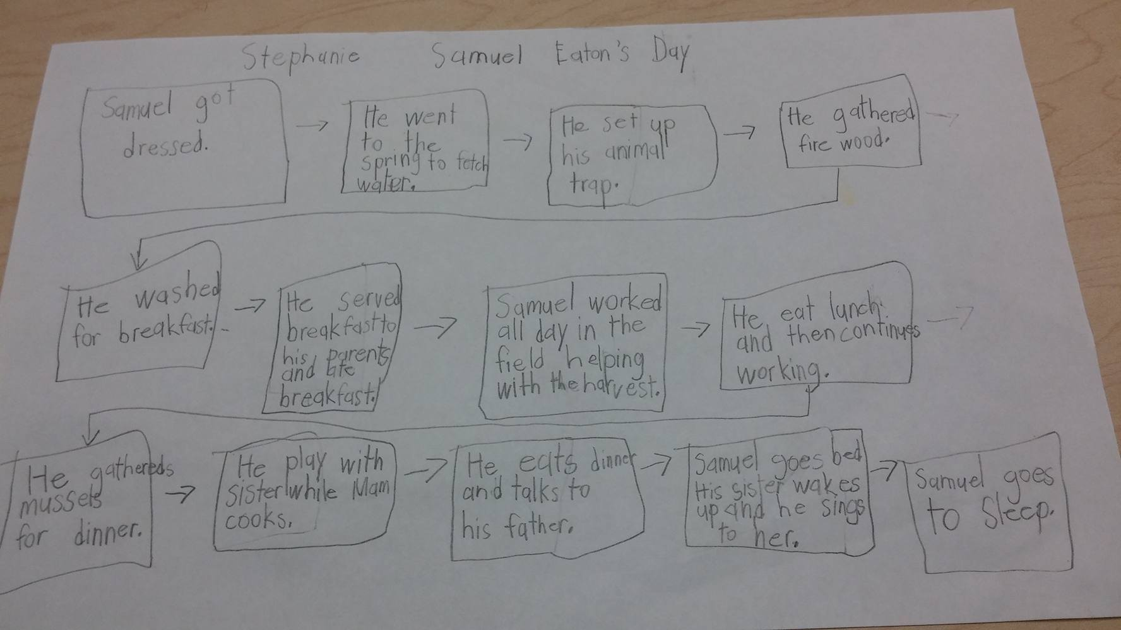  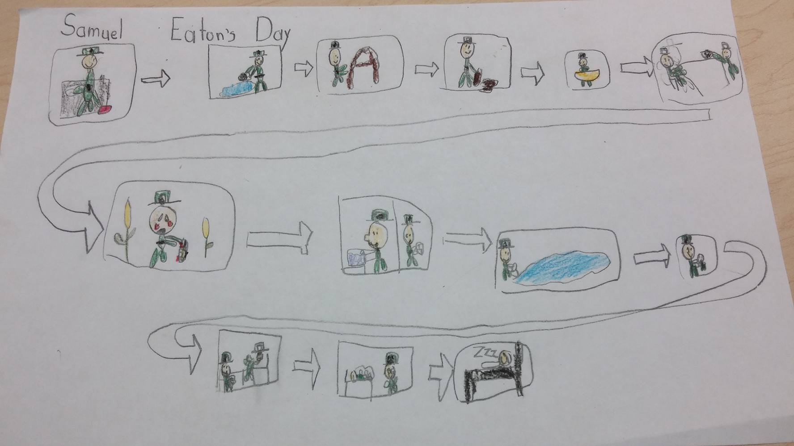

FINAL DAY WITH THE BOOK - Culminating Task
Using complete sentences, explain how Samuel’s life different from yours. Give at least 3 examples.

Sample Response:
Samuel lived in a house with tiny windows and a roof that reaches almost to the ground. His clothes are different from mine, he wears stockings instead of socks. Samuel works in the fields with the men even when he gets blisters and is tired, he keeps working. It doesn’t seem like he goes to school or has time to play.

Vocabulary
These words merit less time and attention  (They are concrete and easy to explain, or describe events/  processes/ideas/concepts/experiences that are familiar to your students) | These words merit more time and attention  (They are abstract, have multiple meanings, and/or are a part  of a large family of words with related meanings. These words are likely to describe events, ideas, processes or experiences that most of your student will be unfamiliar with)
Page 3 longing: to want or desire  Page 3 task: a piece of work to be done  Pages 3, 15, 16, 30 harvest: to gather in crops (v), a crop (n)  Page 8 fetch: to go for and then bring back  Page 9 game: wild mammal or bird hunted for food  Page 14 dally: move slowly  Page 16 vast: a big space  Page 16 wield: to use  Page 18 smart: to hurt  Page 21 ache: a pain in a person’s body  Page 23 hone: to sharpen  Page 29 weary: feeling tired | Page 8 aiding/aided: to help, assist  Page 6 eager: wanting to do or have something very much, impatient longing  Page 8 labors: physical work  Page 13 serve: to act as a servant, to be of use or help  Page 18 bind: to fasten or secure

Extension learning activities for this book and other useful resources
1. Make a pilgrim from construction paper. An example can be found at a blog, Welcome to Room 36.
http://mrswilliamsonskinders.blogspot.com/2011/12/what-we-did-in-november.html
2. Read a similar book, Sarah Morton’s Day (also by Kate Waters). Make a Venn Diagram or double bubble thinking map comparing and contrasting the days of the pilgrim girl and boy. Note: This is particularly supportive of English Language Learners.
3. The Plimoth website also has some useful information about a pilgrim child’s role within the family.
http://www.plimoth.org/learn/just-kids/homework-help/childs-role
Useful websites with activities:
http://thefirstgradeparade.blogspot.com/2014/11/talk-turkey-to-me_18.html
First Grade Wow has a free unit with activities to use with the book. Included is a pattern to make a pilgrim boy and girl.
http://firstgradewow.blogspot.com/2013/11/tree-mendously-thankful-and-samuel.html

Note to Teacher:
- There are many extension activities to couple with this book. Kate Waters has also published a book about a Pilgrim girl and a Native American boy.
- Support for this lesson: visuals, Scholastic videos of Plimoth, expand vocabulary (then vs now), comparisons.
- The book can be purchased from Scholastic:
  - https://www.scholastic.com/teachers/books/samuel-eaton-s-day-by-kate-waters/
- The Plimoth website also has some useful information about a pilgrim child’s role within the family.
  - http://www.plimoth.org/learn/just-kids/homework-help/childs-role
What Makes This Read-Aloud Complex?
- Quantitative Measure
Go to http://www.lexile.com/ and enter the title of your read-aloud in the Quick Book Search in the upper right of home page. Most texts will have a Lexile measure in this database.

Most of the texts that we read aloud in K-2 should be in the 2-3 or 4-5 band, more complex than the students can read themselves.
2-3 band 420-820L
4-5 band 740-1010L

AD 590

- Qualitative Features
Consider the four dimensions of text complexity below. For each dimension*, note specific examples from the text that make it more or less complex.

Life lessons (implicit purpose) (informational)
To show what life was like a long time ago.

A day in the life of Samuel Eaton told in first person. It shows his day in chronological order. The photos support the text.

Unfamiliar words, old-fashioned dialect, high
academic vocabulary

Distinctly different experiences, perspectives unlike their own, cultural/literary knowledge, specialized/specific content

Structure
Meaning/Purpose

Knowledge Demands
Language

*For more information on the qualitative dimensions of text complexity, visit http://www.achievethecore.org/content/upload/Companion_to_Qualitative_Scale_Features_Explained.pdf

- Reader and Task Considerations
What will challenge my students most in this text? What supports can I provide?
- Unfamiliar vocabulary. Support can be provided by using context clues within the text and pictures to understand the vocabulary words. Supports that can be provided are visuals, Scholastic videos of Plimoth, expand vocabulary (then vs. now) (comparisons)
How will this text help my students build knowledge about the world?
- The students will be able to understand struggles and compare/contrast their lives with those that lived long before us, long before modern conveniences. The students will be able to understand the resources and abilities people had to use to make due and overcome obstacles.

- Grade level
What grade does this book best belong in? Grade 1 as a read-aloud

All content linked to within this resource was free for use when this resource was published in March 2018. Over time, the organizations that manage that external content may move or remove it or change the permissions. If the content is no longer available, please email info@studentsachieve.net.

